

**FPT UNIVERSITY**

Capstone Project Document

**Search Engine Platform for Traveling Information based on Apache Lucene**

|  |  |
| --- | --- |
| **Group 01** | |
| **Group members** | Giang Song Trúc – SE61268 Hồ Huy Cường – SE61155  Lê Vĩnh Hoài Trung – SE61074 Nguyễn Duy Khương – 60493 |
| **Supervisor** | Nguyễn Huy Hùng |
| **Ext. Supervisor** | N/A |
| **Capstone Project code** | SEPTIAL |

- Ho Chi Minh city, January 4th 2016 -

**Table of Contents**

Definitions, Acronyms, and Abbreviations 6

1. Report No. 1 Introduction 7
   1. Project Information 7
   2. Introduction 7
   3. Current Situation 7
   4. Problem Definition 7
   5. Proposed Solution 8
      1. Feature functions 8
      2. Advantages and disadvantages 8
   6. Functional Requirements 9
   7. Role and Responsibility 9
2. Report No.2 Software Project Management Plan 10
   1. Problem Definition 10
   2. Name of this Capstone Project 10
   3. Problem Abstract 10
   4. Project Overview 10
   5. Project organization 13
   6. Software Process Model 13
   7. Roles and responsibilities 14
   8. Tools and Techniques 15
   9. Project Management Plan 15
   10. Software development life cycle 15
   11. Phase Detail 17

3.1. All Meeting Minutes 20

* 1. Coding Convention 20

1. Report No. 3 Software Requirement Specification 21
   1. User Requirement Specification 21
   2. User Requirement 21
   3. Staff Requirement 21
   4. Admin Requirement 21
   5. Scheduler Requirement 21
   6. System Requirement Specification 21
   7. External Interface Requirement 21
   8. System Overview Use Case 22

2.1. List of Use Case 23

* 1. Software System Attribute 78
  2. Usability 78
  3. Reliability 78
  4. Availability 78
  5. Security 78
  6. Maintainability 78
  7. Portability 78
  8. Performance 78
  9. Conceptual Diagram 78

1. Report No. 4 Software Design Description 80
   1. Design Overview 80
   2. System Architecture Design 81
   3. Web Application architecture description 81
   4. Mobile Application architecture description 81
   5. Component Diagram 82
   6. Detail Description 82
   7. Class Diagram 82
   8. Class Diagram Explanation 83
   9. Interaction Diagram 87
   10. User Interface Design 113
   11. Web app 113
   12. Mobile app 128
   13. Database Design 130
   14. Entity Relationship Diagram 130
   15. Entity dictionary 130
   16. Algorithms 132
   17. Parse data from Html 132
   18. Parse data from Ajax 133
   19. Remove low-valuable search keywords 134
   20. Search data by keyword 135
   21. Suggest relevant keyword 136
   22. Suggest relevant data 137
   23. Suggest near-by hotels 138
   24. Categorize data by location 139
   25. Group hotel services 140
   26. Updating data process 141
2. System Implementation & Test 143
   1. Introduction 143
   2. Overview 143
   3. Test Approach 143
   4. Database relationship diagram 143
   5. Physical Diagram 143
   6. Data Dictionary 145
   7. Test Plan 146
   8. Feature to be tested 146
   9. Feature not to be tested 146
   10. System Testing Test Case 146

4.1. Test case 146

1. Sofware User’s Manual 152
   1. Installation Guide 152
   2. Setting up environment at server side 152
   3. Web Application Deployment Process 152
   4. User Guide 155
   5. Web application 155
   6. Mobile application 170
2. Appendix 173

# Definitions, Acronyms, and Abbreviations

|  |  |
| --- | --- |
| **Name** | **Definition** |
| SEPTIAL | Search Engine Platform for Traveling Information based on Apache Lucene |
| Data source | Websites contains traveling information used to parse data |
| Data item | General name for hotels/tours/flights parsed from data source |
| Keyword | Search keyword of users |
| Parsing configuration | A set of settings for each data source that specify CSS selectors for data fields, which are used to check html structure of a web page and parse all the available data |
| SimilarityScore | The score that measure the relevance between 2 documents |
| CTR | Click-through rate |
| Users | The un-authenticated users |

1. **Report No. 1 Introduction**

## Project Information

* + - Project name:

**Search Engine Platform for Traveling Information based on Apache Lucene**

* + - Abbreviation: **SEPTIAL**
    - Product Type: **Web app & Mobile app**
    - Start Date: **January 4th 2016**
    - End Date: **April 2016**

## Introduction

In Vietnam, people usually have difficulty searching for traveling information as the current websites usually focus on only one aspect such as hotels, flights, tours, deals. It takes time and effort for customers to find and summarize all the search results from those data sources.

The proposed solution is to build a system that helps people search for all the needed information without having to browse several websites. The system collects data from multiple sources, analyzes users’ behaviors and suggests the most appropriate traveling information available.

## Current Situation

Nowadays, traveling has become an essential part of our lives. Normally, people have two options for their traveling plan: either find a tour or plan everything themselves.

To find the most suitable tour, users have to look through several websites of travel agencies, consider various offers before picking one.

And if they would like to plan their own trips, the workload is often heavier as the process needs to be repeated for every element of the trip, such as flights, hotels, places to go, restaurants to eat.

## Problem Definition

Because of the current situation, people confront with many problems searching for the necessary information. First of all, most people don’t know where to start, what kind of information to look for or which website to visit. Secondly, even when they already have their own intentions, they have to browse through too many websites with a huge amount of data. The main problems with this approach are ineffectiveness, time consuming and low efficiency.

## Proposed Solution

The proposed solution is a system for searching traveling information collected from various sources, named “EzGo”. This system is not only a searching tool but also an assistant suggesting appropriate information based on other similar users’ behaviors.

EzGo includes a web app and a mobile app, with the following features:

### Feature functions

* + - Admin/Staff can manage all the data collections and track activites of all the background processes.
    - Background processes:
      * Periodically parse data from external data sources then add new data to main storage or update the existed data if there are any changes.
      * Categorize raw data and update to Lucene database.
      * Remove redundant and out-of-date data from main storage and Lucene database.
    - Users can search for hotels/tours/flights by keywords, locations, date or price. After search results are displayed, users can sort and filter by criterias.
    - By default, search results will be sorted by users’ trends.
    - The system will suggest possible keywords when users start typing. The suggestions are based on the similarity of keyword content and numbers of users searching for it.
    - Whenever users view detail of a search result, the system will display suggestion of relevant hotels, tours, flights based on the content of those data items, users’ location and other users’ activities.
    - User activities will be collected for optimizing search results and suggestions along with search results.
    - Mobile app are developed with all the searching features as the web app.

### Advantages and disadvantages

Advantages:

* + - Data is periodically collected and updated from differents sources so that users can compare the results and find the most suitable for their needs.
    - Users can search for all the information about hotels, flights or tours without browsing through several websites.
    - Search result can be filtered or sorted by criterias.
    - Users can see suggested information of what other users are interested in or related information to the search result.
    - The search result will be optimized by the time based on users activities.

Disadvantages:

* + - Data will not be real-time updated.
    - The collecting data module must be configured for each websites and can be affected by any changes of the data sources.

## Functional Requirements

System:

* + - Parse and collect data from data sources on a schedule
    - Periodically update data from main storage to Lucene
    - Periodically categorize parsed data
    - Optimize search results and recommendations for users
    - Provide API for mobile app Admin:
    - Manage data sources
    - Manage schedulers
    - Configure data parsing
    - Manage parsed data User:
    - Search for hotels, flights, tours by location, date or price
    - Filter and sort search results
    - See suggestions of trending or related information
    - Use all the functions in web app and mobile app

## Role and Responsibility

|  |  |  |  |  |
| --- | --- | --- | --- | --- |
| **No** | **Full Name** | **Role** | **Position** | **Contact** |
| 1 | Nguyễn Huy Hùng | Product owner | Supervisor | [hungnh@fpt.edu.vn](mailto:hungnh@fpt.edu.vn) |
| 2 | Giang Song Trúc | Developer | Leader | [trucgsse61268@fpt.edu.vn](mailto:trucgsse61268@fpt.edu.vn) |
| 3 | Hồ Huy Cường | Developer | Member | [cuonghhse61155@fpt.edu.vn](mailto:cuonghhse61155@fpt.edu.vn) |
| 4 | Lê Vĩnh Hoài Trung | Developer | Member | [trunglvhse61074@fpt.edu.vn](mailto:trunglvhse61074@fpt.edu.vn) |
| 5 | Nguyễn Duy Khương | Developer | Member | [khuongnd60493@fpt.edu.vn](mailto:khuongnd60493@fpt.edu.vn) |

#### *Table 1 : Roles and Responsibilities*

1. **Report No.2 Software Project Management Plan**

## Problem Definition

### Name of this Capstone Project

* **Official name**:

Search Engine Platform for Travelling Information Based on Apache Lucene

* **Abbreviation**: SEPTIAL

### Problem Abstract

Nowadays in Vietnam, websites and applications for traveling on the market often focus on only a certain task, e.g hotels, flights and tours.

Those websites that focus on several tasks are often designed for international users and thus, are not particularly suitable for Vietnamese people.

The solution is to provide a system for Vietnamese people which allows them to search for everything needed for a trip in a simple and effective way. People don’t have to go through several websites to plan their own trip.

### Project Overview

#### *Current Situation*

Below are the problems encountered in this project:

* + - * **Results for real-time data may not incorrect**: All results provided are collected periodically, so the information may not be updated immediately whenever data changes occur.
      * **Some information require premium package to access**: Valuable information, such as flight fare or number of seats available, require to sign contracts with sellers in order to access efficiently.
      * **Data source formatting**: Websites where the system get the data from may change structures or flows, which makes the data parsing modules not working correctly.
      * **IP block**: Some websites limit the number of time to access their page, thus the system may encounter IP blocking from these sites.

#### *The Proposed System*

* + - * By periodically collecting and updating data from serveral sources, the system provides synthetic information for users.
      * User activities are collected and analyzed for optimizing search results time by time. By studying user behaviors, the system can suggest some related information that users may be interested in.
      * Data synchronization can be satisfied by adjusting data parsing schedule. Data can be considered up-to-date with appropriate settings for particular datasources.
      * In order to parse data from any data sources, admin is provided utilities to configure the data parsing module depended on structure of data sources and demand of the admin. Flexible configurations help admin easily adapt to changes of data sources.
      1. **System**

System is an essential part with main features:

* + - * + Background process:

Periodically parse data from data sources and update to the main storage.

Periodically categorize and update data from the main storage to Lucene database.

Periodically update new keywords and remove low- value keywords.

Periodically remove redundant and out-of-date data from the main storage and Lucene database.

* + - * + Find and suggest appropriate information for users based on the data contents and users’ activities.
        + Collect and analyze user behaviors.
        + Provide API for mobile app.
      1. **Web app**

Web app consists of two main parts:

* + - * + For users:

Search and display information about hotels, flights and tours.

Filter search results: by data type (hotel/tour/flight), by price range, by hotel services, by flight agency, by locations, by date/time.

Sort search results: by price, by rating, by date/time, by trending.

View trending and related results: relevant keywords, relevant hotels, relevant tours, relevant flights, nearby hotels.

* + - * + For admin & staff:

Manage data sources

Configure settings and schedule to collect data from data sources

Manage schedulers

Manage parsed data

* + - 1. **Mobile app**

Mobile application is an optional part used by users. It has the same features as the website counterpart.

#### *Boundaries of the System*

* + - * Collect data from data sources
      * Allow users to search for information about hotels, flights and tours by locations, date or price as well as filter and sort search results
      * Suggest related results to users
      * Allow users to redirect to appropriate websites from result page

#### *Future Plans*

With further research and development, the system can apply the following features:

* + - * The ranking and optimizing algorithms will be improved to capture the search trends at different periods of time.
      * Beside specifing data sources, the system will have a data crawling module to find data sources and parse needed data automatically.
      * The supported information can include interesting places, restaurant, etc.
      * Beside filght data, the system will be upgrade to collect data of the other means of transport.
      * Upgrade parsing modules to be able to collect more detail information such as hotel room prices, deals, offers.

#### *Development Environment*

* + - 1. **Hardware requirements**

- **For server**

|  |  |  |
| --- | --- | --- |
| **Windows** | **Minimum Requirements** | **Recommended** |
| **Internet Connection** | Cable, Wi-Fi (4 Mbps) | Cable, Wi-Fi (8 Mbps) |
| **Operating System** | Window Server 2008 | Window Server 2012 |
| **Computer Processor** | Intel® Xeon ® 1.4GHz | Intel® Xeon ® Quad Core |
| **(12M Cache, 2.50 GHz)** |  |  |

#### *Table 2: Hardware Requirement for Server*

- **For Mobile**

|  |  |  |
| --- | --- | --- |
| Windows | Minimum | Recommended |
| **Internet Connection** | Wi-Fi or 3G (4 Mbps) | Wi-Fi or 3G (8 Mbps) |
| **Operating System** | Android 4.2.2 | Android 4.4.2 |

|  |  |  |
| --- | --- | --- |
| **Computer Processor** | Cortex-A7 Dual-Core 1.3GHz | Cortex-A7 Dual-Core 1.3GHz |
| **Computer Memory** | 1GB RAM | 2GB or more |

#### *Table 3: Hardware Requirement for Mobile*

* + - 1. **Software requirements**

|  |  |  |
| --- | --- | --- |
| **Software** | **Name / Version** | **Description** |
| **Operating system** | Window Server 2012 | Operating system and platform for development |
| **Environment** | .NET Framework 4.5 | Specification for developing web application |
| **IDE** | Visual Studio 2013, Android Studio v1.5.1 | Used for implement website and Android Mobile App. |
| **Design Model tool** | StartUML v2.5.1 | Used for creating modal and diagrams. |
| **DBMS** | Microsoft SQL Server 2014 | Used to create & manage the database for system |
| **Document storage** | Google Drive | Used for storing document |
| **Store and manage source code** | Team Foundation Server | Used to store all source code |

#### *Table 4: Software requirements*

## Project organization

### Software Process Model

The project is developed under Scrum model.

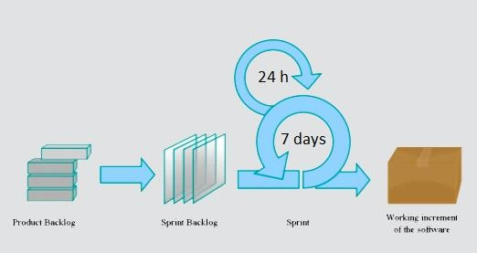

Scrum is an iterative and incremental [agile software](https://en.wikipedia.org/wiki/Agile_software_development) [development](https://en.wikipedia.org/wiki/Agile_software_development) methodology for managing product development. It defines "a flexible, [holistic](https://en.wikipedia.org/wiki/Holism) product development strategy where a development team works as a unit to reach a common goal", challenges assumptions of the "traditional, sequential approach" to product development, and enables teams to self-organize by encouraging physical co-location or close online collaboration of all team members.

Scrum adopts an [empirical](https://en.wikipedia.org/wiki/Empirical) approach—accepting that the problem cannot be fully understood or defined, focusing instead on maximizing the team's ability to deliver quickly, to respond to emerging requirements and to adapt to evolving technologies and changes in market conditions.

### Roles and responsibilities

|  |  |  |  |
| --- | --- | --- | --- |
| **No** | **Full name** | **Role in Group** | **Responsibilities** |
| **1** | Nguyễn Huy Hùng | Supervisor, Product owner | * Specify user requirements * Control the development process * Give out technique and business analysis support |
| **2** | Giang Song Trúc | Team leader, | * Managing process |
|  |  | B.A, Developer, | * Designing database |
|  |  | Tester | * Clarifying requirements |
|  |  |  | * Prepare documents |
|  |  |  | * GUI design |
|  |  |  | * Create test plan |
|  |  |  | * Coding |
|  |  |  | * Testing |
| **3** | Hồ Huy Cường | Team member, | * Designing database |
|  |  | B.A, Developer, | * Clarifying requirements * Prepare documents |
|  |  | Tester | * GUI design |
|  |  |  | * Create test plan |
|  |  |  | * Coding |
|  |  |  | * Test |
| **4** | Lê Vĩnh Hoài Trung | Team member, | * Designing database |
|  |  | B.A, Developer, | * Clarifying requirements * Prepare documents |
|  |  | Tester | * Create test plan |
|  |  |  | * Coding |
|  |  |  | * Test |

|  |  |  |  |
| --- | --- | --- | --- |
| **5** | Nguyễn Duy Khương | Team member, | * Designing database |
|  |  | B.A, Developer, | * Clarifying requirements * Prepare documents |
|  |  | Tester | * Coding |
|  |  |  | * Test |

#### *Table 5: Roles and responsibilities*

### Tools and Techniques

* + - Front – end technologies:
      * HTML5
      * CSS3
      * JavaScript
      * JQuery
    - Back – end:
      * Website: ASP.NET MVC 5 + Entity Framework
      * Web Service: ASP .Net Web API 2.
      * Mobile App: Android
    - Web Server: Microsoft IIS.
    - Database Management System: MS SQL Server 2014

## Project Management Plan

### Software development life cycle

|  |  |  |  |  |  |
| --- | --- | --- | --- | --- | --- |
| **Phase** | **Description** | **Deliverables** | **Resource needed** | **Dependencies and Constrains** | **Risks** |
| **Infrastructure** | * Identify and clarify overall requirements. * Determine the system architecture. * Build infrastructure for the project. | * Database design. * Project main structure with the components: Data, Parsing, Lucene, WebApp | 20 man- days |  | * Unclear project scope. * Lack of member share of understand. |
| **System &**  **Web app** | * Identify and clarify the needed requirements. * Build all the background modules. * Design the web UI. * Build the web app. | * Schedulers: Parsing, Data updating, Redundant data removing. * Search algorithms. * Complete web app for admin & end user. | 300 man- days | - Depends on “Infrastructure” | * Unclear project scope. * Lack of knowlegde in Apache Lucene. * Lack of experience. |
| **Web services** | * Indentify and clarify requirements for the mobile app. * Build the required API for mobile app. | - API for end user functions | 20 man- days | - Depends on “Web app & System” | - Lack of experience. |
| **Mobile app** | * Design the mobile UI * Build mobile app for end users. | - Complete android app. | 50 man- days | - Depends on “Web services” | - Lack of experience. |

#### *Table 6: Software Development Life Cycle Detail*

### Phase Detail

#### *Phase 1: Infrastructure*

|  |  |  |
| --- | --- | --- |
| **Task** | **Description** | **Author** |
|  | - Research some systems | * TrucGS |
|  | currently provide similar | * CuongHH |
| **1. Identify & clarify** | service. | * TrungLVH |
| **overall requirements** | - Determine core functions. | * KhuongND |
| **2. Determine system architecture** | * Determine system architecture: ASP .NET MVC. * Determine software design pattern: Repository & Service. | * TrucGS |
| **3. Build system infrastructure** | - Create the main structure of project | * TrucGS |
|  | - Report: project overview, | * TrucGS |
| **4. Create report &** | problem definition, proposed | * CuongHH |
| **SRS document** | solutions  - SRS: functional requirements | * TrungLVH * KhuongND |

#### *Table 7: Phase 1: Infrastructure*

#### *Phase 2: System & Web app*

|  |  |  |
| --- | --- | --- |
| **Task** | **Description** | **Author** |
| **1. Identify & clarify requirements** | * Determine actors and functions. * Create Use Case diagram | * TrucGS * CuongHH * TrungLVH * KhuongND |
| **2. Design web UI** | - Design and build prototype for web UI | * TrucGS * CuongHH |
| **3. Design databse** | * Create conceptual diagram * Design class diagram * Design database | * TrucGS * CuongHH |

|  |  |  |
| --- | --- | --- |
| **4. Build Lucene server** | * Research: Lucene .NET * Implement all the necessary modules: indexing & CRUD operations. | * TrucGS |
| **5. Build Web parsing module** | * Research: CSQuery * Build generic library for html parsing. * Implement static web parsing module. * Implement configuration module for admin/staff. | * TrucGS * TrungLVH * KhuongND |
| **6. Build Ajax parsing module** | * Research: Ajax, Proxy * Research the target data sources: Abay, Avia * Find free proxy list provider * Prioritize proxies using algorithm: Round Robin * Implement Ajax parsing using proxies. | * TrungLVH |
| **7. Implement Front-end functions** | - Implement all the web UI: layouts, search flow, detail pages, etc. | * CuongHH |
| **8. Implement Back-end functions** | * Implement all the functions in controllers. * Build needed utility classes. * Define sorting & filtering criterias * Suggest nearby hotels: Euclidean distance | * TrucGS * CuongHH * Trung LVH |
| **9. Implement search algorithms** | - Research & Implement: Lucene search mechanisms, string comparison with N-gram & Levenshtein distance algorithm | * TrucGS |

|  |  |  |
| --- | --- | --- |
|  | * Tracking user behaviors: CTR * Suggestion algorithm: Pearson Correlation Coefficient. |  |
| **10. Implement Admin control panel** | - Implement all the management modules for admin and staff | * TrucGS * KhuongND |
| **11. Build schedulers** | - Build schedulers for all the background tasks | * TrucGS * CuongHH * TrungLVH |

#### *Table 8: Phase 2: System & Web app*

#### *Phase 3: Web service*

|  |  |  |
| --- | --- | --- |
| **Task** | **Description** | **Author** |
|  | - Determine functions for | * TrucGS |
| **1. Determine needed** | mobile app. | * CuongHH |
| **functions** | - Write report & SRS | * TrungLVH * KhuongND |
| **2. Create API** | - Create API for mobile app based on functions on the web app. | * CuongHH * KhuongND |

#### *Table 9: Phase 3: Web service*

#### *Phase 4: Mobile app*

|  |  |  |
| --- | --- | --- |
| **Task** | **Description** | **Author** |
| **1. Design UI** | - Design UI for all the functions of mobile app | * TrucGS * CuongHH |
| **2. Implement** | - Implement all the functions based on the designed UI and the provided API. | * TrucGS |

#### *Table 10: Phase 4: Mobile app*

### 3.1. All Meeting Minutes

Meeting minutes are contained in folder “Meeting minutes” in the attached CD.

## Coding Convention

**C#:** Using to develop website and web service.

Summary:

* + - Naming Convention:

+ For variable’s name, use camel case. Eg: minValue, maxValue…

+ For function name, class name, use Pascal case. Eg: AddIncome, AddExpense…

* + - Layout Convention:

+ Indent continuation one tab stop (four spaces).

+ Add at least one blank line between method definitions and property definitions.

+ Use parentheses to make clauses in an expression apparent.

- Commenting Convention:

+ Begin comment text with an uppercase letter.

+ End comment text with a period.

+ Insert one space between the comment delimiter (//) and the comment text.

+ Do not create formatted blocks of asterisks around comments.

**Android:** Using to develop mobile application Summary:

- Naming Convention:

+ For variable’s name, use camel case. Eg: minValue, maxValue…

+ For function name, class name, use Pascal case. Eg: AddIncome, AddExpense…

+ For resource file names are written in lowercase_underscore.

Eg: my_name

- Commenting Convention:

+ Begin comment text with an uppercase letter.

+ End comment text with a period.

+ Insert one space between the comment delimiter (//) and the comment text.

+ Do not create formatted blocks of asterisks around comments.

1. **Report No. 3 Software Requirement Specification**

## User Requirement Specification

### User Requirement

* + - Search and view detail of search results.
    - Sort & filter search result.
    - Search hotels/flights/tours by particular criterias
    - Login

### Staff Requirement

* + - Manage data sources & parsing configuration
    - Manage schedulers
    - Manage parsed data
    - Logout

### Admin Requirement

Admin is a staff with more special privilleges:

* + - Manage staff accounts
    - Active/Deactive accounts

### Scheduler Requirement

* + - Periodically parse data from data sources by following the specified configuration to update main data storage.
    - Periodically update data from main storage to Lucene server.
    - Periodically categorize parsed data
    - Periodically update/remove search keywords

## System Requirement Specification

### External Interface Requirement

#### *User Interface*

* The user interface uses Vietnamese language in both web application and android application.
* The user interface displays best on 1366x768 resolution on desktop, and 1080x1920 on mobile.

#### *Hardware Interface*

* Desktop:
  + RAM: 2GB
  + CPU: 2.5Ghz
* Android Smartphone:
  + RAM: 512MB
  + CPU: 1Ghz

#### *Software Interface*

* Web application: Works with Firefox (v30 or above), Google Chrome (v25 or above), Internet Explorer (v10 or above) or with any web browser that supports HTML5 & CSS3.
* Mobile application: Android operating system (v4.0 or above).

#### *Communication Protocol*

* Use HTTP 1.1 to communicate between the web browser and the web server.

### System Overview Use Case

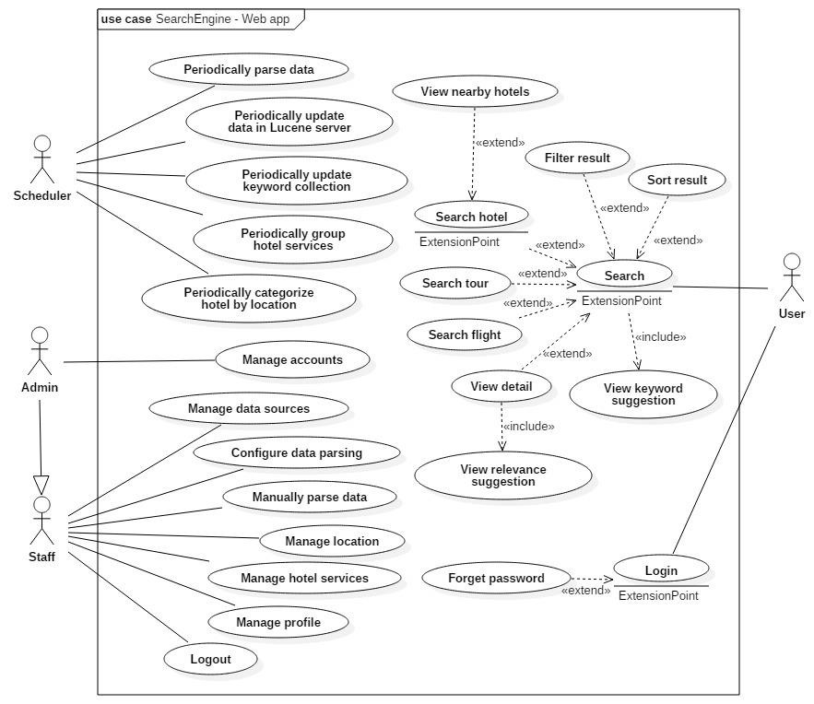

### 2.1. List of Use Case

#### *.<User> Overview Use Case*

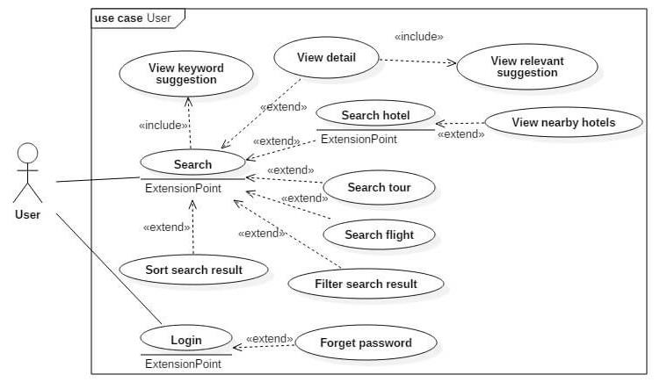

* + - 1. <User> Login

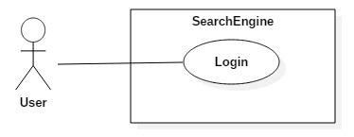

|  |  |  |  |
| --- | --- | --- | --- |
| **USE CASE – <UC number>** | | | |
| **Use Case No.** | UC 1.1 | **Use Case Version** | 1.0 |
| **Use Case Name** | Login | | |
| **Author** | KhuongND | | |
| **Date** | 3/30/2016 | **Priority** | Normal |
| **Actor:**   * User   **Summary:**   * This use case allows authorized user to log in system.   **Goal:**   * User can log in the system.   **Triggers:**   * User sends the login command.   **Preconditions:**   * N/A   **Post Conditions:** | | | |

* + - **Success:** User login successful into the system and can use all functions follow role.
    - **Fail:** Show error message

**Main Success Scenario:**

|  |  |  |
| --- | --- | --- |
| Step | Actor Action | System Response |
| 1 | User goes to login page. | System require information:   * Username: free text input. * Password: free text input. |
| 2 | User inputs information (username and password). [Exception 2, 3] |  |
| 3 | User sends command to login (Click Login button after input login form).  [Alternative 1] | User will login system with their specific roles.  [Exception 1,2,3] |

**Alternative Scenario:**

[Alternative 1]

|  |  |  |
| --- | --- | --- |
| Step | Actor Action | System Response |
| 1 | User click “Forgot Password” link. | System will direct to “Forgot password” page. |

**Exceptions:**

[Exception 1]

|  |  |  |
| --- | --- | --- |
| No | Cause | System Response |
| 1 | Wrong username or password. | Show error message: “Your username and password are invalid. Try again”. |

[Exception 2]

|  |  |  |
| --- | --- | --- |
| No | Cause | System Response |
| 2 | “Username” is empty or least than 6 words. | Show error message: “Please enter username more than 6 words”. |

[Exception 3]

|  |  |  |
| --- | --- | --- |
| No | Cause | System Response |
| 2 | “Password” is empty or least than 6 words. | Show error message: “Please enter password more than 6 words”. |

**Relationships:** N/A

**Business Rules:**

* Username: textbox, at least 6 words, required.
* Password: textbox, at least 6 words, required.
* Logged in users have 2 role: staff and admin
  + - 1. <User> Forget password

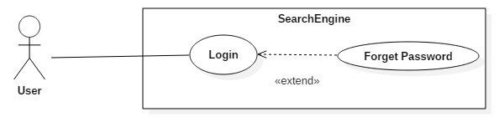

|  |  |  |  |  |  |  |
| --- | --- | --- | --- | --- | --- | --- |
| **USE CASE – <UC number>** | | | | | | |
| **Use Case No.** | | | UC 1.2 | **Use Case Version** | 1.0 | |
| **Use Case Name** | | | Forget passwod | | | |
| **Author** | | | KhuongND | | | |
| **Date** | | | 3/30/2016 | **Priority** | Normal | |
| **Actor:**   * User   **Summary:**   * This use case allows user can send request to reset their password.   **Goal:**   * User will receive an email from system to request reset password.   **Triggers:**   * User sends the forget password command.   **Preconditions:**   * N/A   **Post Conditions:**   * **Success:** Send email confirm reset password. * **Fail:** Show error message.   **Main Success Scenario:** | | | | | | |
|  | Step | Actor Action | | System Response | |  |
|  | 1 | User goes to login page and click link “Forgot password?”. | | System require information:   * Email: textbox ,email type, required. * Email link: button send forgot password command. * Reset password: link direct to “Reset password” page. * Login: link direct to “Login” page. | |  |
|  | 2 | User input information (email). | |  | |  |
|  | 3 | User sends command to forgot password with inputted information to system(Click Email Link button after fills forgot password form). | | User will be notified “Please check your email to have code for reset your password at this link”. | |  |

|  |  |  |  |  |
| --- | --- | --- | --- | --- |
|  |  | [Alternative 1,2] | [Exception 1,2] |  |
| **Alternative Scenario:**  [Alternative 1]  [Alternative 2]  **Exceptions:**  [Exception 1]  [Exception 2]  **Relationships:** extends UC “Login”  **Business Rules:**   * A token code will be created with 8 words which will be random**:[a-zA-Z0-9]**.This token code will be sent to the email user and stored in session (will be used in “Reset password” function).   - Email pattern should be: **/^[a-zA-Z0-9.!#$%&'*+\/=?^_`{|}~-]+@[a-zA-Z0- 9](?:[a-zA-Z0-9-]{0,61}[a-zA-Z0-9])?(?:\.[a-zA-Z0-9](?:[a-zA-Z0-9-]{0,61}[a-**  **zA-Z0-9])?)*$/** (following *RFC 5322 standard)*.   * Form Email will be sent:      * This token code stored in session, so will expire after session time out. * Email will be checked already exist in database before do process. | | | | |

|  |  |  |
| --- | --- | --- |
| Step | Actor Action | System Response |
| 1 | User click “Reset password” link. | System will direct to “Reset password” page. |

|  |  |  |
| --- | --- | --- |
| Step | Actor Action | System Response |
| 1 | User click “Login” link. | System will direct to “Login” page. |

|  |  |  |
| --- | --- | --- |
| No | Cause | System Response |
| 1 | Email does not vaild email | System show error message: “Email is incorrect. Your input please email”. |

|  |  |  |
| --- | --- | --- |
| No | Cause | System Response |
| 2 | Email is not found in the database. | System show error message: “This account does not exist”. |

* + - 1. <User> Reset password

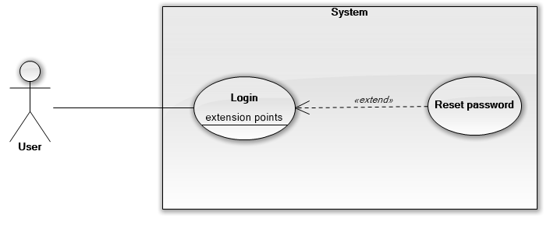

|  |  |  |  |  |  |  |  |
| --- | --- | --- | --- | --- | --- | --- | --- |
| **USE CASE – <UC number>** | | | | | | | |
| **Use Case No.** | | | UC 1.3 | **Use Case Version** | | 1.0 | |
| **Use Case Name** | | | Reset passwod | | | | |
| **Author** | | | KhuongND | | | | |
| **Date** | | | 3/30/2016 | **Priority** | | Normal | |
| **Actor:**   * User   **Summary:**   * This use case allows user can reset their password.   **Goal:**   * User will reset password and use this password to login.   **Triggers:**   * User sends the reset password command.   **Preconditions:**   * N/A   **Post Conditions:**   * **Success:** Reset password successful. * **Fail:** Show error message.   **Main Success Scenario:** | | | | | | | |
|  | Step | Actor Action | | | System Response | |  |
|  | 1 | +The first way:  User goes to url login and click link “Forgot password?”. At “Forgot password” page click link “Reset password”.  +The second way:  Click link reset password form email (Email sent at “Forgot password” function).  +The third way:  When finish “Forgot password” function, system will show message success and link “Reset password”. | | | System navigates to “Reset password” page:   * Username: textbox,length at least 6 words, required. * Token code: textbox, length 8 words,required. * Password: textbox, length at least 6 words, required. * Confirm password: textbox, length at least 6 words, required. * Reset:button send reset password command. | |  |

|  |  |  |  |  |  |
| --- | --- | --- | --- | --- | --- |
|  | 2 | User fills in information of their account (username,token,password,confirm password). | |  |  |
|  | 3 | User sends command to reset password with inputted information to system(Click Reset button after fills reset password form). | | System will be show success message: “Your password has been reset. Please click here to login ”.  [Exception 1,2,3,4,5,6,7] |  |
| **Alternative Scenario:N/A Exceptions:**  [Exception 1]  [Exception 2]  [Exception 3]  [Exception 4]  [Exception 5]  [Exception 6] | | | | | |
|  | No | Cause | System Response | |  |
|  | 6 | “Token code” is empty or not equal | Show error message: “Please enter token | |  |

|  |  |  |
| --- | --- | --- |
| No | Cause | System Response |
| 1 | “Username” is empty or least at 6 words. | System show error message: “Incorrect username. Please fills username and more than 6 words”. |

|  |  |  |
| --- | --- | --- |
| No | Cause | System Response |
| 2 | “Username” does not already exist in database. | System show error message: “Cant find your account.”. |

|  |  |  |
| --- | --- | --- |
| No | Cause | System Response |
| 3 | “Password” is empty or least than 6 words. | Show error message: “Please enter password more than 6 words”. |

|  |  |  |
| --- | --- | --- |
| No | Cause | System Response |
| 4 | “Confirm password” is empty or least than 6 words. | Show error message: “Please enter confirm password more than 6 words”. |

|  |  |  |
| --- | --- | --- |
| No | Cause | System Response |
| 5 | “Password” and “Confirm password” do not match. | Show error message: “Please enter a password and confirm password match”. |

|  |  |  |  |  |
| --- | --- | --- | --- | --- |
|  |  | 8 words. | with 8 words”. |  |
| [Exception 7]  [Exception 8]  **Relationships:** N/A  **Business Rules:**   * The token code user enter will be check match with the token in session which stored at “Forgot password” function. * Check session contains token code. If session is null, system show error message request user use “Forgot password” function again. * After reset password successful, all session login with this account will be logged off. * After reset password successful, the session contains token code will be removed. * Password must be encrypted before saving to server. | | | | |

|  |  |  |
| --- | --- | --- |
| No | Cause | System Response |
| 7 | “Token code” is incorrect. | Show error message: “Please check your email again. Token code is incorrect”. |

|  |  |  |
| --- | --- | --- |
| No | Cause | System Response |
| 8 | Session contains token code time out. | Show error message: “Your token code time out. Please try again”. |

* + - 1. <User> General search

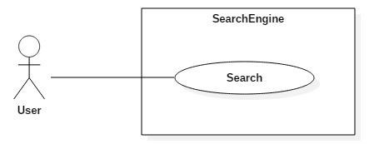

|  |  |  |  |
| --- | --- | --- | --- |
| **USE CASE – <UC number>** | | | |
| **Use Case No.** | UC 1.4 | **Use Case Version** | 1.0 |
| **Use Case Name** | General Search | | |
| **Author** | TrucGS | | |
| **Date** | 3/30/2016 | **Priority** | High |
| **Actor:**   * User   **Summary:**   * This use case allows user to search for general information by keyword.   **Goal:** | | | |

* User can see the trending hotels/tours/flights related to the input keyword.

**Triggers:**

* User clicks search button on tab “Tìm kiếm chung”.

**Preconditions:**

* N/A

**Post Conditions:**

* **Success:** Redirect to search result page and show search results.
* **Fail:** Show error message

**Main Success Scenario:**

|  |  |  |
| --- | --- | --- |
| Step | Actor Action | System Response |
| 1 | In tab “Tìm kiếm chung”, enter keyword. | - Suggest relevant keywords in the dropdown list of the auto-complete text field. |
| 2 | Click search button. | * Update the input keyword. * Redirect to result page and show search result with 3 groups of data: Hotels, Tours, Flights * [Exceptions 1] |

**Alternative Scenario:**

|  |  |  |
| --- | --- | --- |
| Step | Actor Action | System Response |
| 1 | In the search result page, click on 1 of 3 tabs: “Khách sạn”, “Tour”, “Chuyến bay”. | * Filter the search results by the selected data type. * Switch to the selected tab and display search results. |

**Exceptions:**

[Exception 1]

|  |  |  |
| --- | --- | --- |
| No | Cause | System Response |
| 1 | Keyword is empty. | Show error message: “Vui lòng nhập từ khoá”. |

**Relationships:** N/A

**Business Rules:**

* Keyword cannot be empty.
* Update keyword:
  + If the input keyword does not exist, the keyword is added to database with SearchCount = 1;
  + Else, increase the SearchCount of the existed keyword by 1 and update to database.
* Suggest: The relevant keywords are retrieved using Pearson Correlation algorithm (mentioned in section D.7.5)

* Search: The search results are scored by RelevanceScore = SimilarityScore*Click- through rate (mentioned in section D.7.4)
* Display order: The 3 groups of data (Hotels/Tours/Flights) are sorted by the average RelevanceScore of each group. In group “Hotel” and “Tour”, data is sorted by RelevanceScore. In group “Flight”, data is sorted by price ascending.
* Filter by data type: The filtered search results are also sorted by the RelevanceScore.
  + - 1. <User> Search hotel

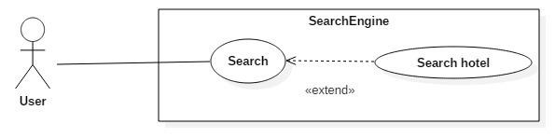

|  |  |  |  |  |  |  |
| --- | --- | --- | --- | --- | --- | --- |
| **USE CASE – <UC number>** | | | | | | |
| **Use Case No.** | | | UC 1.5 | **Use Case Version** | 1.0 | |
| **Use Case Name** | | | Search hotel | | | |
| **Author** | | | TrucGS | | | |
| **Date** | | | 3/30/2016 | **Priority** | High | |
| **Actor:**   * User   **Summary:**   * This use case allows user to search for hotels by keyword and location.   **Goal:**   * User can limit the search result in the scope of a city/province when searching for hotels.   **Triggers:**   * User clicks search button on tab “Khách sạn”.   **Preconditions:**   * N/A   **Post Conditions:**   * **Success:** Redirect to search result page and show search results. * **Fail:** Show error message.   **Main Success Scenario:** | | | | | | |
|  | Step | Actor Action | | System Response | |  |
|  | 1 | In tab “Khách sạn”, select location and enter keyword. | | - Suggest relevant keywords in the dropdown list of the auto-complete text field. | |  |
|  | 2 | Click search button. | | * Update the input keyword. * Redirect to result page and show search results. | |  |

|  |  |  |  |  |
| --- | --- | --- | --- | --- |
|  |  |  | - [Exceptions 1] |  |
| **Alternative Scenario:** N/A  **Exceptions:**  [Exception 1]  **Relationships:** extends UC “General Search”  **Business Rules:**   * Keyword cannot be empty. * Update keyword:   + If the input keyword does not exist, the keyword is added to database with SearchCount = 1 and match to the selected location.   + If the input keyword exists in database without relationship to the selected location, match the keyword to the location and update SearchCount.   + Else, increase the SearchCount of the existed keyword by 1 and update to database. * Suggest: The relevant keywords are retrieved using Pearson Correlation algorithm (mentioned in section D.7.5) and filtered by location. * Search: The search results are scored by RelevanceScore = SimilarityScore*Click- through rate (mentioned in section D.7.4) * Display order: By default, hotels are sorted by the RelevanceScore. | | | | |

|  |  |  |
| --- | --- | --- |
| No | Cause | System Response |
| 1 | Keyword is empty. | Show error message: “Vui lòng nhập từ khoá”. |

* + - 1. <User> View nearby hotels

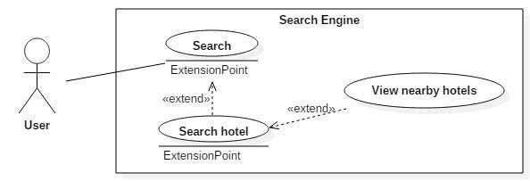

|  |  |  |  |
| --- | --- | --- | --- |
| **USE CASE – <UC number>** | | | |
| **Use Case No.** | UC 1.6 | **Use Case Version** | 1.0 |
| **Use Case Name** | View nearby hotels | | |
| **Author** | CuongHH | | |
| **Date** | 3/30/2016 | **Priority** | High |
| **Actor:**   * User   **Summary:**   * This use case allows user to view nearby hotels of a particular hotel search | | | |

result.

**Goal:**

* User can find the other hotels in the same area as the selected hotel to choose the most appropriate hotel for their demand.

**Triggers:**

* User clicks on button “Khách sạn lân cận” in the hotel search result.

**Preconditions:**

* User is on the hotel search result page.

**Post Conditions:**

* **Success:** Show the nearby hotels.
* **Fail:** Show error message.

**Main Success Scenario:**

|  |  |  |
| --- | --- | --- |
| Step | Actor Action | System Response |
| 1 | In tab “Khách sạn”, click on button “Khách sạn lân cận” in the search result. | - Find 5 nearest hotels to the selected hotel and display the results. |

**Alternative Scenario:** N/A

**Exceptions:** N/A

**Relationships:** extends UC “Search hotel”

**Business Rules:**

* The nearby hotels are found based on longtitude and latitude (retrieved using hotel address and Google Map API when parsing data).
* The distance between hotels are calculated using Euclidean Distance (mention in section D.7.7).
  + - 1. <User> Search tour

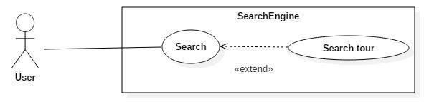

|  |  |  |  |
| --- | --- | --- | --- |
| **USE CASE – <UC number>** | | | |
| **Use Case No.** | UC 1.7 | **Use Case Version** | 1.0 |
| **Use Case Name** | Search tour | | |
| **Author** | CuongHH | | |
| **Date** | 3/30/2016 | **Priority** | High |
| **Actor:**  - User  **Summary:** | | | |

* This use case allows user to search for tours by keyword and location.

**Goal:**

* User can limit the search result in the scope of a city/province when searching for tours.

**Triggers:**

* User clicks search button on tab “Tour”.

**Preconditions:**

* N/A

**Post Conditions:**

* **Success:** Redirect to search result page and show search results.
* **Fail:** Show error message

**Main Success Scenario:**

|  |  |  |
| --- | --- | --- |
| Step | Actor Action | System Response |
| 1 | In tab “Tour”, select location and enter keyword. | - Suggest relevant keywords in the dropdown list of the auto-complete text field. |
| 2 | Click search button. | * Update the input keyword. * Redirect to result page and show search results. * [Exceptions 1] |

**Alternative Scenario:** N/A

**Exceptions:**

[Exception 1]

|  |  |  |
| --- | --- | --- |
| No | Cause | System Response |
| 1 | Keyword is empty. | Show error message: “Vui lòng nhập từ khoá”. |

**Relationships:** extends UC “General Search”

**Business Rules:**

* Keyword cannot be empty.
* Update keyword:
  + If the input keyword does not exist, the keyword is added to database with SearchCount = 1 and match to the selected location.
  + If the input keyword exists in database without relationship to the selected location, match the keyword to the location and update SearchCount.
  + Else, increase the SearchCount of the existed keyword by 1 and update to database.
* Suggest: The relevant keywords are retrieved using Pearson Correlation algorithm (mentioned in section D.7.5) and filtered by location.
* Search: The search results are scored by RelevanceScore = SimilarityScore*Click- through rate (mentioned in section D.7.4)

|  |  |  |
| --- | --- | --- |
| Step | Actor Action | System Response |
| 1 | In tab “Chuyến bay”, select departure/arrival date and locations, then click search button. | - Redirect to result page and show search flight result.  - [Exceptions 1,2,3,4,5,6] |

- Display order: By default, tours are sorted by the RelevanceScore.

* + - 1. <User> Search flight

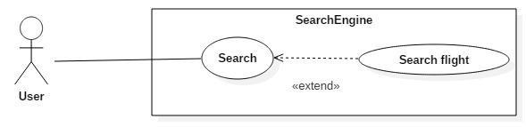

|  |  |  |  |  |  |  |  |
| --- | --- | --- | --- | --- | --- | --- | --- |
| **USE CASE – <UC number>** | | | | | | | |
| **Use Case No.** | | | UC 1.8 | | **Use Case Version** | 1.0 | |
| **Use Case Name** | | | Search flight | | | | |
| **Author** | | | TrungLVH | | | | |
| **Date** | | | 3/30/2016 | | **Priority** | High | |
| **Actor:**   * User   **Summary:**   * This use case allows user to search for flights by date and location.   **Goal:**   * User can search for flights more exactly by specifing the departure/arrival date/time and locations.   **Triggers:**   * User clicks search button on tab “Chuyến bay”.   **Preconditions:**   * N/A   **Post Conditions:**   * **Success:** Redirect to search result page and show search results. * **Fail:** Show error message.   **Main Success Scenario:**  **Alternative Scenario:** N/A  **Exceptions:**  [Exception 1] | | | | | | | |
|  | No | Cause | | System Response | | |  |
|  | 1 | Date start is empty. | | Show error message: “Vui lòng chọn ngày đi”. | | |  |

[Exception 2]

|  |  |  |
| --- | --- | --- |
| No | Cause | System Response |
| 2 | Date end is empty. | Show error message: “Vui lòng chọn ngày về”. |

[Exception 3]

|  |  |  |
| --- | --- | --- |
| No | Cause | System Response |
| 3 | Start location is empty. | Show error message: “Vui lòng chọn địa điểm khởi hành”. |

[Exception 4]

|  |  |  |
| --- | --- | --- |
| No | Cause | System Response |
| 4 | End location is empty. | Show error message: “Vui lòng chọn địa điểm đến”. |

[Exception 5]

|  |  |  |
| --- | --- | --- |
| No | Cause | System Response |
| 5 | Date start is large than date end | Show error message: “Ngày đi phải nhỏ hơn ngày về”. |

[Exception 6]

|  |  |  |
| --- | --- | --- |
| No | Cause | System Response |
| 6 | Start location and end location are duplicated. | Show error message: “Điểm đi và điểm đến không được trùng nhau”. |

**Relationships:** extends UC “General Search”

**Business Rules:**

* Departure date and Arrival date are in the format “dd/MM/yyyy”; Arrival date must not be less than Departure date.
* The location lists don’t contain cities/provinces without airports.
* Departure location and Arrival location must not be the same.
* By default, the flight results are grouped by flight agency and sorted by date and price ascending.
  + - 1. <User> Sort search result

|  |  |  |
| --- | --- | --- |
| Step | Actor Action | System Response |
| 1 | In search result page, select sorting criterias. | - System display search result in the appropriate order. |

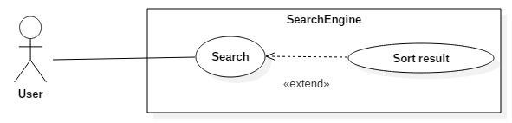

|  |  |  |  |
| --- | --- | --- | --- |
| **USE CASE – <UC number>** | | | |
| **Use Case No.** | UC 1.9 | **Use Case Version** | 1.0 |
| **Use Case Name** | Sort result | | |
| **Author** | CuongHH | | |
| **Date** | 3/30/2016 | **Priority** | Normal |
| **Actor:**   * User   **Summary:**   * This use case allows user to sort search results by criterias.   **Goal:**   * The search result will be displayed in the appropriate order of user’s demand.   **Triggers:**   * User sends sorting result request.   **Preconditions:**   * User is on the search result page of hotels, tours or flights.   **Post Conditions:**   * **Success:** Show sorted results. * **Fail:** Show error message.   **Main Success Scenario:**  **Alternative Scenario:** N/A  **Exceptions:** N/A  **Relationships:** extends UC “General Search”  **Business Rules:**   * Sorting criterias for each data type:   + Hotel: price (ascending/descending), rating (ascending/descending)   + Tour: price (ascending/descending)   + Flight: price (ascending/descending), departure time (ascending/descending) * When user deselect all the sorting criterias, the search results are sorted by RelevanceScore (mentioned in section D.7.4). | | | |

* + - 1. <User> View detail

|  |  |  |
| --- | --- | --- |
| Step | Actor Action | System Response |
| 1 | Click link on a search result. | Open new tab to view detail hotel/tour and relevant suggestion. |

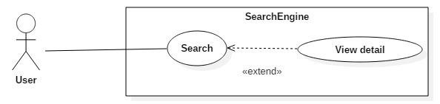

|  |  |  |  |
| --- | --- | --- | --- |
| **USE CASE – <UC number>** | | | |
| **Use Case No.** | UC 1.10 | **Use Case Version** | 1.0 |
| **Use Case Name** | View Detail | | |
| **Author** | CuongHH | | |
| **Date** | 3/30/2016 | **Priority** | Normal |
| **Actor:**   * User   **Summary:**   * This use case allows user view detail of a hotel/tour.   **Goal:**   * User can view detail information of hotel/tour along with the suggestion of relevant hotels and relevants tours.   **Triggers:**   * User clicks on a hotel/tour search result.   **Preconditions:**   * User is on the search result page of hotels or tours.   **Post Conditions:**   * **Success:** Open a new tab to view the detail page. * **Fail:** Show error page.   **Main Success Scenario:**  **Alternative Scenario:** N/A  **Exceptions:** N/A  **Relationships:** extends UC “General Search”  **Business Rules:**   * Detail information for each data type:   + Hotel: preview image, address, hotel name, full description, hotel services, comments, price   + Tour: preview image, tour name, full description, tour route plan, price * Relevant suggestion are rendered into 3 groups: hotels, tours, flights. | | | |

* + - 1. <User> View relevance suggestion

|  |  |  |
| --- | --- | --- |
| Step | Actor Action | System Response |
| 1 | View detail of a particular hotel/tour. | Find relevance suggestion and show results a 3 groups: hotels, tours, flights. |

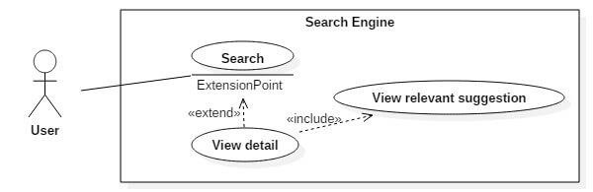

|  |  |  |  |
| --- | --- | --- | --- |
| **USE CASE – <UC number>** | | | |
| **Use Case No.** | UC 1.11 | **Use Case Version** | 1.0 |
| **Use Case Name** | View relevance suggestion | | |
| **Author** | TrucGS | | |
| **Date** | 3/30/2016 | **Priority** | High |
| **Actor:**   * User   **Summary:**   * This use case allows user view relevance suggestion when view detail of a hotel/tour.   **Goal:**   * User can view the suggestion of relevant hotels/tours/flights to the current hotel/tour to get more options for their intent.   **Triggers:**   * User view detail of a hotel/tour.   **Preconditions:**   * User is on the detail page of hotels or tours.   **Post Conditions:**   * **Success:** Display relevant hotels/tours/flights. * **Fail:** Show error page.   **Main Success Scenario:**  **Alternative Scenario:** N/A  **Exceptions:** N/A  **Relationships:** included in UC “View Detail”  **Business Rules:**   * Relevant suggestion are:   + Relevant hotels and relevant tours: use Pearson Correlation algorithm (mention in section D.7.6)   + Relevant flights: the system will detect user’s current location and find the nearest airport, then suggest 5 cheapest flights within 7 days from the found airport to the location of the selected tour/hotel. If there no flight found, the section of relevance flights will be hidden. | | | |

#### *.<Scheduler> Overview Use Case*

|  |  |  |
| --- | --- | --- |
| Step | Actor Action | System Response |
| 1 | Automatically start after an interval of pending. | Crawl all the url of the data source and parse all the data available.  [Exception 1] |

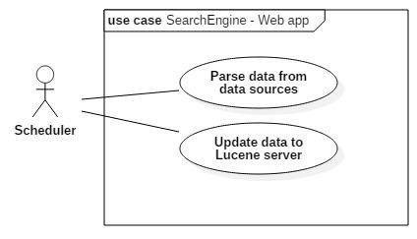

* + - 1. <Scheduler> Parse data from data sources

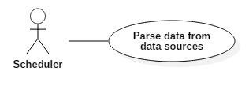

|  |  |  |  |
| --- | --- | --- | --- |
| **USE CASE – <UC number>** | | | |
| **Use Case No.** | UC 2.1 | **Use Case Version** | 1.0 |
| **Use Case Name** | Periodically parse data | | |
| **Author** | TrungLVH | | |
| **Date** | 3/29/2016 | **Priority** | High |
| **Actor**:   * Scheduler   **Summary**:   * This use case allows the scheduler to parse data automatically.   **Goal**:   * Automatically collect data from a particular external data source.   **Triggers**:   * The timer hits configured time.   **Preconditions**:   * The data source must be enabled.   **Post Conditions**:   * **Success**: The parsed data will be add/update to database. * **Fail**: Error details will be logged in a log file.   **Main Success Scenario:**  **Alternative Scenario:** N/A | | | |

|  |  |  |
| --- | --- | --- |
| No | Cause | System Response |
| 1 | Timeout request | Error details will be logged in a log file with the following structure:  [Time]: [Scheduler Name] - [Error details] |

* + - 1. <Scheduler> Update data to Lucene server

**Exceptions:**

[Exception 1]

**Relationships:** N/A

**Business Rules:**

* There are 2 type of parsing:
  + Html parsing (for hotels and tours): used to parse those data sources that rendered fully information in html without lazy loading.
  + Ajax parsing (for flights): used to parse those data sources that rendered partial information via Ajax request.
* The parsing process is mentioned in section D.7.1 and D.7.2.

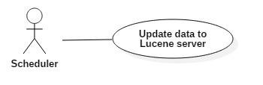

|  |  |  |  |
| --- | --- | --- | --- |
| **USE CASE – <UC number>** | | | |
| **Use Case No.** | UC 2.2 | **Use Case Version** | 1.0 |
| **Use Case Name** | Periodically update data in Lucene server | | |
| **Author** | CuongHH | | |
| **Date** | 3/29/2016 | **Priority** | High |
| **Actor**:   * Scheduler   **Summary**:   * This use case allows scheduler to update data from main storage to Lucene database periodically .   **Goal**:   * Data will be indexed and updated to Lucene database for searching with high performance.   -  **Triggers**:   * The timer hits configured time.   -  **Preconditions**:   * The scheduler is enabled.   **Post Conditions**:   * **Success**: Data will be updated to Lucene database. * **Fail**: Error details will be logged in a log file. | | | |

|  |  |  |
| --- | --- | --- |
| Step | Actor Action | System Response |
| 1 | Automatically start after an interval of pending. | * Get all un-updated hotels/tours/flights from mainstorage. * Add/Override all the retrieved data to the corresponding data in Lucene database. |

* + - 1. <Scheduler> Update keyword collection

**Main Success Scenario:**

**Alternative Scenario:** N/A

**Exceptions:** N/A

**Relationships:** N/A

**Business Rules:**

* Un-updated hotels/tours/flights are those data with the property:
  + IsLuceneUpdated = false.
* Hotel updating, Tour updating, Flight updating are 3 independent threads that execute concurrently.
* Data are indexed in Lucene using ShingleAnalyzer (works based on n-gram).

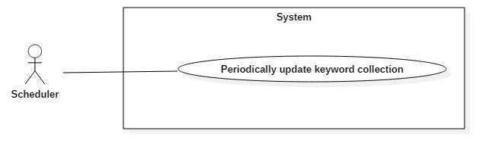

|  |  |  |  |
| --- | --- | --- | --- |
| **USE CASE – <UC number>** | | | |
| **Use Case No.** | UC 2.3 | **Use Case Version** | 1.0 |
| **Use Case Name** | Periodically update keyword collection | | |
| **Author** | KhuongND | | |
| **Date** | 3/29/2016 | **Priority** | High |
| **Actor**:   * Scheduler   **Summary**:   * This use case allows scheduler to update the keyword collection in Lucene database periodically.   **Goal**:   * Periodically update new keywords and remove redundant keywords from main storage and Lucene database to optimize the keyword suggestion.   **Triggers**:   * The timer hits configured time.   -  **Preconditions**:   * The scheduler is enabled. | | | |

|  |  |  |
| --- | --- | --- |
| Step | Actor Action | System Response |
| 1 | Automatically start after an interval of pending. | * Get all the new keywords from main storage and add to Lucene database. * Remove all the redundant keywords from main storage and Lucene database. |

* + - 1. <Scheduler> Categorize hotels by location

**Post Conditions**:

* **Success**: New keywords will be added; Redundant keywords will be removed.
* **Fail**: Error details will be logged in a log file.

**Main Success Scenario:**

**Alternative Scenario:**N/A

**Exceptions:** N/A **Relationships:** N/A **Business Rules:**

* New keywords are those keywords with the property:
  + IsLuceneUpdated = false
* Redundant keywords are found and removed as mentioned in section D.7.

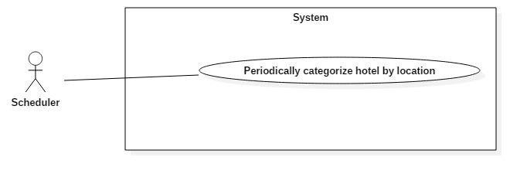

|  |  |  |  |
| --- | --- | --- | --- |
| **USE CASE – <UC number>** | | | |
| **Use Case No.** | UC 2.4 | **Use Case Version** | 1.0 |
| **Use Case Name** | Periodically categorize hotel by location | | |
| **Author** | TrucGS | | |
| **Date** | 3/29/2016 | **Priority** | Normal |
| **Actor**:   * Scheduler   **Summary**:   * This use case allows scheduler to categorize hotel by location periodically.   **Goal**:   * The parsed hotels will be categorized by location based on the hotel address.   **Triggers**:   * The timer hits configured time.   **Preconditions**:   * The scheduler is enabled. | | | |

|  |  |  |
| --- | --- | --- |
| Step | Actor Action | System Response |
| 1 | Automatically start after | - Get all the un-located hotels from main |
|  | an interval of pending. | storage. |
|  |  | - Categorize those hotels using hotel |
|  |  | addressed and the current location list. |

* + - 1. <Scheduler> Categorize hotel services

**Post Conditions**:

* **Success**: Hotels will be categorized by location.
* **Fail**: Error details will be logged in a log file.

**Main Success Scenario:**

**Alternative Scenario:**N/A

**Exceptions:** N/A **Relationships:** N/A **Business Rules:**

* Un-located hotels are those hotels with the property: LocationID = null
* A hotel is supposed to be associated with the location having the highest score using Levenshtein Distance (mentioned in section D.7.8).

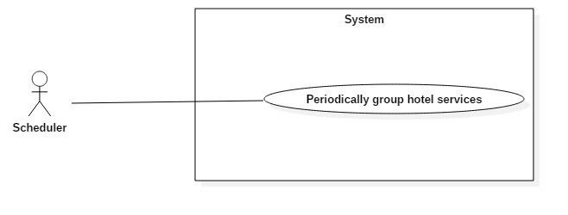

|  |  |  |  |
| --- | --- | --- | --- |
| **USE CASE – <UC number>** | | | |
| **Use Case No.** | UC 2.5 | **Use Case Version** | 1.0 |
| **Use Case Name** | Periodically group hotel services | | |
| **Author** | TrucGS | | |
| **Date** | 3/29/2016 | **Priority** | Normal |
| **Actor**:   * Scheduler   **Summary**:   * This use case allows scheduler to group hotel services periodically.   **Goal**:   * The parsed hotel services from different data sources will be grouped based on the similarity of service names.   **Triggers**:   * The timer hits configured time. | | | |

|  |  |  |
| --- | --- | --- |
| Step | Actor Action | System Response |
| 1 | Automatically start after an interval of pending. | Group all the un-categorized hotel services into the most relevant group. |

#### *.<Staff> Overview Use Case*

**Preconditions**:

* The scheduler is enabled.

**Post Conditions**:

* **Success**: Hotel services will be grouped to the most relevant services.
* **Fail**: Error details will be tracked in a log file.

**Main Success Scenario:**

**Alternative Scenario:**N/A

**Exceptions:** N/A **Relationships:** N/A **Business Rules:**

* Un-categorized hotel services are those services with the property: IsCategorized = false
* A hotel service will be temporarily categorized to the most relevant service group (based on ServiceName and Synonyms) and need the approval of admin/staff to be the official service (mentioned in section D.7.9).

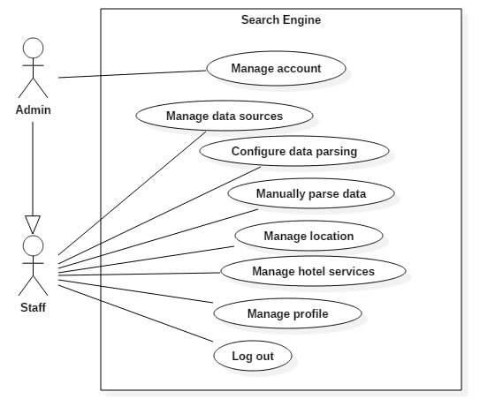

* + - 1. <Staff > Manage HotelService

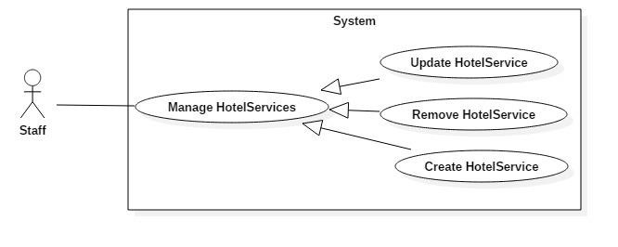

* + - * 1. *< Staff > Create HotelService*

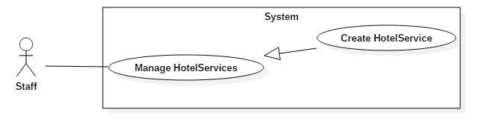

|  |  |  |  |
| --- | --- | --- | --- |
| **USE CASE – <UC number>** | | | |
| **Use Case No.** | UC 3.1 | **Use Case Version** | 1.0 |
| **Use Case Name** | Create HotelService | | |
| **Author** | KhuongND | | |
| **Date** | 3/29/2016 | **Priority** | Normal |
| **Actor:**   * Staff   **Summary:**   * This use case allows staff to create new hotel service.   **Goal:**   * User can create new hotel services using for filtering hotel search results.   **Triggers:**   * User sends the create new hotel service command.   **Preconditions:**  - User logged in to the system with role staff (status in-active) or admin.  **Post Conditions:**   * **Success:** New hotel service is create into database and show success message * **Fail:** Show error message | | | |

**Main Success Scenario:**

**Alternative Scenario:N/A**

**Exceptions:**

[Exception 1]

**Relationships:** N/A

**Business Rules:**

-

-

-

-

Name: textbox, max length:250, required.

Synonyms: textbox.

Icon plus: button sends create new hotel services command. After create new hotel service, data table will be auto update.

|  |  |  |
| --- | --- | --- |
| Step | Actor Action | System Response |
| 1 | Staff go to “Manage hotel services” page and choose “Services” tab. | System list following information in “Services” tab.   * Name: textbox,max length:250, required. * Synonyms: textbox. * Icon plus: button sends create new hotel services command. |
| 2 | Staff fills in information of hotel services. |  |
| 3 | Staff sends command to create new hotel services with inputted information to system(Click Icon plus). | New hotel services will be created into database. Show success message: “Created successfully!” and back “Manage hotel services” page.  [Exception 1] |

|  |  |  |
| --- | --- | --- |
| No | Cause | System Response |
| 1 | “Name” is empty or longer than 250 words. | Show error message: “Please enter name hotel service less than 250 words”. |

* + - * 1. *< Staff > Update HotelService*

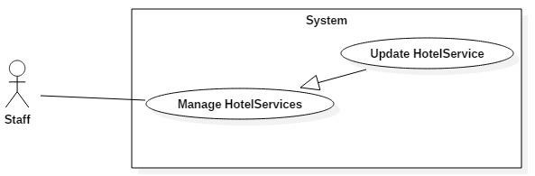

|  |  |  |  |  |  |  |
| --- | --- | --- | --- | --- | --- | --- |
| **USE CASE – <UC number>** | | | | | | |
| **Use Case No.** | | | UC 3.2 | **Use Case Version** | 1.0 | |
| **Use Case Name** | | | Update HotelService | | | |
| **Author** | | | KhuongND | | | |
| **Date** | | | 3/29/2016 | **Priority** | Normal | |
| **Actor:**   * Staff   **Summary:**   * This use case allows staff to update existed hotel service.   **Goal:**   * Update existed hotel service.   **Triggers:**   * Staff sends the update hotel service information command.   **Preconditions:**   * User logged in to the system with role staff (status in-active) or admin. * Staff selects a hotel service exist in “Manage hotel service” page.   **Post Conditions:**   * **Success:** Hotel service information will be updated and show success message * **Fail:** Show error message   **Main Success Scenario:** | | | | | | |
|  | Step | Actor Action | | System Response | |  |
|  | 1 | Staff go to “hotel service” page, choose “Service” or “New Service”, click link “Edit” | | System show modal following information:   * Name: textbox,max length:250, required. * Synonyms: textbox. * If choose hotel service in “New Services” tab to update, modal will add a field:   + Expected Service: dropdownlist,(all hotel service with “IsApproved” by “true” in database),required.   * Button “Save Changes” sends update data sources command. * Butten “Close” cancels update process. | |  |
|  | 2 | Staff fills in updated information of hotel service. | |  | |  |

|  |  |  |  |  |
| --- | --- | --- | --- | --- |
|  | 3 | Staff click on “Save Changes” button.  [Alternative 1] | Hotel service will be updated to database. [Exception 1,2] |  |
| **Alternative Scenario:**  [Alternative 1]  **Exceptions:**  [[Exception 1]  [Exception 2]  **Relationships:** N/A  **Business Rules:**  - A “Hotel service” can have one or more “Synonyms”. | | | | |

|  |  |  |
| --- | --- | --- |
| Step | Actor Action | System Response |
| 1 | Staff click on “Close” button. | System close modal. |

|  |  |  |
| --- | --- | --- |
| No | Cause | System Response |
| 1 | “Name” is empty or longer than 250 words. | Show error message: “Please enter name hotel service less than 250 words”. |

|  |  |  |
| --- | --- | --- |
| No | Cause | System Response |
| 3 | Hotel service which the staff chose dont exist (another staff remove when update). | Show error message: “Hotel service not found.”. |

* + - * 1. *< Staff > Remove HotelService*

|  |  |  |
| --- | --- | --- |
| Step | Actor Action | System Response |
| 1 | Staff go to ”Hotel Service” page choose “Service” or “New Service”, click link “Remove” | -System confirm with staff to remove hotel service. |
| 2 | Staff confirms “Yes” to remove hotel service.  [Alternative 1] | Hotel service will be removed to database. [Exception 1] |

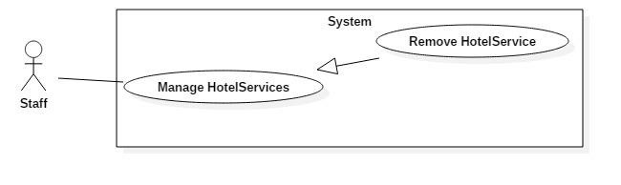

|  |  |  |  |  |  |  |
| --- | --- | --- | --- | --- | --- | --- |
| **USE CASE – <UC number>** | | | | | | |
| **Use Case No.** | | | UC 3.3 | **Use Case Version** | 1.0 | |
| **Use Case Name** | | | Remove HotelService | | | |
| **Author** | | | KhuongND | | | |
| **Date** | | | 3/29/2016 | **Priority** | Normal | |
| **Actor:**   * Staff   **Summary:**   * This use case allows staff to remove hotel service.   **Goal:**   * System removes hotel service.   **Triggers:**   * Staff sends the remove hotel service command.   **Preconditions:**   * User logged in to the system with role staff (status in-active) or admin. * Staff selects a hotel service exist in “Manage hotel service” page.   **Post Conditions:**   * **Success:** Hotel service will be removed and show success message. * **Fail:** Show error message   **Main Success Scenario:**  **Alternative Scenario:**  [Alternative 1] | | | | | | |
|  | Step | Actor Action | | System Response | |  |
|  | 1 | Staff click on “Cancel” button. | |  | |  |

|  |  |  |  |  |
| --- | --- | --- | --- | --- |
|  |  |  | System close confim, cancel remove process. |  |
| **Exceptions:**  [Exception 1]  **Relationships:** N/A  **Business Rules:**   * If remove hotel service success, a “Hotel service” will be removed in database immediately. * List “Hotel service” in “Manage Hotel Service” page will be updated after this function finished. * If this “Hotel service” is being used, system will not remove this “Hotel service”. * Before remove a “Hotel service”, system must find this “Hotel service” in database exist or not? then removed if exist to avoid errors. | | | | |

|  |  |  |
| --- | --- | --- |
| No | Cause | System Response |
| 1 | Hotel service which the staff chose dont exist (another staff remove when remove). | Show error message: “Hotel service not found.”. |

* + - 1. < Staff > Manage Location

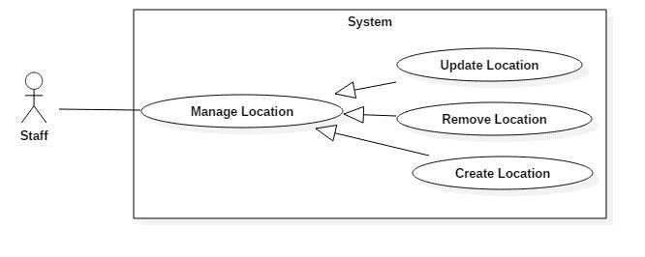

* + - * 1. *< Staff > Create Location*

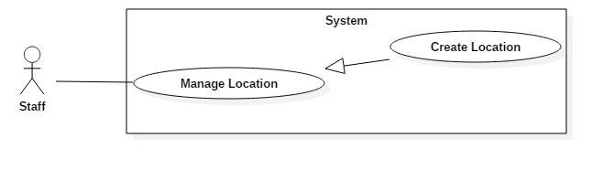

|  |  |  |
| --- | --- | --- |
| Step | Actor Action | System Response |
| 1 | Staff go to “Manage location” page and click “Add New” button. | System show modal following information:   * ShortName: textbox, max length:50. * FullName: : textbox, required * Location type: dropdownlist (Location, Airport), required. * If choose “Location type” with value “Airport”, modal will add a field:   - + Location: dropdownlist,(all location with “Location type” by “Location” in database),required   * Synonyms: textbox. * Button “Add New” sends create new location command. * Button “Close” cancel create process. |
| 2 | Staff fills in information location. |  |
| 3 | Staff sends command to create new location with inputted information to system(Click “Add New” button).  [Alternative 1] | New location will be created into database. [Exception 1,2] |

|  |  |  |  |
| --- | --- | --- | --- |
| **USE CASE – <UC number>** | | | |
| **Use Case No.** | UC 3.4 | **Use Case Version** | 1.0 |
| **Use Case Name** | Create Location | | |
| **Author** | KhuongND | | |
| **Date** | 3/29/2016 | **Priority** | Normal |
| **Actor:**   * Staff   **Summary:**   * This use case allows staff to create new location.   **Goal:**   * User can create new location.   **Triggers:**   * User sends the create new location command.   **Preconditions:**  - User logged in to the system with role staff (status in-active) or admin.  **Post Conditions:**   * **Success:** New location is create into database and show success message * **Fail:** Show error message   **Main Success Scenario:** | | | |

|  |  |  |
| --- | --- | --- |
| Step | Actor Action | System Response |
| 1 | Staff click “Close” button to cancel process | System close modal and cancel create process. |

|  |  |  |
| --- | --- | --- |
| No | Cause | System Response |
| 1 | “FullName” is empty. | Show error message: “Please enter FullName”. |

|  |  |  |
| --- | --- | --- |
| No | Cause | System Response |
| 2 | “ShortName” is longer than 50 words. | Show error message: “Please enter ShortName location less than 50 words”. |

* + - * 1. *< Staff > Update Location*

**Alternative Scenario:**

[Alternative 1]

**Exceptions:**

[Exception 1]

[Exception 2]

**Relationships:** N/A

**Business Rules:**

* List location in “Manage location” page will be updated with new location.
* List “Location” and list “Airport” will be using a lot of other functions in system .
* When this function finish, a “Location” or “Airport” will be added in “Location” table in database immediately.
* A “Location” will have more “Synonyms”, all synonyms of this “Location” will save 1 field in database and separated by commas.

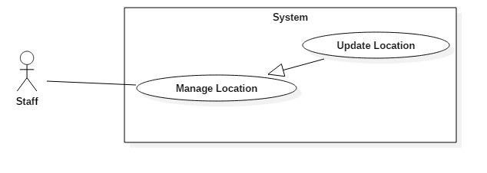

|  |  |  |  |  |  |  |
| --- | --- | --- | --- | --- | --- | --- |
| **USE CASE – <UC number>** | | | | | | |
| **Use Case No.** | | | UC 3.5 | **Use Case Version** | 1.0 | |
| **Use Case Name** | | | Update Location | | | |
| **Author** | | | KhuongND | | | |
| **Date** | | | 3/29/2016 | **Priority** | Normal | |
| **Actor:**   * Staff   **Summary:**   * This use case allows staff to update existed location.   **Goal:**   * Update existed location.   **Triggers:**   * Staff sends the update location information command.   **Preconditions:**   * User logged in to the system with role staff (status in-active) or admin. * Staff selects a location exist in “Manage location” page.   **Post Conditions:**   * **Success:** Location information will be updated and show success message * **Fail:** Show error message   **Main Success Scenario:**  **Alternative Scenario:**  [Alternative 1] | | | | | | |
|  | Step | Actor Action | | System Response | |  |

|  |  |  |
| --- | --- | --- |
| Step | Actor Action | System Response |
| 1 | Staff go to “Location Manager” page and click link “Edit | System show modal following information:   * ShortName: textbox, max length:50. * FullName: : textbox, required * Location type: dropdownlist (Location, Airport), required. * If choose “Location type” with value “Airport”, modal will add a field:   + Location: dropdownlist,(all location with “Location type” by “Location” in database),required.   * Synonyms: textbox. * Button “Save Changes” sends create new location command. * Button “Close” cancel create process. |
| 2 | Staff fills in updated information of location. |  |
| 3 | Staff click on “Save Changes” button.  [Alternative 1] | Location will be updated to database. [Exception 1,2,3] |

|  |  |  |  |  |
| --- | --- | --- | --- | --- |
|  | 1 | Staff click on “Close” button. | System close modal. |  |
| **Exceptions:**  [Exception 1]  [Exception 2]  [Exception 4]  **Relationships:** N/A  **Business Rules:**   * If update location success, a “Location” will be updated in database immediately. * List “Location” in “Manage location” page will be updated after this function finished. * A “Location” will have more “Synonyms”, all synonyms of this “Location” will update 1 field in database and separated by commas. * Before update a “Location”, system must find this “Location” in database exist or not? then updated if exist to avoid errors. | | | | |

|  |  |  |
| --- | --- | --- |
| No | Cause | System Response |
| 1 | “FullName” is empty. | Show error message: “Please enter FullName”. |

|  |  |  |
| --- | --- | --- |
| No | Cause | System Response |
| 2 | “ShortName” is longer than 50 words. | Show error message: “Please enter ShortName location less than 50 words”. |

|  |  |  |
| --- | --- | --- |
| No | Cause | System Response |
| 3 | Location which the staff chose dont exist (another staff remove when update). | Show error message: “Location not found.”. |

* + - * 1. *< Staff > Remove Location*

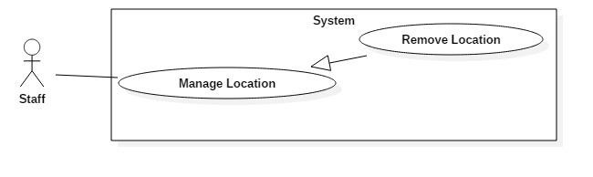

|  |  |  |  |  |  |  |
| --- | --- | --- | --- | --- | --- | --- |
| **USE CASE – <UC number>** | | | | | | |
| **Use Case No.** | | | UC 3.6 | **Use Case Version** | 1.0 | |
| **Use Case Name** | | | Remove Location | | | |
| **Author** | | | KhuongND | | | |
| **Date** | | | 3/29/2016 | **Priority** | Normal | |
| **Actor:**   * Staff   **Summary:**   * This use case allows staff to remove location.   **Goal:**   * System removes location.   **Triggers:**   * Staff sends the remove location command.   **Preconditions:**   * User logged in to the system with role staff (status in-active) or admin. * Staff selects a location exist in “Manage location” page.   **Post Conditions:**   * **Success** Location will be removed and show success message. * **Fail:** Show error message   **Main Success Scenario:**  **Alternative Scenario:**  [Alternative 1]  **Exceptions:**  [Exception 1] | | | | | | |
|  | No | Cause | | System Response | |  |
|  | 1 | Location which the staff chose dont exist (another staff remove when remove). | | Show error message: “Location not found.”. | |  |

|  |  |  |
| --- | --- | --- |
| Step | Actor Action | System Response |
| 1 | Staff go to “Location Manager” page and click link “Remove | -System confirm with staff to remove location. |
| 2 | Staff confirms “Yes” to remove location.  [Alternative 1] | Location will be removed to database. [Exception 1] |

|  |  |  |
| --- | --- | --- |
| Step | Actor Action | System Response |
| 1 | Staff click on “Cancel” button. | System close confim, cancel remove process. |

**Relationships:** N/A

**Business Rules:**

* If remove location success, a “Location” will be removed in database immediately.
* List “Location” in “Manage Location” page will be updated after this function finished.
* If this “Location” is being used, system will not remove this “Location”.
* Before remove a “Location”, system must find this “Location” in database exist or not? then removed if exist to avoid errors.
  + - 1. < Staff > Manage FlightAgency

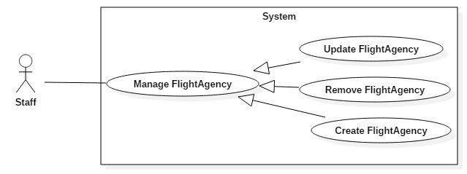

* + - * 1. *< Staff > Create FlightAgency*

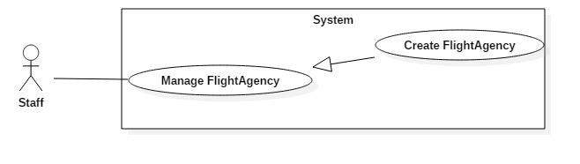

|  |  |  |  |
| --- | --- | --- | --- |
| **USE CASE – <UC number>** | | | |
| **Use Case No.** | UC 3.7 | **Use Case Version** | 1.0 |
| **Use Case Name** | Create FlightAgency | | |
| **Author** | TrungLVH | | |
| **Date** | 3/29/2016 | **Priority** | Normal |
| **Actor:**   * Staff   **Summary:**   * This use case allows staff to create new flight agency.   **Goal:**   * User can create new flight agency. | | | |

|  |  |  |  |  |
| --- | --- | --- | --- | --- |
| **Triggers:**  - User sends the create flight agency command.  **Preconditions:**  - User logged in to the system with role staff (status in-active) or admin.  **Post Conditions:**   * **Success:** New flight agency is create into database and show success message * **Fail:** Show error message   **Main Success Scenario:**  **Alternative Scenario:**  **Exceptions:**  Exception 1]  [Exception 2] | | | | |
|  | No | Cause | System Response |  |
|  | 2 | “Logo” doesn’t have true extension [jpg,jpeg,png,gif]. | Show error message: “Please choose |  |

|  |  |  |
| --- | --- | --- |
| Step | Actor Action | System Response |
| 1 | Staff go to “Manage flight agency” page and click “Add New” button. | System show modal following information:   * Name: textbox, max length:250, required. * Logo: fileupload, extension of fileupload contain [jpg,jpeg,png,gif]. * Button “Add New” sends create new flight agency command. * Button “Close” cancel create process. |
| 2 | Staff fills in information of flight agency. |  |
| 3 | Staff sends command to create new flight agency with inputted information to system(Click “Add New” button).  [Alternative 1] | New flight agency will be created into database.  [Exception 1,2] |

|  |  |  |
| --- | --- | --- |
| Step | Actor Action | System Response |
| 1 | Staff click “Close” button to cancel process | System close modal and cancel create process. |

|  |  |  |
| --- | --- | --- |
| No | Cause | System Response |
| 1 | “Name” is empty or longer than 250 words. | Show error message: “Please enter name flight agency less than 250 words”. |

|  |  |  |  |  |
| --- | --- | --- | --- | --- |
|  |  |  | image for logo ”. |  |
| **Relationships:** N/A  **Business Rules:**   * “Logo” must type image (jpg/jpeg/png/gif), check type before added. * List flight agency in “Manage flight agency” page will be updated with new flight agency after this function finished. * When this function finish, a “Flight agency” will be added in “FlightAgency” table in database immediately. | | | | |

* + - * 1. *< Staff > Update FlightAgency*

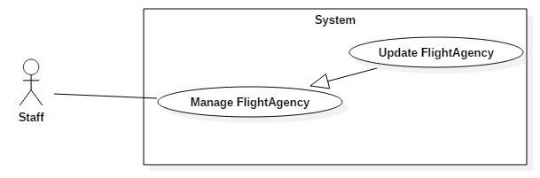

|  |  |  |  |  |  |  |
| --- | --- | --- | --- | --- | --- | --- |
| **USE CASE – <UC number>** | | | | | | |
| **Use Case No.** | | | UC 3.8 | **Use Case Version** | 1.0 | |
| **Use Case Name** | | | Update flight agency | | | |
| **Author** | | | TrungLVH | | | |
| **Date** | | | 3/29/2016 | **Priority** | Normal | |
| **Actor:**   * Staff   **Summary:**   * This use case allows staff to update existed flight agency.   **Goal:**   * Update existed flight agency.   **Triggers:**   * Staff sends the update flight agency information command.   **Preconditions:**   * User logged in to the system with role staff (status in-active) or admin. * Staff selects a flight agency exist in “Manage flight agency” page.   **Post Conditions:**   * **Success:** Flight agency information will be updated and show success message * **Fail:** Show error message   **Main Success Scenario:** | | | | | | |
|  | Step | Actor Action | | System Response | |  |
|  | 1 | Staff go to “Flight Agency | |  | |  |

|  |  |  |  |  |
| --- | --- | --- | --- | --- |
|  |  | Manager” page and click “Edit”. | System show modal following information:   * Name: textbox, max length:250, required. * Logo: fileupload, extension of fileupload contain [jpg,jpeg,png,gif]. * Button “Save Changes” sends update flight agency command. * Button “Close” cancel create process. |  |
|  | 2 | Staff fills in updated information of flight agency. |  |  |
|  | 3 | Staff click on “Save Changes” button.  [Alternative 1] | Flight agency will be updated to database. [Exception 1,2,3] |  |
| **Alternative Scenario:**  [Alternative 1]  **Exceptions:**  [Exception 1]  [Exception 2]  [Exception 3]  **Relationships:** N/A  **Business Rules:**   * “Logo” must have contension image [jpg,jpeg,png,gif], check type image before updated. * If update flight agency success, a “flight agency” will be updated in database | | | | |

|  |  |  |
| --- | --- | --- |
| Step | Actor Action | System Response |
| 1 | Staff click on “Close” button. | System close modal. |

|  |  |  |
| --- | --- | --- |
| No | Cause | System Response |
| 1 | “Name” is empty or longer than 250 words. | Show error message: “Please enter name flight agency less than 250 words”. |

|  |  |  |
| --- | --- | --- |
| No | Cause | System Response |
| 2 | “Logo” doesn’t have true extension [jpg,jpeg,png,gif]. | Show error message: “Please choose image for logo ”. |

|  |  |  |
| --- | --- | --- |
| No | Cause | System Response |
| 3 | Flight agency which the staff chose dont exist (another staff remove when update). | Show error message: “Flight agency not found.”. |

immediately.

* List “Flight agency” in “Manage Flight Agency” page will be updated after this function finished.
* Before update a “Flight agency”, system must find this “Flight agency” in database exist or not? then updated if exist to avoid errors.
  + - * 1. *< Staff > Remove FlightAgency*

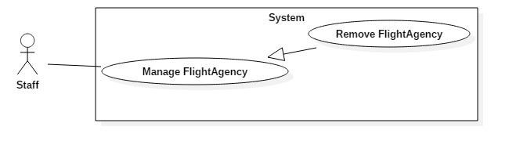

|  |  |  |  |  |  |  |
| --- | --- | --- | --- | --- | --- | --- |
| **USE CASE – <UC number>** | | | | | | |
| **Use Case No.** | | | UC 3.9 | **Use Case Version** | 1.0 | |
| **Use Case Name** | | | Remove FlightAgency | | | |
| **Author** | | | TrungLVH | | | |
| **Date** | | | 3/29/2016 | **Priority** | Normal | |
| **Actor:**   * Staff   **Summary:**   * This use case allows staff to remove flight agency.   **Goal:**   * System removes flight agency.   **Triggers:**   * Staff sends the remove flight agency command.   **Preconditions:**   * User logged in to the system with role staff (status in-active) or admin. * Staff selects a flight agency exist in “Manage flight agency” page.   **Post Conditions:**   * **Success:** Flight agency will be removed and show success message. * **Fail:** Show error message   **Main Success Scenario:** | | | | | | |
|  | Step | Actor Action | | System Response | |  |
|  | 1 | Staff go to “Flight Agency Manager” page and click link “Remove”. | | -System confirm with staff to remove flight agency. | |  |
|  | 2 | Staff confirms “Yes” to remove flight agency .  [Alternative 1] | | Flight agency will be removed to database. | |  |

|  |  |  |  |  |
| --- | --- | --- | --- | --- |
|  |  |  | [Exception 1] |  |
| **Alternative Scenario:**  [Alternative 1]  **Exceptions:**  [Exception 1]  **Relationships:** N/A  **Business Rules:**   * If remove flight agency success, a “Flight agency” will be removed in database immediately. * List “Flight agency” in “Manage Flight Agency” page will be updated after this function finished. | | | | |

|  |  |  |
| --- | --- | --- |
| Step | Actor Action | System Response |
| 1 | Staff click on “Cancel” button. | System close confim, cancel remove process. |

|  |  |  |
| --- | --- | --- |
| No | Cause | System Response |
| 1 | Flight agency which the staff chose dont exist (another staff remove when remove). | Show error message: “flight agency not found.”. |

* + - 1. < Staff > Manage DataSource

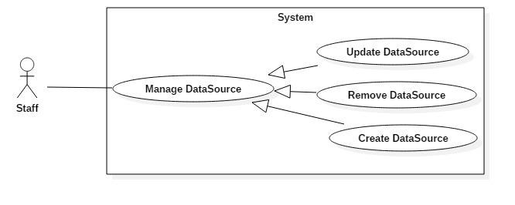

* + - * 1. *< Staff > Create DataSource*

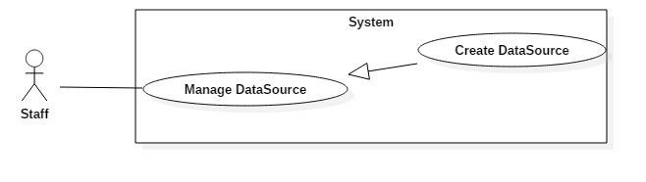

*Web Application Use Case – < Staff > Create DataSource*

|  |  |  |  |  |  |  |
| --- | --- | --- | --- | --- | --- | --- |
| **USE CASE – <UC number>** | | | | | | |
| **Use Case No.** | | | UC 3.10 | **Use Case Version** | 1.0 | |
| **Use Case Name** | | | Create data source | | | |
| **Author** | | | KhuongND | | | |
| **Date** | | | 3/29/2016 | **Priority** | Normal | |
| **Actor:**   * Staff   **Summary:**   * This use case allows staff to create new data sources.   **Goal:**   * User can create new data sources.   **Triggers:**   * User sends the create new data sources command.   **Preconditions:**  - User logged in to the system with role staff (status in-active) or admin.  **Post Conditions:**   * **Success:** New data sources is create into database and show success message * **Fail:** Show error message   **Main Success Scenario:** | | | | | | |
|  | Step | Actor Action | | System Response | |  |
|  | 1 | Staff go to “Manage data sources”. | | System navigates to “Manage data sources” page.   * Data type: dropdownlist (Hotel, Flight,Tour), required. * Data source URL: textbox, contain “http” or “https”, required. * Icon plus: button sends create new data sources command. | |  |
|  | 2 | Staff fills in information of datasources. | |  | |  |
|  | 3 | Staff sends command to create | |  | |  |

|  |  |  |  |  |
| --- | --- | --- | --- | --- |
|  |  | new data sources with inputted information to system(Click Icon plus). | New data sources will be created into database.  [Exception 1] |  |
| **Alternative Scenario:N/A Exceptions:**  [Exception 1]  **Relationships:** N/A  **Business Rules:**   * List data sources in “Manage data sources” page will be updated with new data sources, after this function finished. * “Data source URL” must start with “http” or “https”. | | | | |

* + - * 1. *< Staff > Update DataSource*

|  |  |  |
| --- | --- | --- |
| No | Cause | System Response |
| 1 | “Data source URL” is empty or doesnt contain “http” or “https”. | Show error message: “Please enter data source URL start with “http” or “https””. |

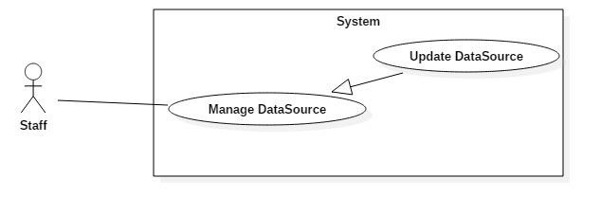

*Web Application Use Case – < Staff > Update DataSource*

|  |  |  |  |
| --- | --- | --- | --- |
| **USE CASE – <UC number>** | | | |
| **Use Case No.** | UC 3.11 | **Use Case Version** | 1.0 |
| **Use Case Name** | Update datasource | | |
| **Author** | KhuongND | | |
| **Date** | 3/29/2016 | **Priority** | Normal |
| **Actor:**   * Staff   **Summary:**   * This use case allows staff to update existed datasource.   **Goal:**   * Update existed datasource.   **Triggers:**   * Staff sends the update datasource information command. | | | |

**Preconditions:**

* User logged in to the system with role staff (status in-active) or admin.
* Staff selects a datasource exist in “Manage data sources” page.

**Post Conditions:**

* **Success:** Datasource information will be updated and show success message
* **Fail:** Show error message

**Main Success Scenario:**

|  |  |  |
| --- | --- | --- |
| Step | Actor Action | System Response |
| 1 | Staff go to “Manage data sources” and click “Edit” | System show modal following information:   * Data type: dropdownlist (Hotel, Flight,Tour), required. * Data source URL: textbox, contain “http” or “https”, required. * Button “Save Changes” sends update data sources command. * Butten “Close” cancels update process. |
| 2 | Staff fills in updated information of datasources. |  |
| 3 | Staff click on “Save Changes” button.  [Alternative 1] | Data sources will be updated to database. [Exception 1,2] |

**Alternative Scenario:**

[Alternative 1]

|  |  |  |
| --- | --- | --- |
| Step | Actor Action | System Response |
| 1 | Staff click on “Close” button. | System close modal. |

**Exceptions:**

[Exception 1]

|  |  |  |
| --- | --- | --- |
| No | Cause | System Response |
| 1 | “Data source URL” is empty or doesnt contain “http” or “https”. | Show error message: “Please enter data source URL start with “http” or “https””. |

[Exception 2]

|  |  |  |
| --- | --- | --- |
| No | Cause | System Response |
| 3 | Data source which the staff chose dont exist (another staff remove when update). | Show error message: “Data source not found.”. |

**Relationships:** N/A

**Business Rules:**

* “Data source URL” must start with “http” or “https”,check before updated.
* If update datasource success, a “Datasource” will be updated in database immediately.
* List “Datasource” in “Manage Data Source” page will be updated after this function finished.
  + - * 1. *< Staff > Remove DataSource*

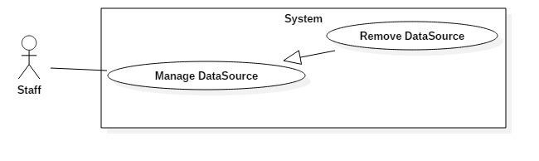

|  |  |  |  |  |  |  |
| --- | --- | --- | --- | --- | --- | --- |
| **USE CASE – <UC number>** | | | | | | |
| **Use Case No.** | | | UC 3.12 | **Use Case Version** | 1.0 | |
| **Use Case Name** | | | Remove data source | | | |
| **Author** | | | KhuongND | | | |
| **Date** | | | 3/29/2016 | **Priority** | Normal | |
| **Actor:**   * Staff   **Summary:**   * This use case allows staff to remove datasource.   **Goal:**   * System removes datasource.   **Triggers:**   * Staff sends the remove datasource command.   **Preconditions:**   * User logged in to the system with role staff (status in-active) or admin. * Staff selects a datasource exist in “Manage data sources” page.   **Post Conditions:**   * **Success:** Datasource will be removed and show success message. * **Fail:** Show error message   **Main Success Scenario:** | | | | | | |
|  | Step | Actor Action | | System Response | |  |
|  | 1 | Staff go to “Manage data sources” and click “Remove” | | -System confirm with staff to remove datasource | |  |
|  | 2 | Staff confirms “Yes” to remove data source. | |  | |  |

|  |  |  |  |  |
| --- | --- | --- | --- | --- |
|  |  | [Alternative 1] | Data source will be removed to database. [Exception 1] |  |
| **Alternative Scenario:**  [Alternative 1]  **Exceptions:**  [Exception 1]  **Relationships:** N/A  **Business Rules:**   * If remove datasource success, a “Datasource” will be removed in database immediately. * List “Datasource” in “Manage Datasource” page will be updated after this function finished. * If this “Datasource” is being used, system will not remove this “Datasource”. * If data source have more configurations,system will remove all those configurations before remove data source. | | | | |

|  |  |  |
| --- | --- | --- |
| Step | Actor Action | System Response |
| 1 | Staff click on “Cancel” button. | System close confim, cancel remove process. |

|  |  |  |
| --- | --- | --- |
| No | Cause | System Response |
| 1 | Data source which the staff chose dont exist (another staff remove when remove). | Show error message: “Data source not found.”. |

* + - 1. <Staff > Configure data parsing

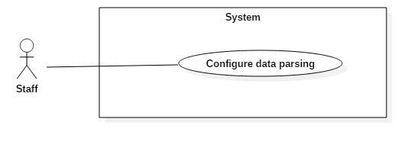

*Web Application Use Case – < Staff > Configure data parsing*

|  |  |  |  |
| --- | --- | --- | --- |
| **USE CASE – <UC number>** | | | |
| **Use Case No.** | UC 3.13 | **Use Case Version** | 1.0 |
| **Use Case Name** | Configure data parsing | | |
| **Author** | TrucGS | | |

|  |  |  |  |
| --- | --- | --- | --- |
| **Date** | 3/29/2016 | **Priority** | High |
| **Actor:**   * Staff   **Summary:**   * This use case allows staff to configure data parsing for a particular data source.   **Goal:**   * All the configuration created are used for checking html structure and parse the corresponding data from data sources.   **Triggers:**   * User sends the configure data parsing command.   **Preconditions:**   * User must login with role Staff (status “Active”) or Admin.   **Post Conditions:**   * **Success:** The configuration are saved to database. * **Fail:** Show error message.   **Main Success Scenario:**  **Alternative Scenario:**N/A **Exceptions:** N/A **Relationships:** N/A **Business Rules:**   * The configuration properties are different for each data type:   + Hotel: Name, PreviewImgUrl, Address, Description, DescriptionHtml, Price, Rating, ProvidedServices, Comments   + Tour: Name, PreviewImgUrl, Location, Agency, Description, DescriptionHtml, Route, RouteHtml, Price   + Flight: MinProxyCount, MaxThreadCount, MaxResponse, MaxAttemp | | | |

|  |  |  |
| --- | --- | --- |
| Step | Actor Action | System Response |
| 1 | Choose a data source and click on button “Config” in “Manage data sources” page . | Show list of properties depending on type of the data source. |
| 2 | Fill in configuration properties by selecting the data area in iframe that contains html of the sample page to get CSS selector of the element. |  |
| 3 | Click on “Save Changes” button. | Data parsing configuration saved to the database. |

* + - 1. <Staff > Manually parse data

|  |  |  |
| --- | --- | --- |
| Step | Actor Action | System Response |
| 1 | Choose a datasource and click “Force Start” button in “Manage data sources” page . | Start parsing process and show message: “Parsing progress has been started”. |

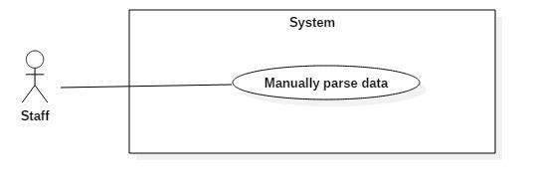

*Web Application Use Case – < Staff > Manually parse data*

|  |  |  |  |
| --- | --- | --- | --- |
| **USE CASE – <UC number>** | | | |
| **Use Case No.** | UC 3.14 | **Use Case Version** | 1.0 |
| **Use Case Name** | Manually parse data | | |
| **Author** | TrucGS | | |
| **Date** | 3/29/2016 | **Priority** | Normal |
| **Actor:**   * Staff   **Summary:**   * This use case allows staff to manually parse data.   **Goal:**   * User can manually parse data.   **Triggers:**   * User sends the manually parse data command.   **Preconditions:**   * User must login with role Staff (status “Active”) or Admin.   **Post Conditions:**   * **Success:** Parsing data process of the selected data source will start and run in background. * **Fail:** Show error message.   **Main Success Scenario:**  **Alternative Scenario:**N/A **Exceptions:** N/A **Relationships:** N/A **Business Rules:**   * There are 2 type of parsing:   + Html parsing (for hotels and tours): used to parse those data sources that rendered fully information in html without lazy loading. | | | |

* Ajax parsing (for flights): used to parse those data sources that rendered partial information via Ajax request.

- The parsing process is mentioned in section D.7.1 and D.7.2.

* + - 1. <Staff> Change password

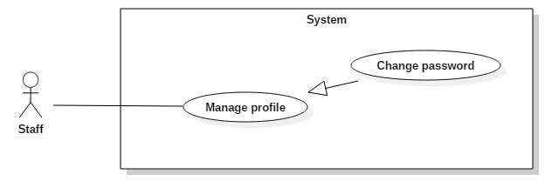

|  |  |  |  |  |  |  |  |
| --- | --- | --- | --- | --- | --- | --- | --- |
| **USE CASE – SEPTIAL05** | | | | | | | |
| **Use Case No.** | | | UC 3.15 | | **Use Case Version** | 1.0 | |
| **Use Case Name** | | | Change Password | | | | |
| **Author** | | | KhuongND | | | | |
| **Date** | | | 15/02/2016 | | **Priority** | Normal | |
| Actor:   * Staff and admin Summary: * This use case allows staff to change password of his/her account. Goal: * User can update his/her password. Triggers: * User sends request change password. Preconditions: * User logged in to the system. Post Conditions: * Success: Account data is updated password into storage. * Fail: Show error message. Main Success Scenario: | | | | | | | |
|  | Step | Actor Action | | System Response | | |  |
|  | 1 | Admin click link “Change password” in “Manage profile” page. | | System navigates to “Change password” | | |  |

|  |  |  |  |  |
| --- | --- | --- | --- | --- |
|  |  |  | page:   * Old Password: textbox, length: 1 - 10 character, required. * New Password: textbox, length: 1 - 10 character, required . * Confirm New Password: textbox, length: 1 - 10 character, required . * Change password: button. |  |
|  | 2 | Input field. |  |  |
|  | 3 | Click on “Change password” |  |  |
|  | button. | Password of user will be updated to |
|  |  | database. Show success message: |
|  |  | “Account change password successfully ”. |
|  |  | [Exception 1,2,3,4,5] |
| Alternative Scenario: N/A Exceptions:  Relationships: N/A Business Rules:   * If account is logged on a different session and change personal info success, account will be logout. * If user fill wrong old password 3 times, account will be blocked in 30 minutes. | | | | |

|  |  |  |
| --- | --- | --- |
| No | Cause | System Response |
| 1 | Click on “Change password” button. | New password and confirm password don’t match. Show error message: “New password and confirm password don’t match”. |
| 2 | Click on “Change password” button | Old Password is blank. Show error message: “Please fill old password”. |
| 3 | Click on “Change password” button | New Password is blank. Show error message: “Please fill new password”. |
| 4 | Click on “Change password” button | Confirm New Password is blank. Show error message: “Please fill confirm new password”. |
| 5 | Click on “Change password” button | Old Password isn’t match with old password of account in database. Show error message: “Please fill old password, this password is wrong”. |

|  |  |  |
| --- | --- | --- |
| Step | Actor Action | System Response |
| 1 | User click button “Logout” in menu bar. | System takes user out of system and display login page. |

- New password will be prompted security level (strength,weak).

* + - 1. <Staff> Logout

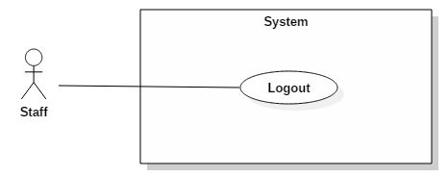

|  |  |  |  |
| --- | --- | --- | --- |
| **USE CASE – SEPTIAL04** | | | |
| **Use Case No.** | UC 3.16 | **Use Case Version** | 1.0 |
| **Use Case Name** | Logout | | |
| **Author** | KhuongND | | |
| **Date** | 15/02/2016 | **Priority** | Normal |
| **Actor**:   * Staff and admin   **Summary**:   * This use case allows staff to log out of system.   **Goal**:   * User can log out of system.   **Triggers**:   * User sends request logout.   **Preconditions**:   * User logged in to the system.   **Post Conditions**:   * **Success**: Display login page. * **Fail**: N/A.   **Main Success Scenario**:  **Alternative Scenario**: N/A  **Exceptions**:N/A | | | |

**Relationships**: N/A

**Business Rules**:

* If user logout while send request to system, all request will be delete.
* If user is not available longer than 30 minutes, they will see the login view when they be back.

#### *.<Admin> Overview Use Case*

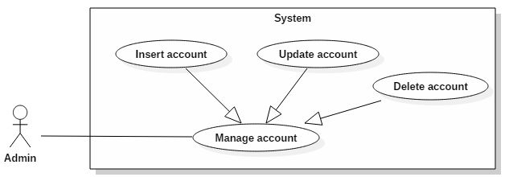

* + - 1. <Admin> Create account

|  |  |  |  |
| --- | --- | --- | --- |
| **USE CASE – SEPTIAL01** | | | |
| **Use Case No.** | UC 3.17 | **Use Case Version** | 1.0 |
| **Use Case Name** | Create Account | | |
| **Author** | CuongHH | | |
| **Date** | 15/02/2016 | **Priority** | Normal |
| **Actor:**   * Admin   **Summary:**   * Create a new account   **Goal:**   * A account is created with role Staff   **Triggers:**   * Admin sends request to create account.   **Preconditions:**   * User logged in the system with role “Admin”.   **Post Conditions:**   * **Success:** New account will be created for staff. * **Fail:** Show error message.   **Main Success Scenario:** | | | |

|  |  |  |  |  |
| --- | --- | --- | --- | --- |
|  | Step | Actor Action | System Response |  |
|  | 1 | Admin click button “Create Account” in menu bar. | System navigates to “Insert Account” page.   * Email: textbox, length: 1 – 50 character, required. * Password: textbox, length: 1 - 10 character, required. * Confirm Password: textbox, length: 1 -10 character, required. * Full name: textbox, length: 1 - 50 character, required. * Gender: dropdownlist (male, female), required. * Birthdate: datepicker, required, value from 1900 to current year. * Register: button. |  |
|  | 2 | Input field. |  |  |
|  | 3 | Click on “Insert” button. | New account will be added to database. Show success message: “A account staff created successfully”.  [Exception 1,2,3,4] |  |
| **Alternative Scenario:** N/A  **Exceptions:**  **Relationships:** N/A  **Business Rules:**   * New Account will be created with status in-active. * System must ensure has not duplicated email. | | | | |

|  |  |  |
| --- | --- | --- |
| No | Cause | System Response |
| 1 | Password and confirming password don’t match. | Show error message: “Password and confirm password don’t match”. |
| 2 | Password is blank. | Show error message: “Please fill password”. |
| 3 | Email is blank or wrong format. | Show error message: “Please fill email”. |
| 4 | Duplicated email. | Show error message: “Please choose another email. Email already in use”. |

* + - 1. <Admin> Update account

|  |  |  |  |  |  |  |  |
| --- | --- | --- | --- | --- | --- | --- | --- |
| **USE CASE – SEPTIAL02** | | | | | | | |
| **Use Case No.** | | | UC 3.18 | | **Use Case Version** | 1.0 | |
| **Use Case Name** | | | Update Account | | | | |
| **Author** | | | CuongHH | | | | |
| **Date** | | | 15/02/2016 | | **Priority** | Normal | |
| **Actor**:   * Admin   **Summary:**   * Update account information   **Goal:**   * Update account information   **Triggers:**   * Admin sends request to update account.   **Preconditions:**   * User logged in to the system as Admin role.   **Post Conditions:**   * **Success:** Account data is updated into storage. * **Fail:** Show error message.   **Main Success Scenario:** | | | | | | | |
|  | Step | Actor Action | | System Response | | |  |
|  | 1 | Admin click link “Update” in list account. | | System navigates to “Update account” page and fill information of this account to form:   * Email: textbox, length: 1 - 50 character, read-only. * Full name: textbox, length: 1 - 50 character. * New Password: textbox, length: 1 - 10 character . * Confirm New Password: textbox, length: 1 - 10 character . * Gender: dropdownlist (male, female). * Birthdate: datepicker, value from 1900 to current year. * Status: dropdownlist (in-active, | | |  |

|  |  |  |  |  |
| --- | --- | --- | --- | --- |
|  |  |  | blocked).  - Update: button. |  |
|  | 2 | Input field. |  |  |
|  | 3 | Click on “Update” button. | Account will be updated to database. Show success message: “Account updated successfully ”.  [Exception 1] |  |
| **Alternative Scenario:** N/A  **Exceptions:**  **Relationships:** N/A  **Business Rules:**  - If account’s status is changed to “blocked”, the account won’t be able to access the system. | | | | |

|  |  |  |
| --- | --- | --- |
| No | Cause | System Response |
| 1 | New password and confirm password don’t match. | Show error message: “New password and confirm password don’t match”. |

* + - 1. <Admin> Delete account

|  |  |  |  |
| --- | --- | --- | --- |
| **USE CASE – SEPTIAL03** | | | |
| **Use Case No.** | UC 3.19 | **Use Case Version** | 1.0 |
| **Use Case Name** | Delete Account | | |
| **Author** | CuongHH | | |
| **Date** | 15/02/2016 | **Priority** | Normal |
| **Actor:**   * Admin   **Summary:**   * Delete an account in system.   **Goal:**   * Remove a staff account.   **Triggers:**   * Admin sends request delete account. | | | |

**Preconditions:**

* User has to log in to the system as Admin role.

**Post Conditions:**

* **Success:** The account is deleted.
* **Fail:** Show error message.

**Main Success Scenario:**

**Alternative Scenario:**

**Exceptions:** N/A

**Relationships:** N/A

**Business Rules:**

- Admin cannot delete himself/herself.

|  |  |  |
| --- | --- | --- |
| Step | Actor Action | System Response |
| 1 | Admin click link “Delete” in list account. | - System shows message options to confirm delete account: “Do you want to delete this account ?”. |
| 2 | Admin confirms “Yes” to delete account.  [Alternative 1] | Account will be deleted to database. Show success message: “Account deleted successfully ”. |

|  |  |  |
| --- | --- | --- |
| Step | Actor Action | System Response |
| 1 | Admin confirm “Cancel” to cancel account | System abort to delete account. |

## Software System Attribute

### Usability

* + - The system usability is easy to use that users generally don’t need to look at the document in order to use them.

### Reliability

* + - The data provided by the system needs to be updated within 30 minutes – 2 hours.
    - The data should be backed up everyday.

### Availability

* + - The web app must be available 24/7.
    - The mobile application needs to connect to the internet.

### Security

* + - Users can use the software without having to register or provide their private information.
    - The mobile application does not install anything else beside itself to user’s phone.

### Maintainability

* + - The software is organized into modules.

### Portability

* + - The software itself is a web application, therefore it can be used in any platform that has a web browser and can connect to the internet.
    - Users can use mobile app on every Android smart phone that supports Android API 4.0 or above.

### Performance

* + - Requests from users are responded in less than 10 seconds at 5 Mbps bandwidth speed.

## Conceptual Diagram

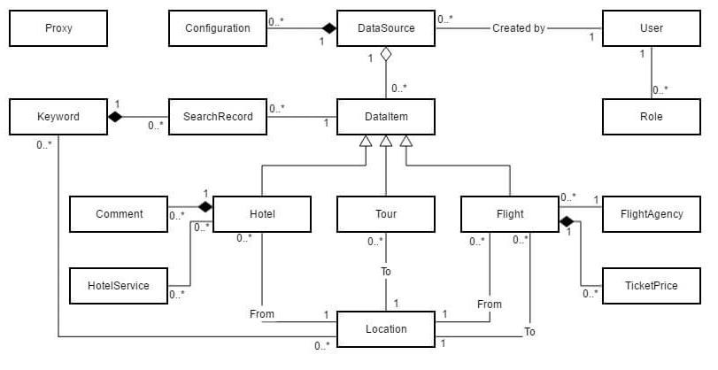

**Data Dictionary:**

|  |  |
| --- | --- |
| **Entity Name** | **Description** |
| **DataSource** | Contains all the information about websites to be parsed. |
| **Configuration** | Specifies needed properties for parsing data. |
| **DataItem** | Has 3 types: Hotel, Tour, Flight |
| **Hotel** | Contains all the properties about hotels. |
| **Flight** | Contains all the properties about tours. |
| **Tour** | Contains all the properties about flights. |
| **Keyword** | Recorded from search keywords of users. |
| **SearchRecord** | Used to update click count & view count from user behaviors. |
| **Location** | Used to categorize data by cities/provinces. |
| **Comment** | Parsed comments associated with hotels. |
| **HotelService** | Parsed services associated with hotels. |
| **FlightAgency** | Parsed agencies associated with hotels. |
| **TicketPrice** | Categorize flight data into 3 type of tickets: Adult, Children, Orphan |
| **Proxy** | Contains the list of proxies used to parse data without being banned by the data sources. |
| **User** | Store information of admin and staff of the system. |
| **Role** | Has 2 types: Admin, Staff |

#### *Table 11: Conceptual Diagram Data Dictionary*

1. **Report No. 4 Software Design Description**

## Design Overview

This document describes the technical and user interface design of SEPTIAL. It includes the architectural design, the detailed design of common functions and business functions and the design of database model.

The architectural design describes the overall architecture of the system and the architecture of each main component and subsystem.

The detailed design describes static and dynamic structure for each component and functions. It includes class diagrams, class explanations and sequence diagrams for each use cases.

The database design describes the relationships between entities and details of each entity.

**Document overview:**

* Section 2: Overall description of the system architecture design.
* Section 3: Component diagrams that describe the connection and integration of the system.
* Section 4: Detail design description which includes class diagram, class explanation, and sequence diagram to details the application functions.
* Section 5: Interface design for web, android applications.
* Section 6: ERD with logical diagram.

## System Architecture Design

### Web Application architecture description

The web app is developed under ASP .NET MVC architecture with the following components:

* + - Model: Model objects are the parts of the application that implement the logic for the application's data domain.
    - View: Views are the components that display the application's user interface.
    - Controller: Controllers are the components that handle user interaction, work with the model, and ultimately select a view to render that displays UI.

Besides, the system includes:

* + - Lucene server: Lucene server has a No-SQL database that contains all the data used for retrieving search results.
    - Scheduler: Scheduled tasks parse data from external data sources, then categorize and update data from main storage to Lucene database.

### Mobile Application architecture description

The application is developed as an Android native application. In general, the application architecture conforms to Android architecture: Activity is the basic core of an android application that handles user input, create thread to run AsyncTask, send request and receive data from server via web sevices.

## Component Diagram

## Detail Description

### Class Diagram

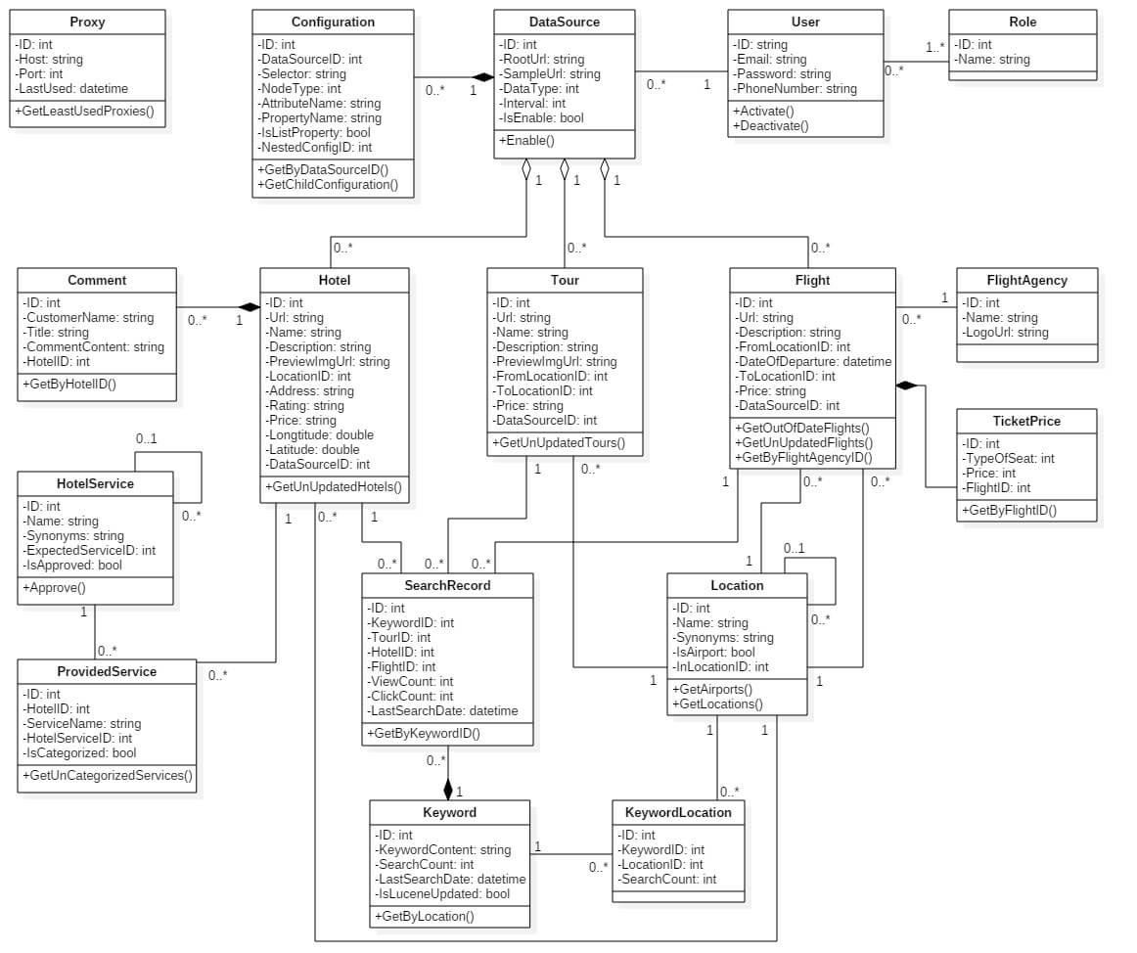

### Class Diagram Explanation

|  |  |
| --- | --- |
| **Entity Name** | **Description** |
| **DataSource** | Contains all the information about websites to be parsed. |
| **Configuration** | Specifies needed properties for parsing data. |
| **Hotel** | Contains all the properties about hotels. |
| **Flight** | Contains all the properties about tours. |
| **Tour** | Contains all the properties about flights. |
| **Keyword** | Recorded from search keywords of users. |
| **SearchRecord** | Used to update click count & view count from user behaviors. |
| **Location** | Used to categorize data by cities/provinces. |
| **Comment** | Parsed comments associated with hotels. |
| **HotelService** | Offical hotel services used for filtering search results. |
| **ProvidedService** | Parsed services associated with hotels. |
| **FlightAgency** | Parsed agencies associated with hotels. |
| **TicketPrice** | Categorize flight data into 3 type of tickets: Adult, Children, Orphan |
| **Proxy** | Contains the list of proxies used to parse data without being banned by the data sources. |
| **User** | Store information of admin and staff of the system. |
| **Role** | Has 2 types: Admin, Staff |

#### *DataSource*

|  |  |
| --- | --- |
| **Attribute** | **Description** |
| **ID** | Unique ID for each data source |
| **RootUrl** | The root url of the data source used for limit the crawled urls when parsing data |

|  |  |
| --- | --- |
| **SampleUrl** | The url to the web page with the standard html structure |
| **DataType** | Can be 3 types:   * Hotel = 0 * Tour = 1 * Flight = 2 |
| **Interval** | The pending time (in minute) after the scheduler complete parsing data from the data source. When the pending time is up, the scheduler start to run again. |
| **IsEnabled** | Can be True or False.  If IsEnabled = True, the scheduler automatically run to parse data after the interval of pending. |

#### *Configuration*

|  |  |
| --- | --- |
| **Attribute** | **Description** |
| **ID** | Unique ID for each configuration |
| **DataSourceID** | ID of the data source that contains the configuration |
| **PropertyName** | The property name of hotel, tour, or flight that will be parsed |
| **Selector** | The CSS selector of the element containing data for the specified property |
| **NodeType** | Can be 3 type:   * Text = 0 * Attribute = 1 * Html = 2 |
| **AttributeName** | * If the NodeType = 1, AttributeName will contain the name of the attribute that contain data for the specified property. * Else, AttributeName = null. |
| **IsListProperty** | Can be True or False.   * True: The specified property is a list of objects (Ex: list of comments on a hotel) * False: The specified property is a single property (Ex: |

|  |  |
| --- | --- |
|  | Hotel name, description) |
| **NestedConfigID** | If the specified property is the property of the object type in a list-property, the NestedConfigID is the ID of the Configuration of the list-property.  Ex: Hotel has the list-property “Comments”, Comment has the property “CommentContent”. The ID of the configuration corresponding to property “Comments” is the NestedConfigID of the configuration corresponding to the property “CommentContent”. |

#### *Keyword*

|  |  |
| --- | --- |
| **Attribute** | **Description** |
| **ID** | Unique ID for each keyword |
| **KeywordContent** | The whole input keyword. |
| **SearchCount** | By default, SearchCount = 1. Whenever users enter a keyword, increase SearchCount by 1. |
| **LastSearchDate** | The last time this keyword is searched. |
| **IsLuceneUpdated** | Can be True or False.  If the KeywordContent and SearchCount is updated to Lucene database, IsLuceneUpdated = true. |

#### *SearchRecord*

|  |  |
| --- | --- |
| **Attribute** | **Description** |
| **ClickCount** | By default, ClickCount = 1. Whenever users select a hotel/tour/flight to view detail, increase ClickCount by 1. |
| **ViewCount** | By default, ViewCount = 1. Whenever a search result is display to users, increase ViewCount by 1. |
| **LastSearchDate** | The last time users clicks on a search result for the input keyword. |

#### *HotelService*

|  |  |
| --- | --- |
| **Attribute** | **Description** |

|  |  |
| --- | --- |
| **ID** | Unique ID for each hotel service |
| **Name** | Name of the group of similar services |
| **Synonyms** | All the similar service names in the group |
| **ExpectedServiceID** | ID of the service that is supposed to be in the same group with this service. |
| **IsApproved** | Can be True or False.  If Admin or Staff approve this service, IsApproved = true. |

#### *ProvidedService*

|  |  |
| --- | --- |
| **Attribute** | **Description** |
| **ID** | Unique ID for each provided service. |
| **ServiceName** | The parsed service name from the data source |
| **HotelServiceID** | ID of the service group that is supposed to contain this service.  If system cannot find any relevant hotel service, HotelServiceID = null. |
| **IsCategorized** | Can be True or False.  Used to mark if this service is already categorized to a service group or not. |

### Interaction Diagram

#### *Web App*

* + - 1. User
         1. *General search*

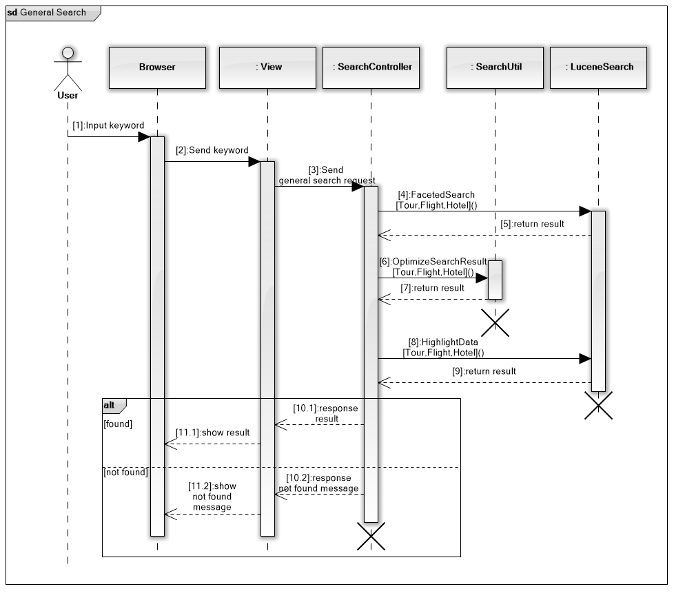

* + - * 1. *Search hotel*

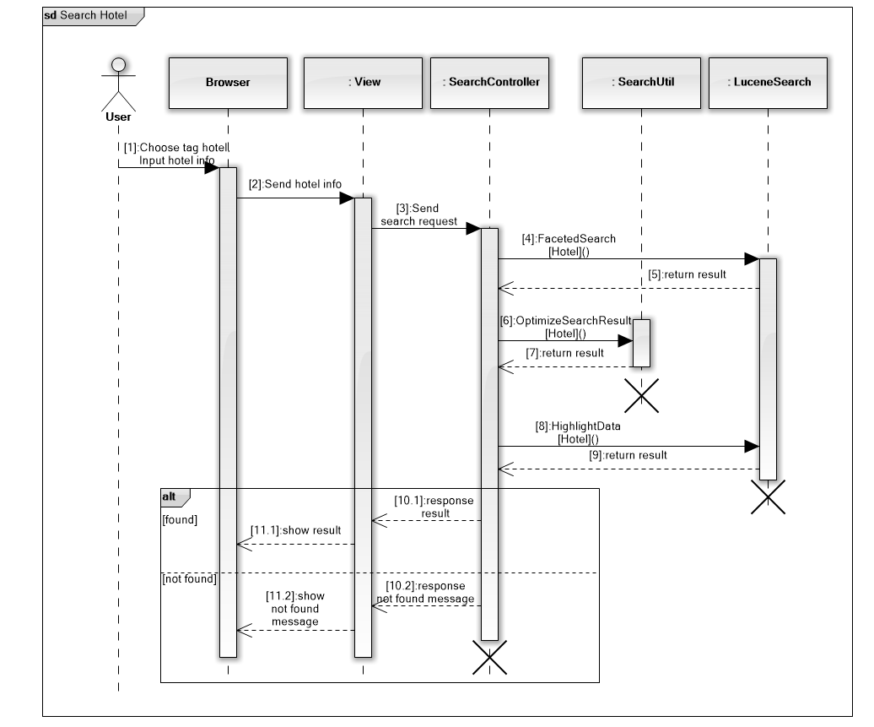

* + - * 1. *Search tour*

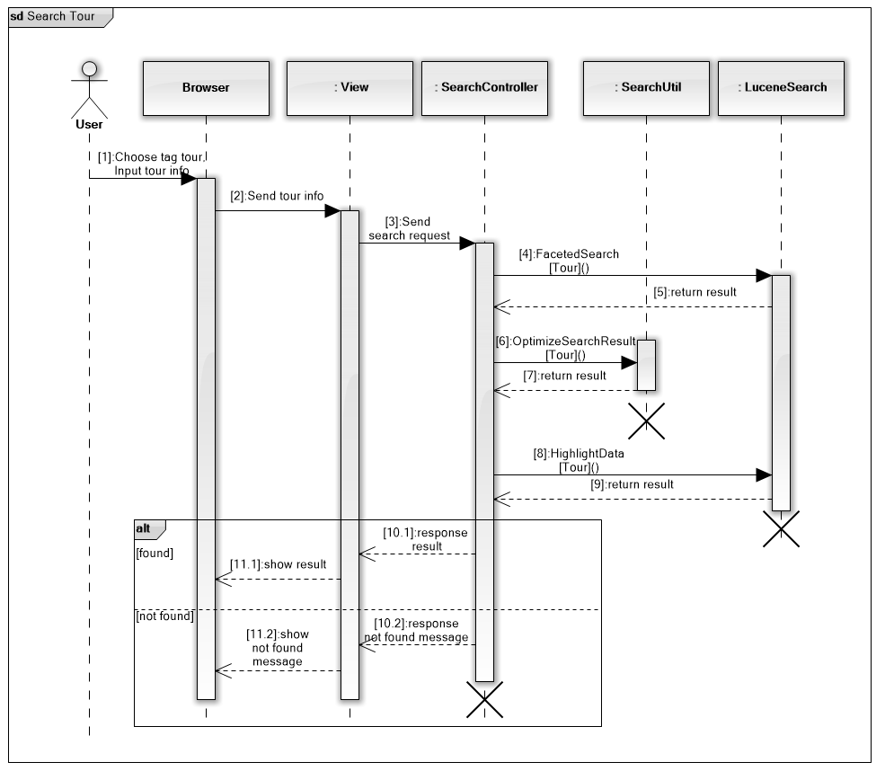

* + - * 1. *Search flight*

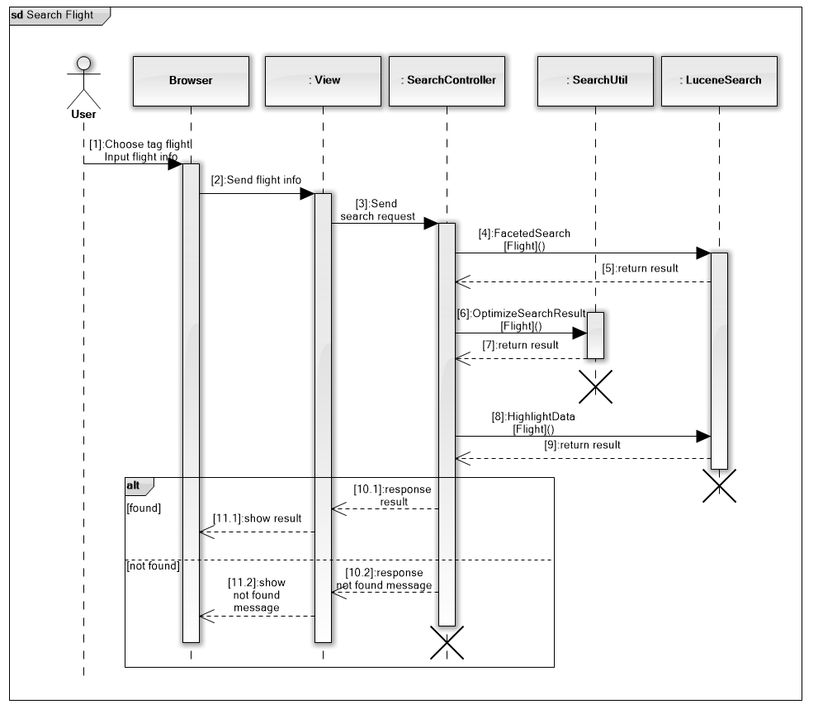

* + - * 1. *Filter & sort hotel search result*

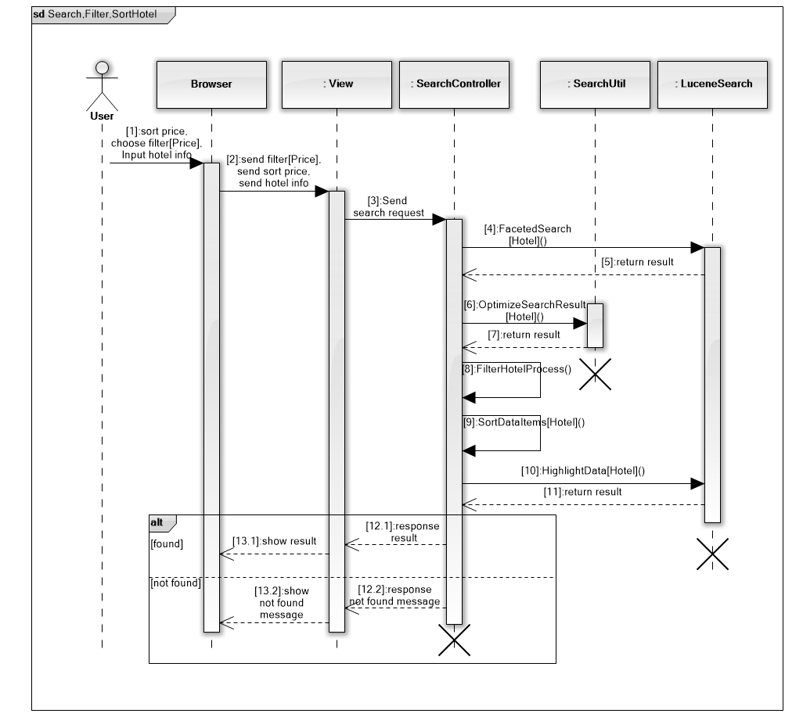

* + - * 1. *Filter & sort tour search result*

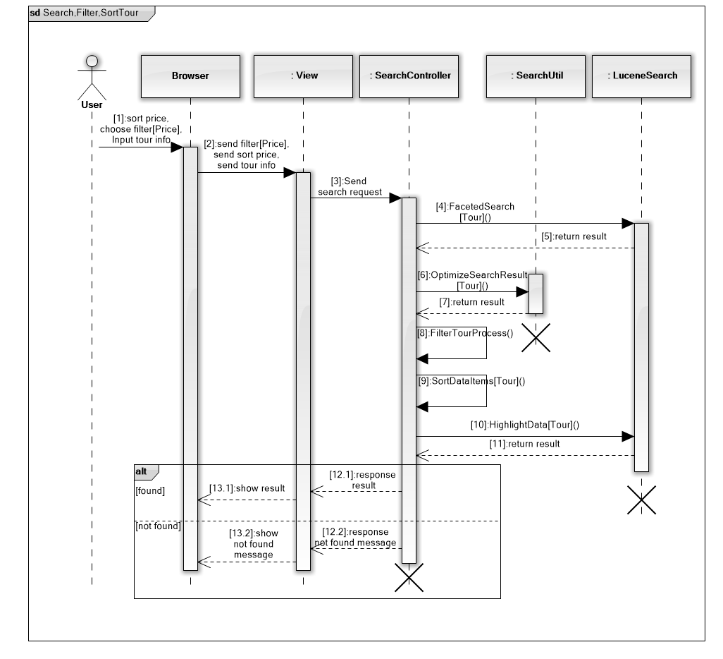

* + - * 1. *View hotel detail*

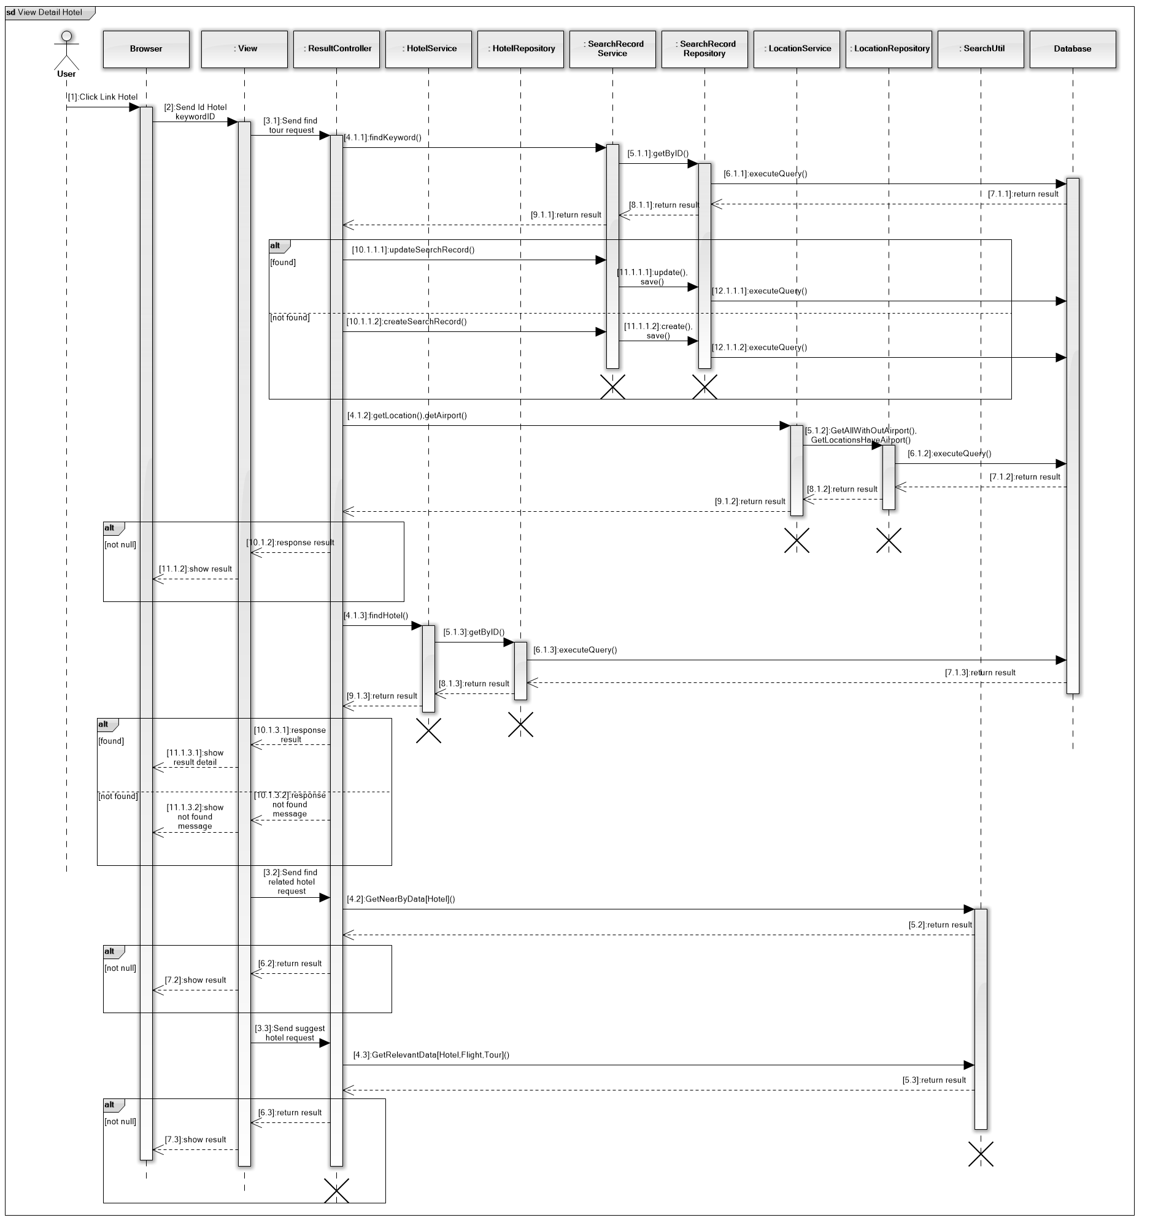

* + - * 1. *Login*

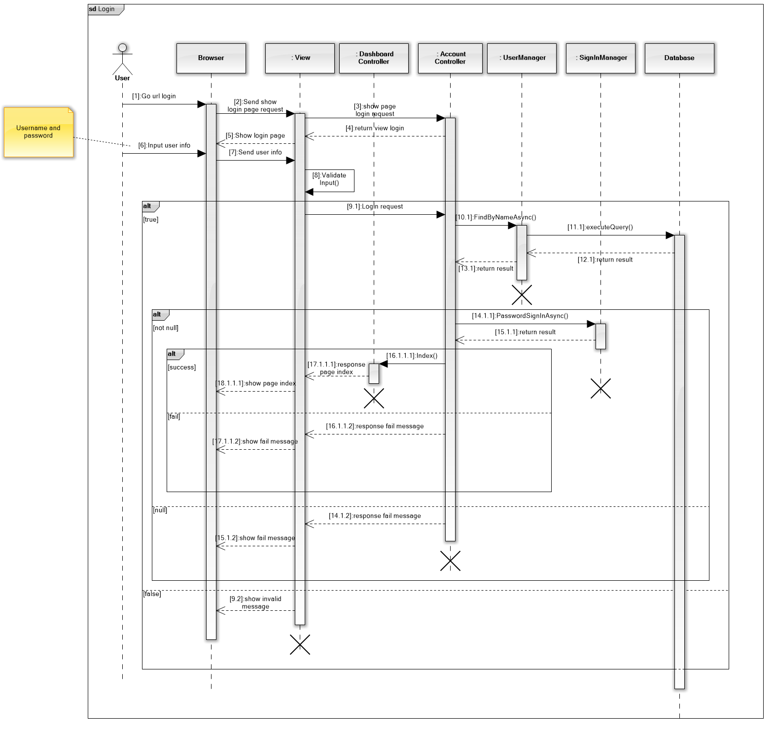

* + - * 1. *Forget password*

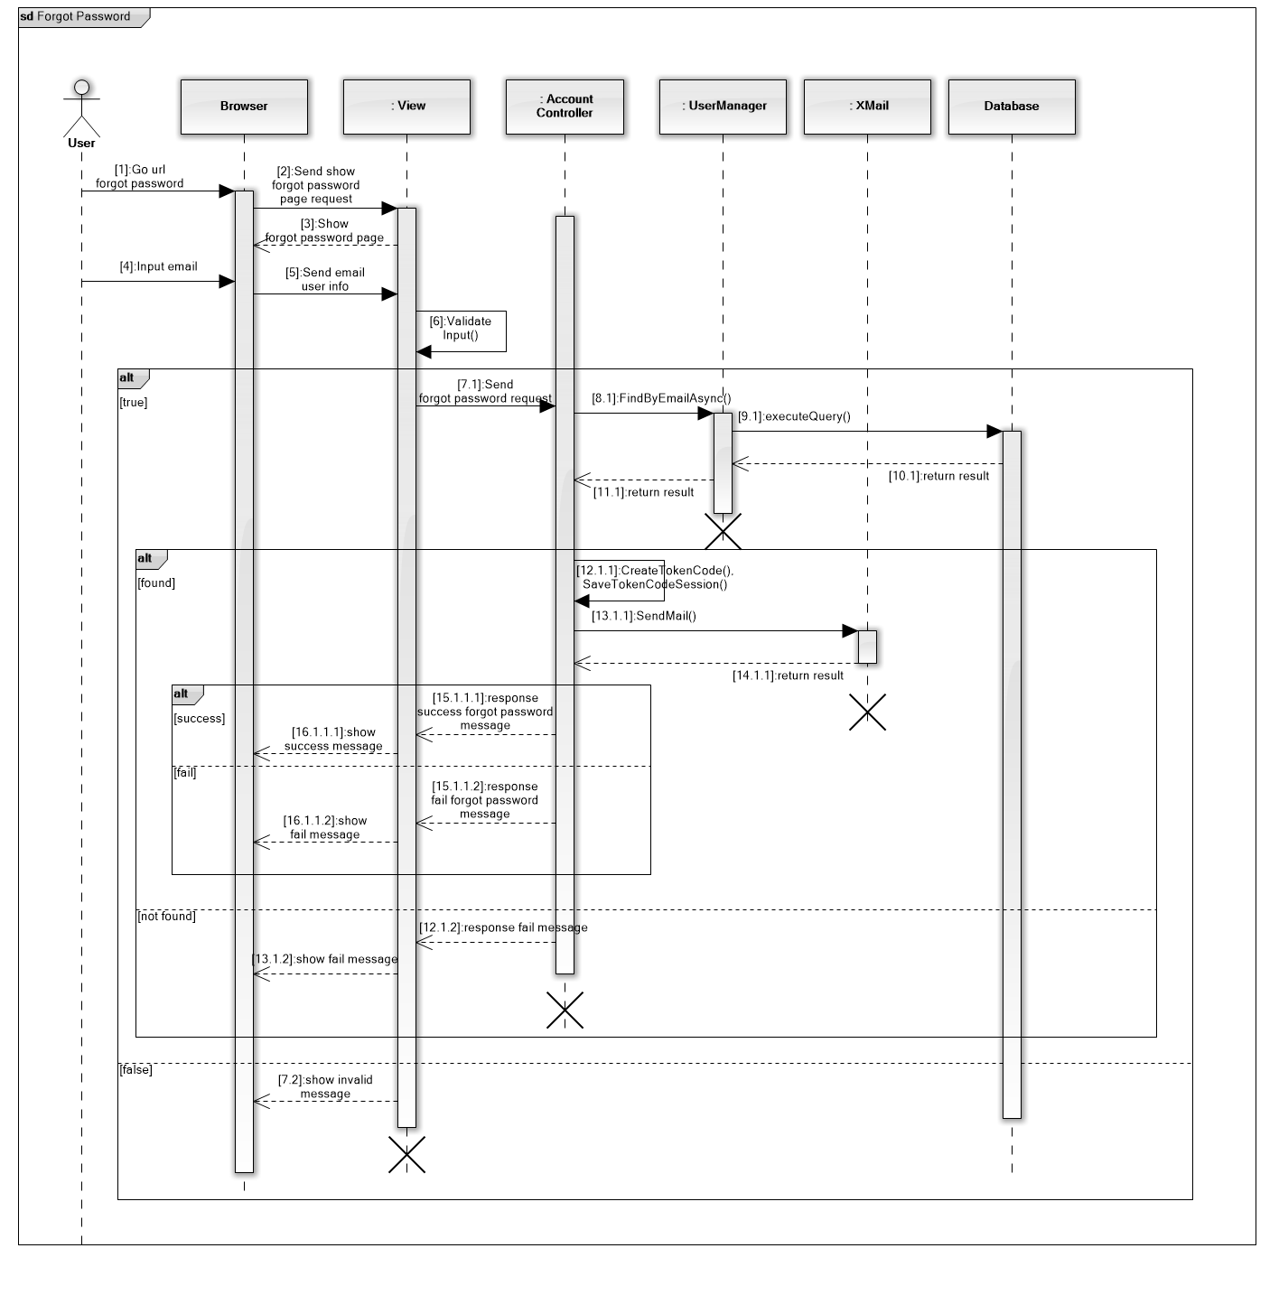

* + - * 1. *Reset password*

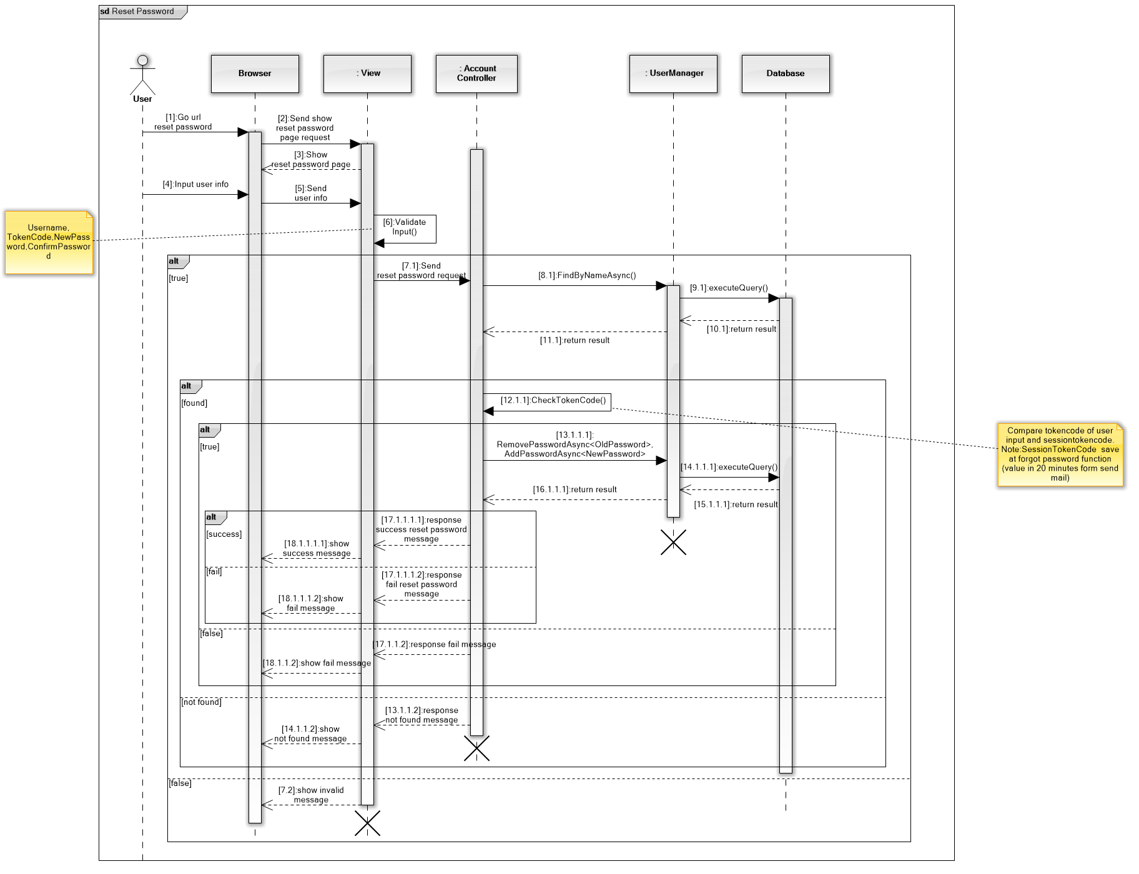

* + - 1. Admin/Staff
         1. *Create data source*

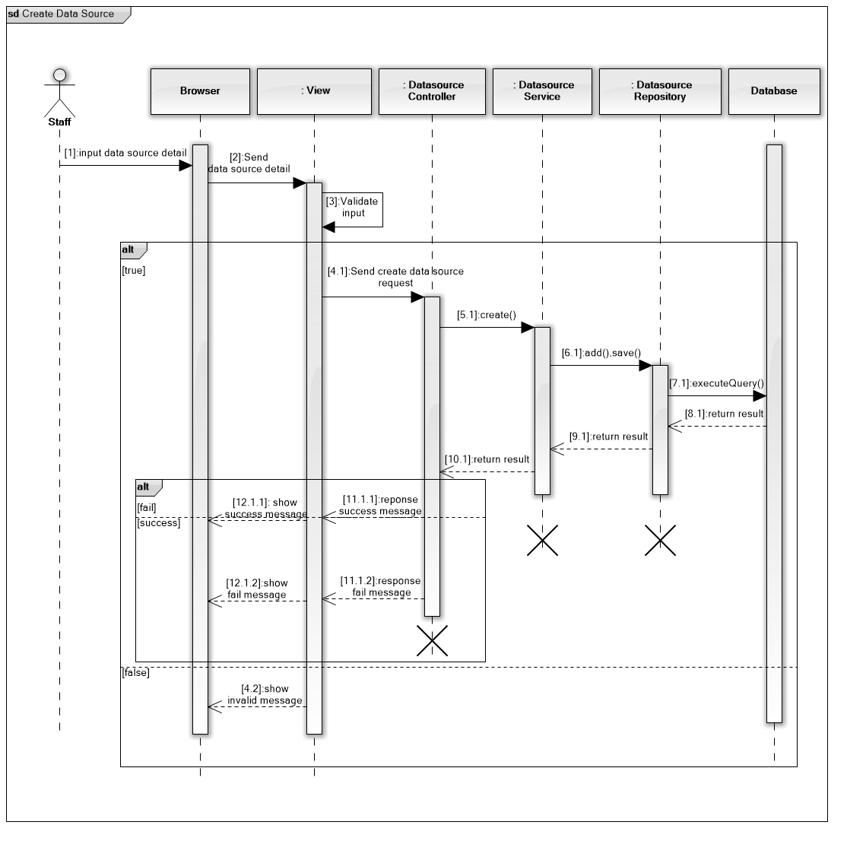

* + - * 1. *Edit data source*

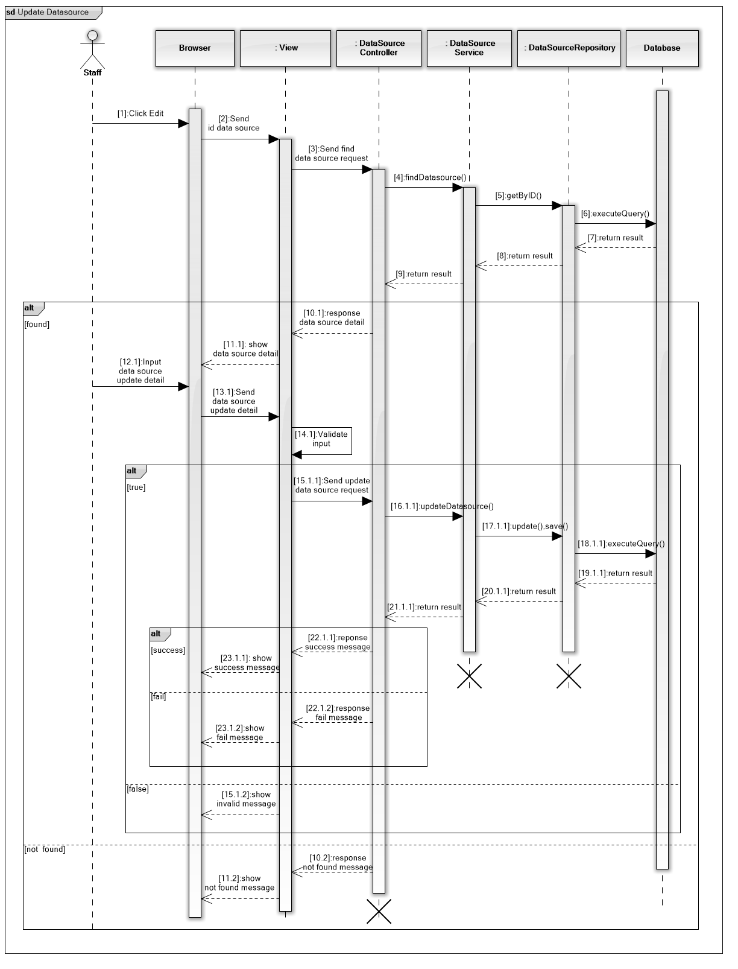

* + - * 1. *Remove data source*

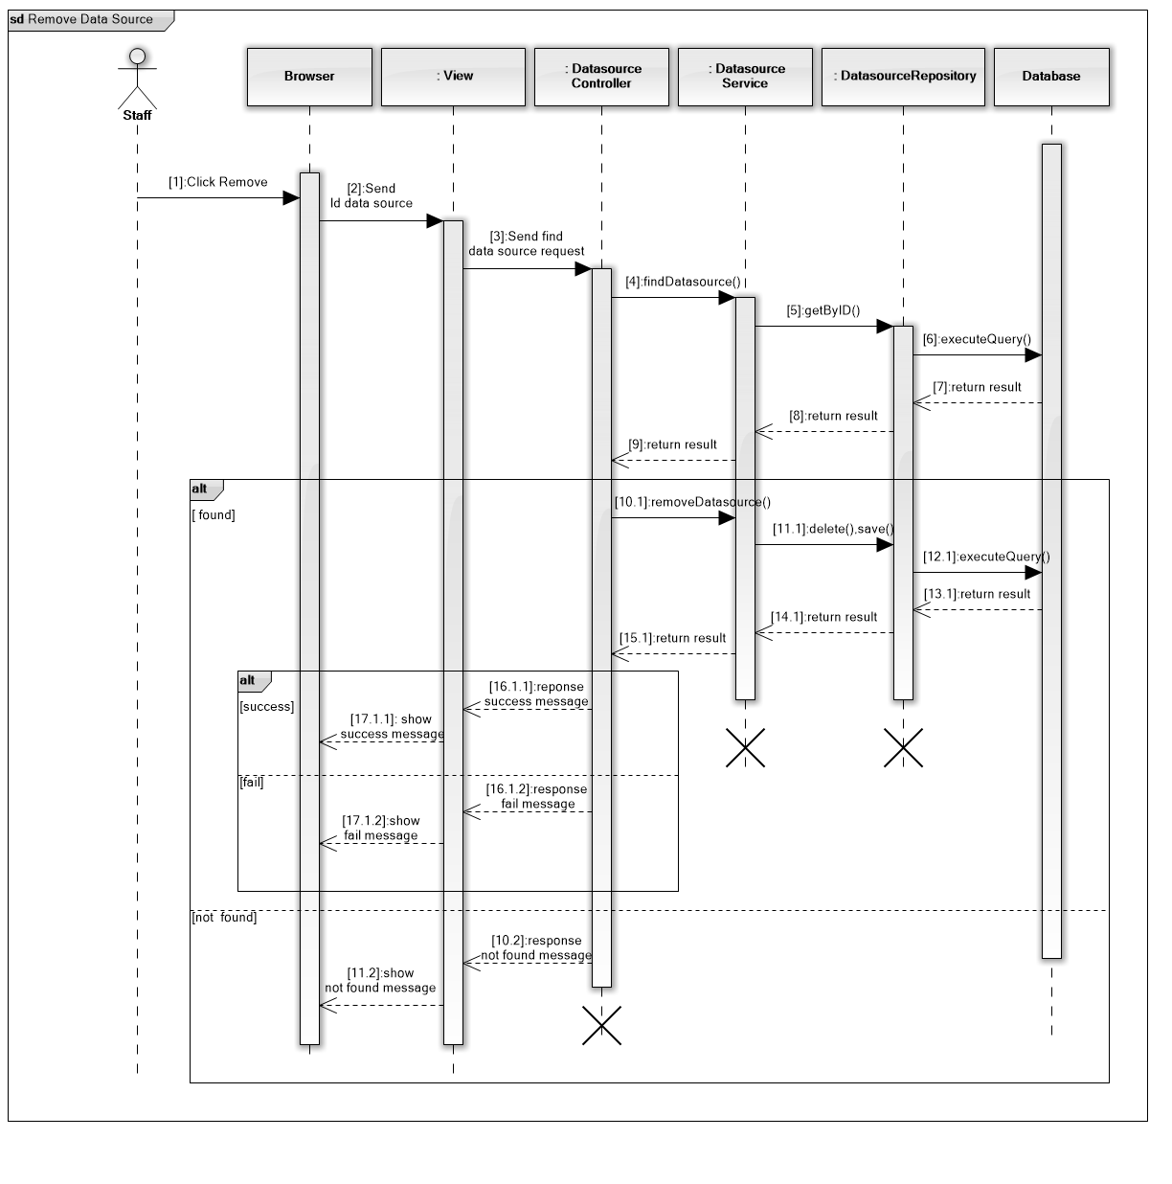

* + - * 1. *Manually start parsing scheduler*

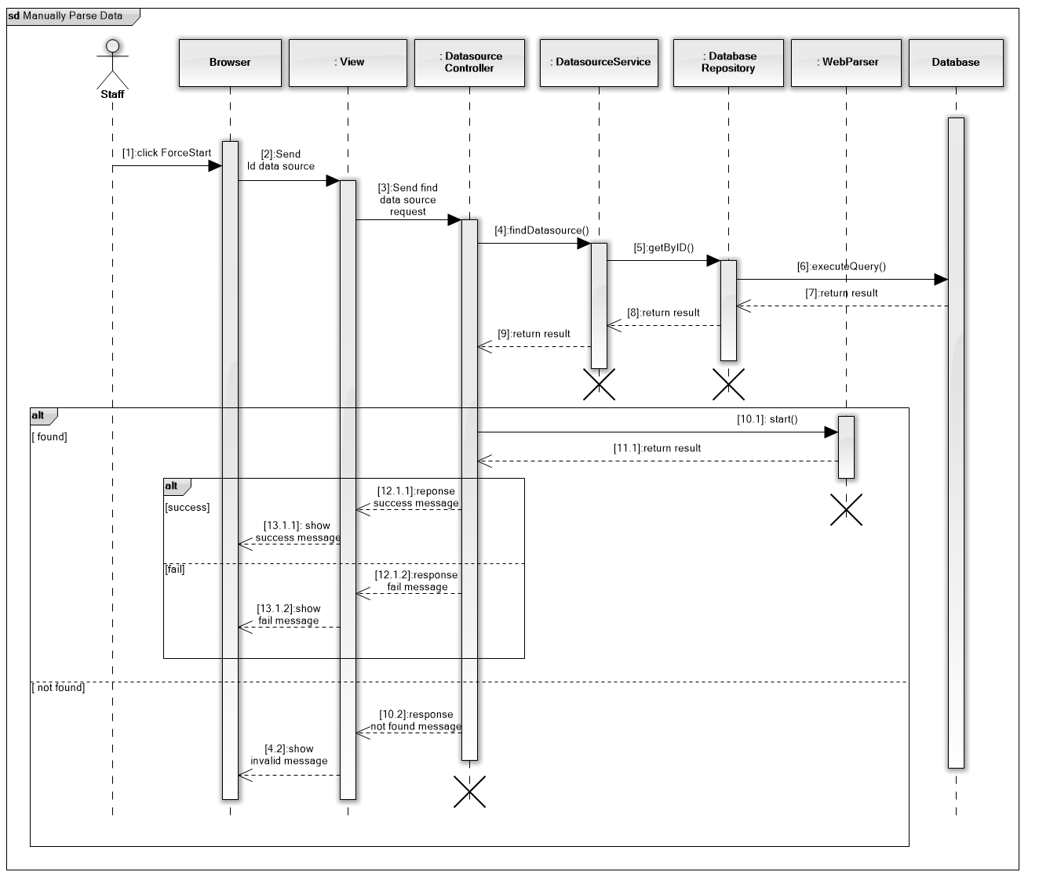

* + - * 1. *Configure parsing*

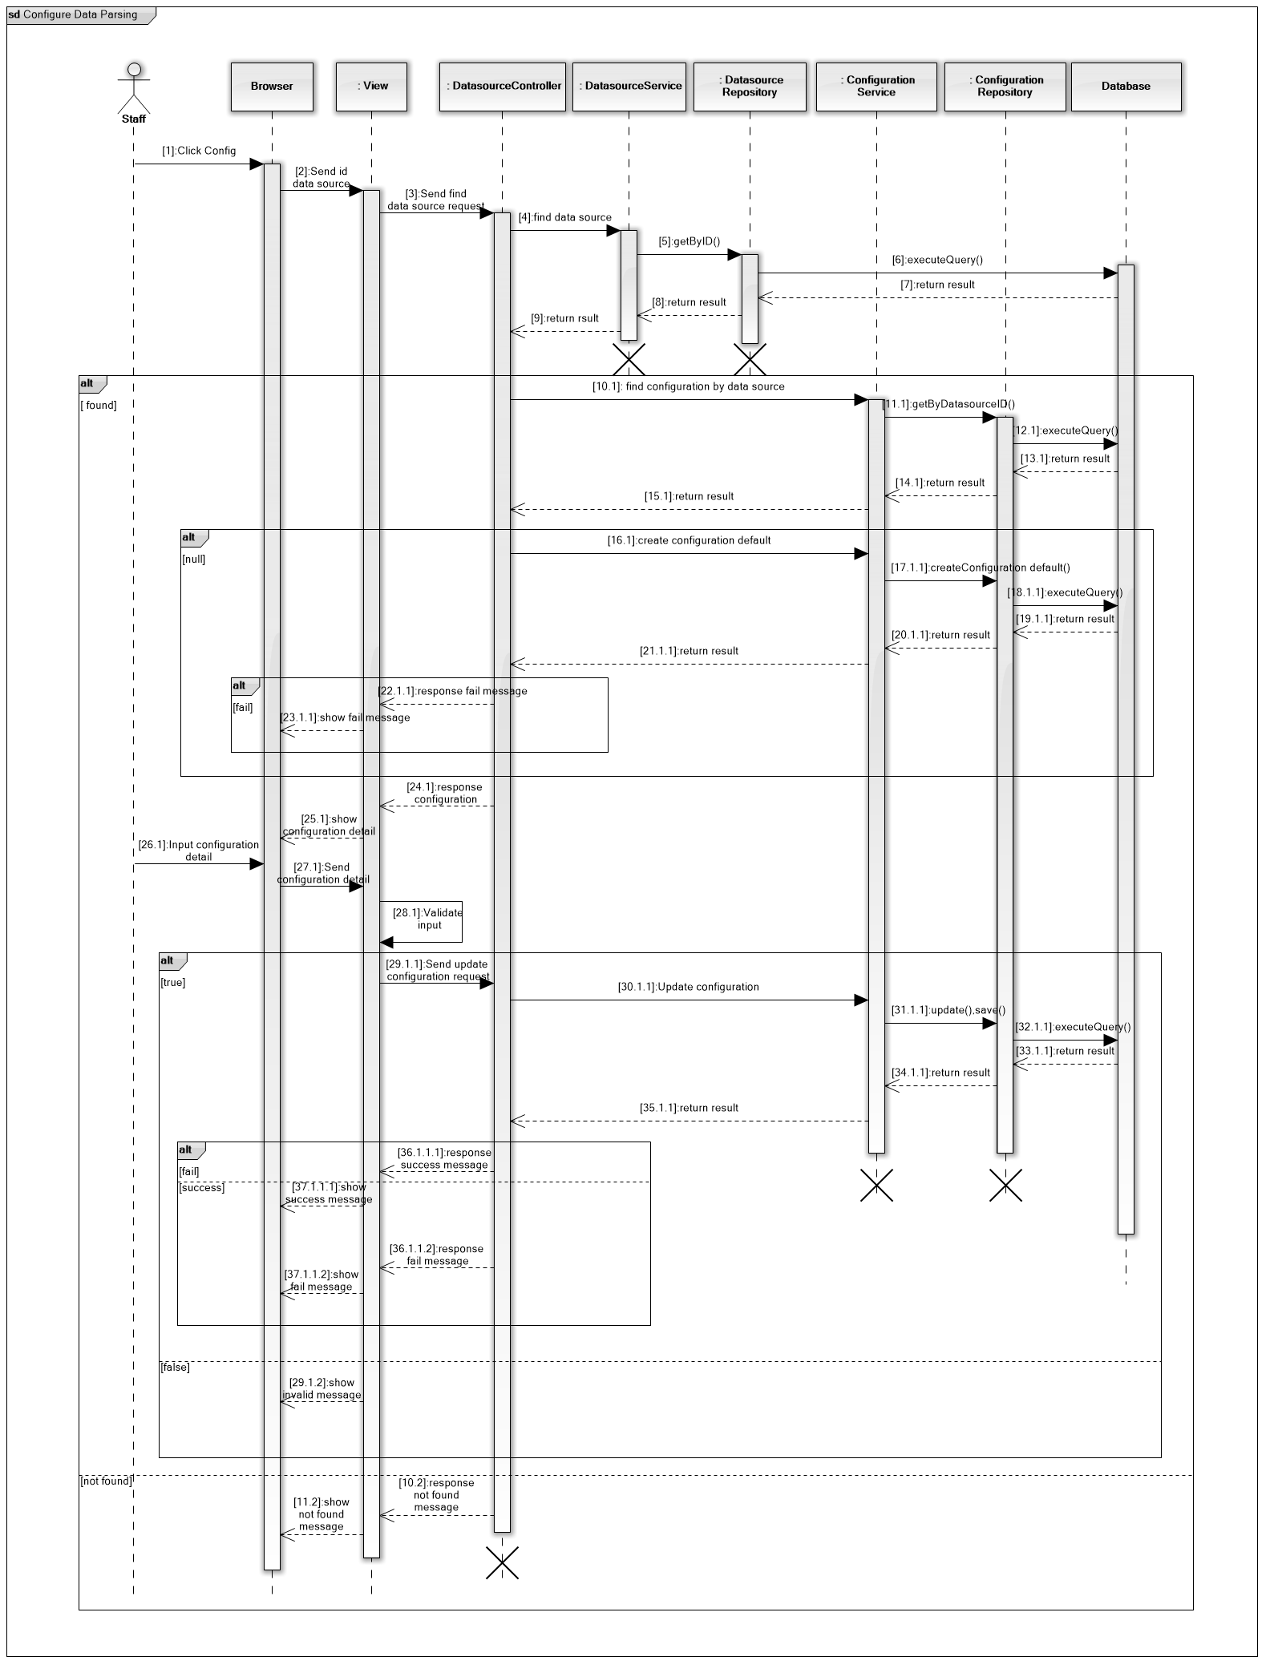

* + - * 1. *Create hotel service*

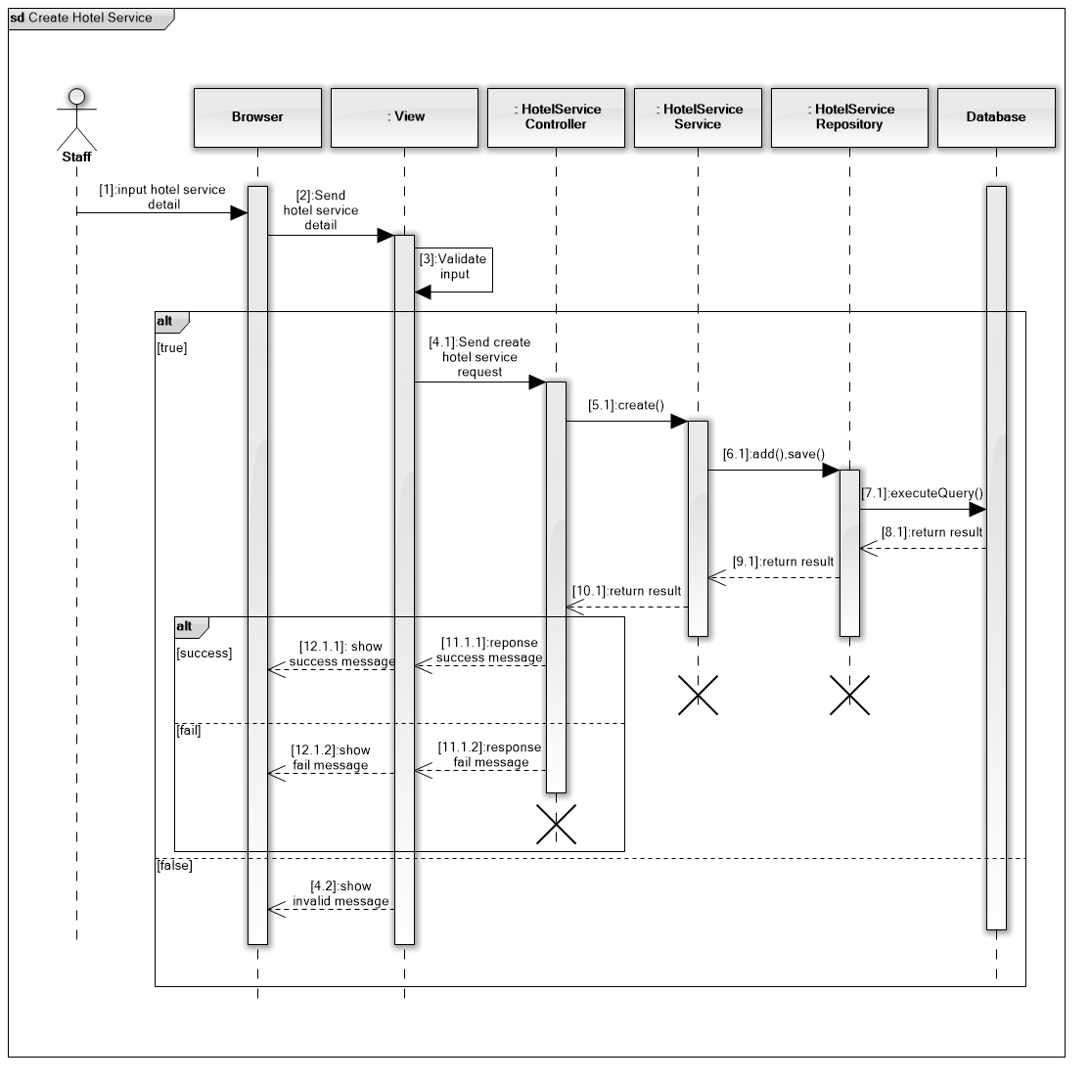

* + - * 1. *Edit hotel service*

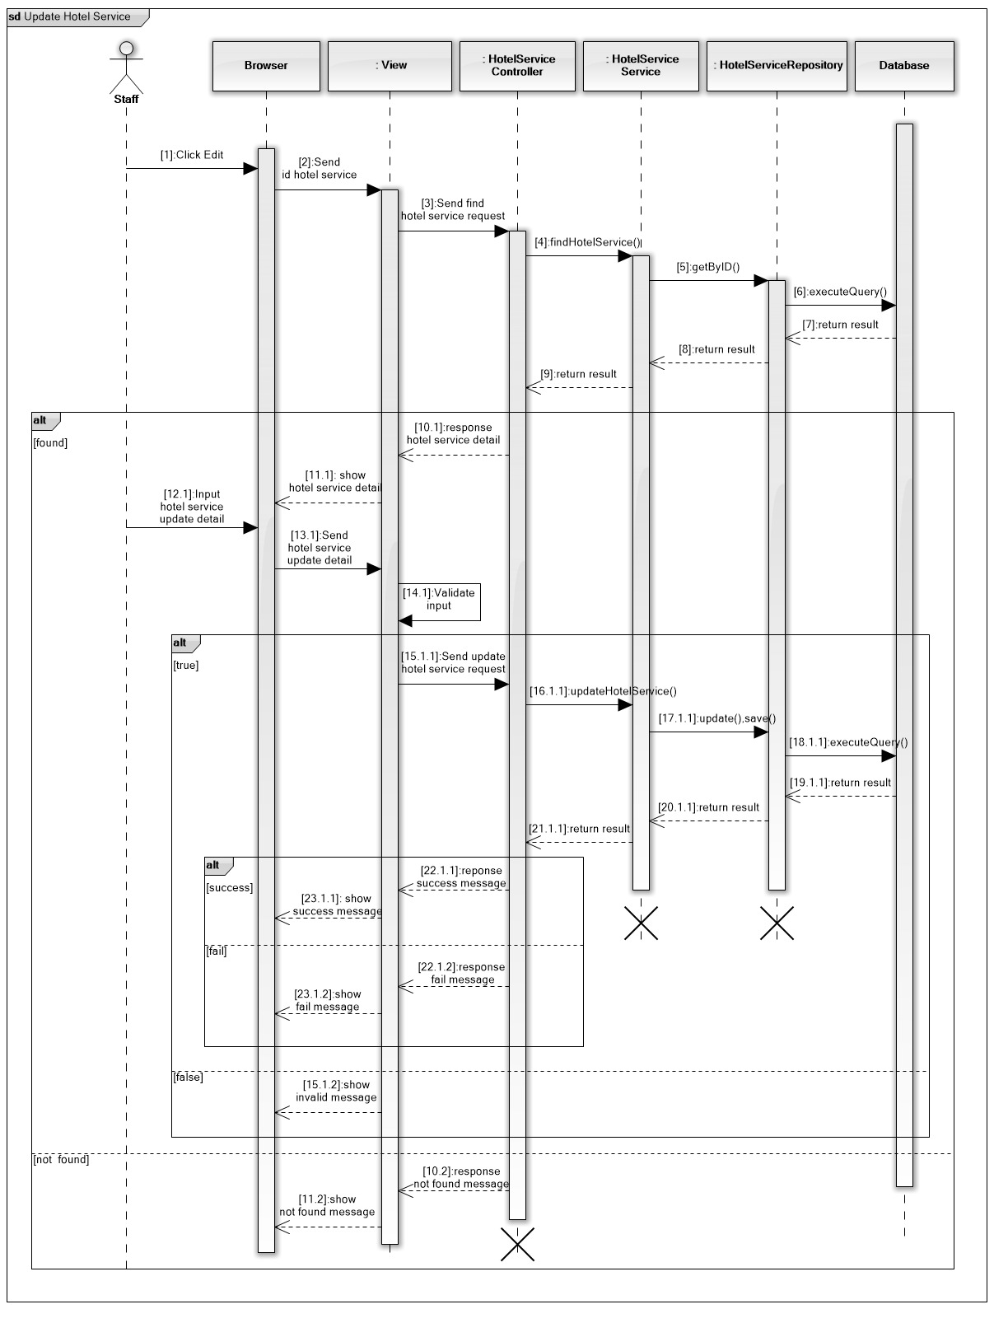

* + - * 1. *Remove hotel service*

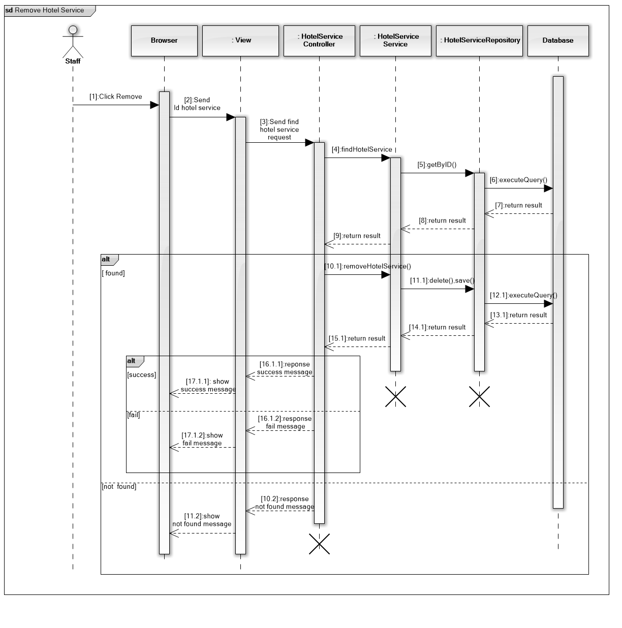

* + - * 1. *Create account*

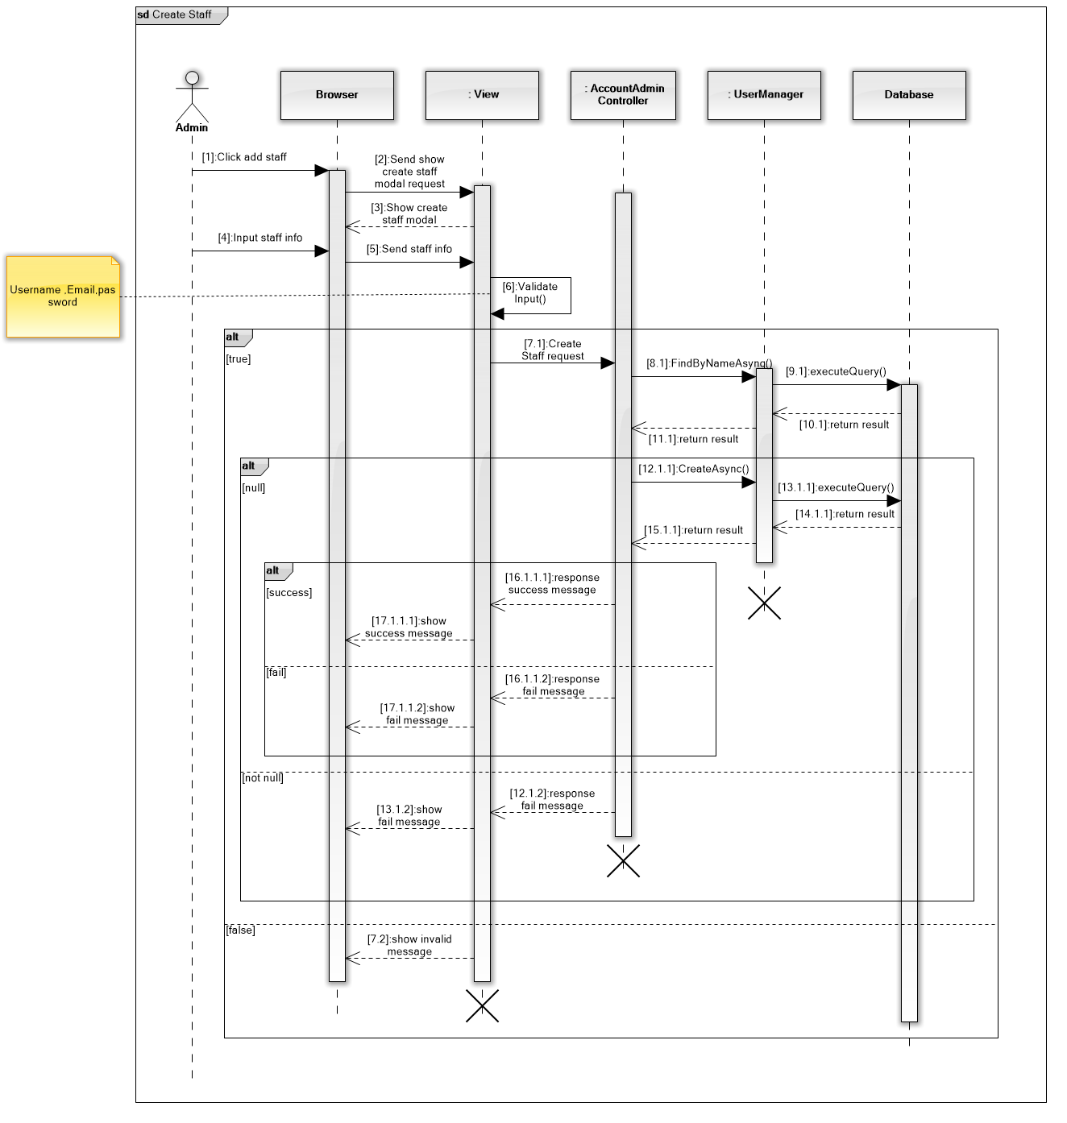

* + - * 1. *Activate/Deactivate account*

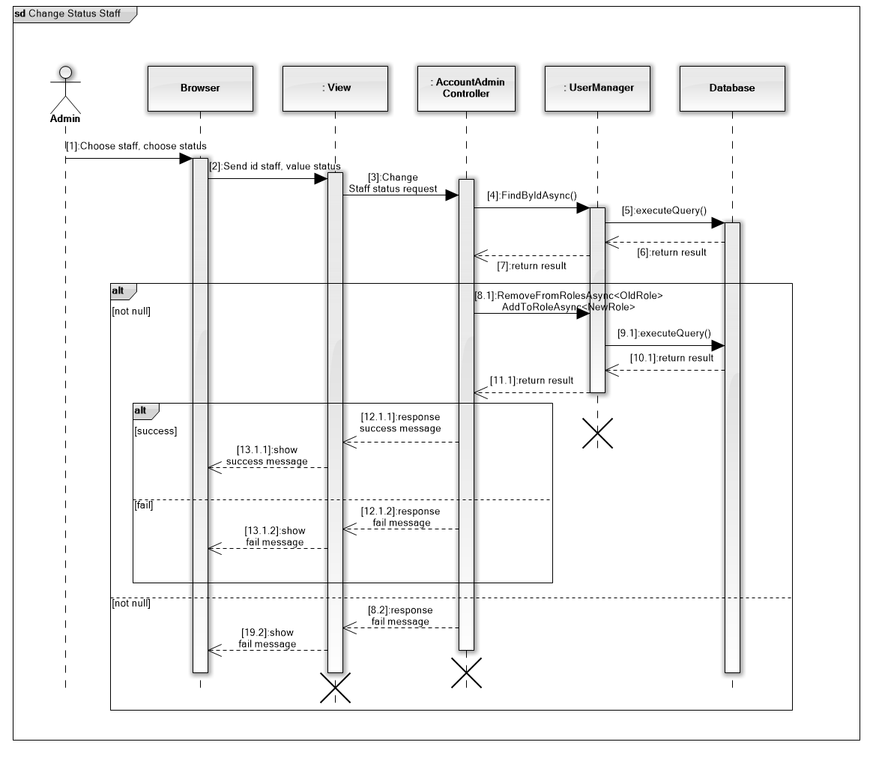

* + - * 1. *Change password*

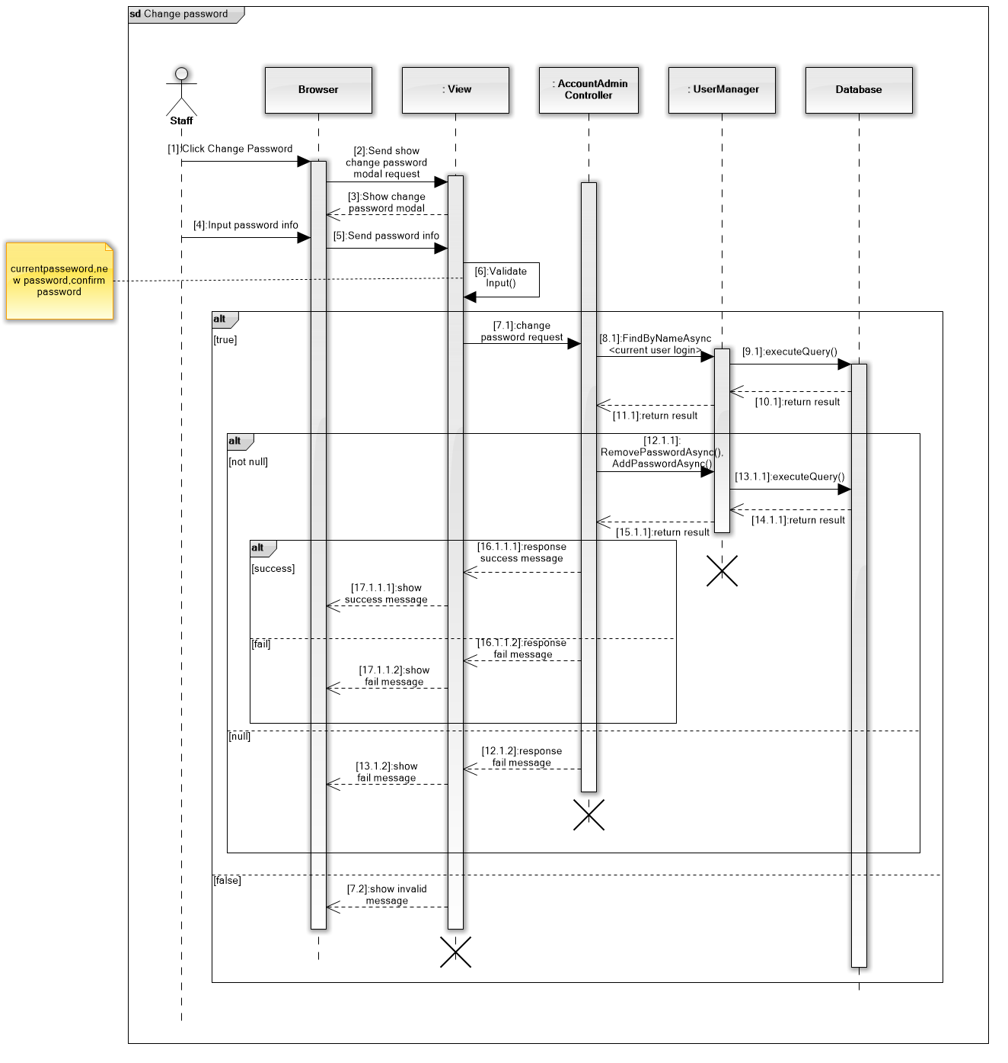

* + - 1. Scheduler
         1. *Parse data*

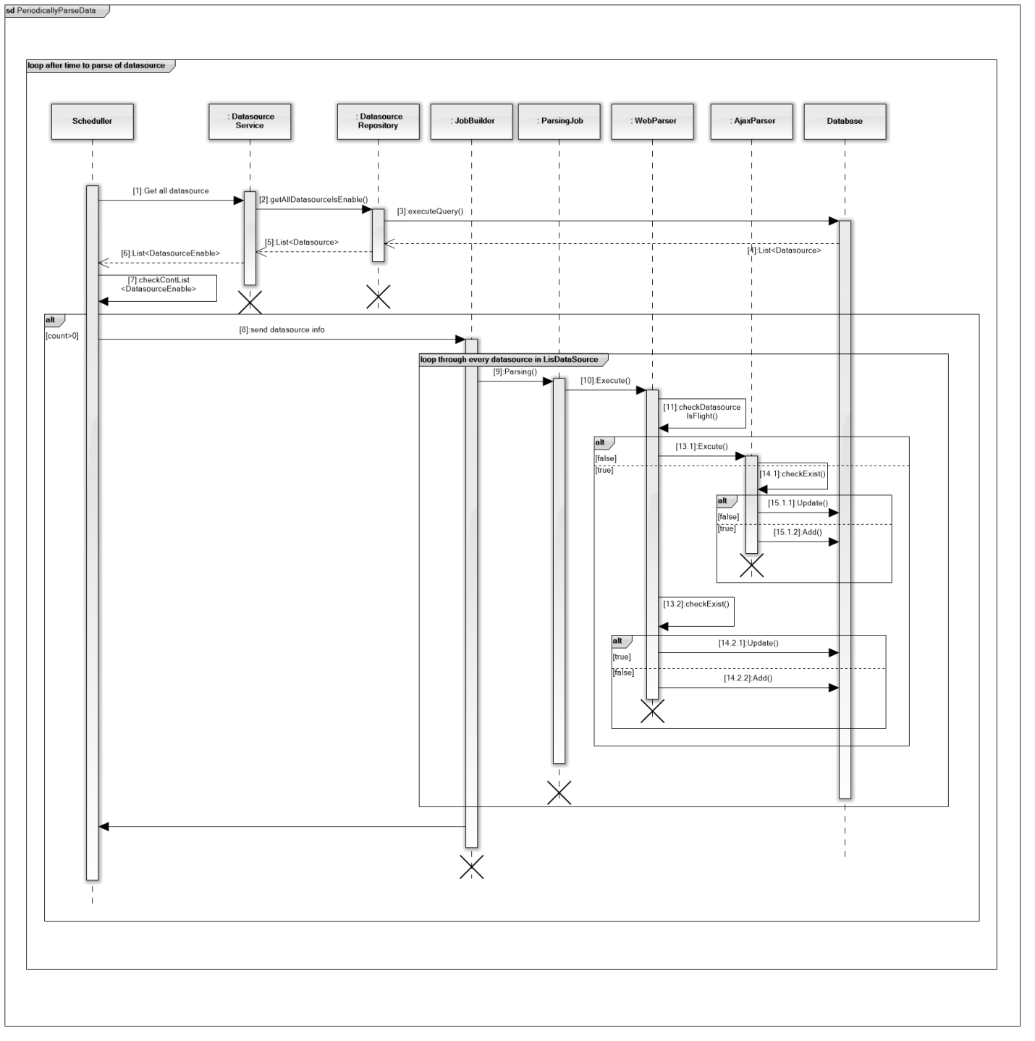

* + - * 1. *Update data to Lucene*

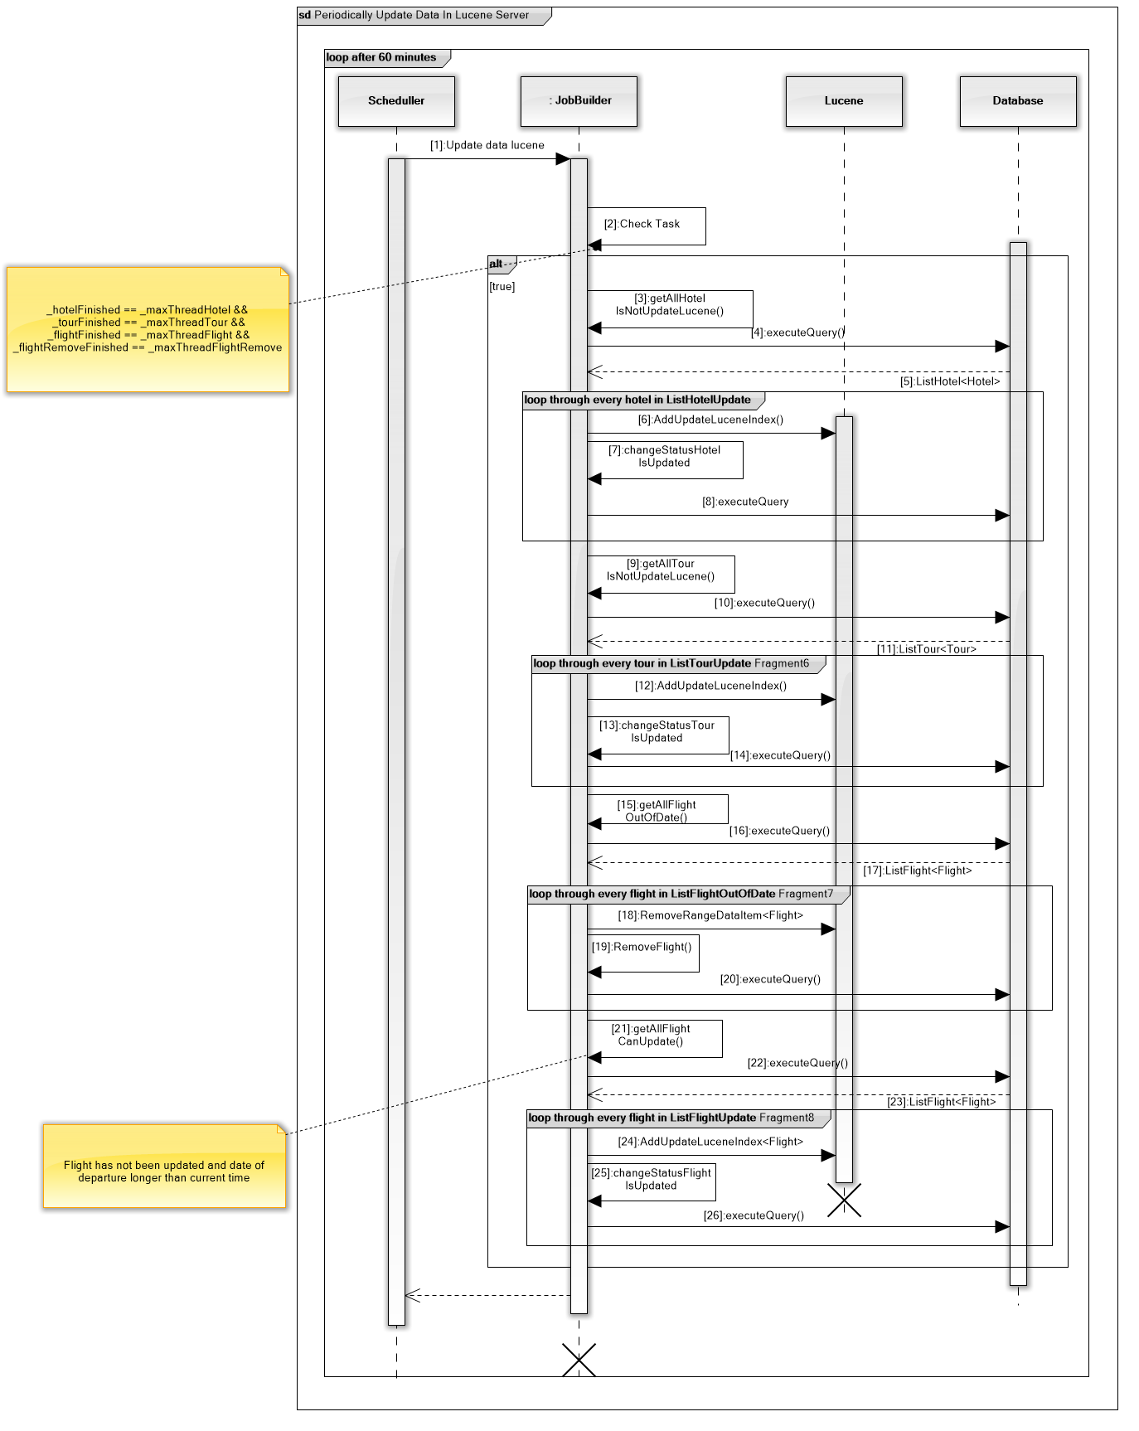

* + - * 1. *Remove redundant keywords*

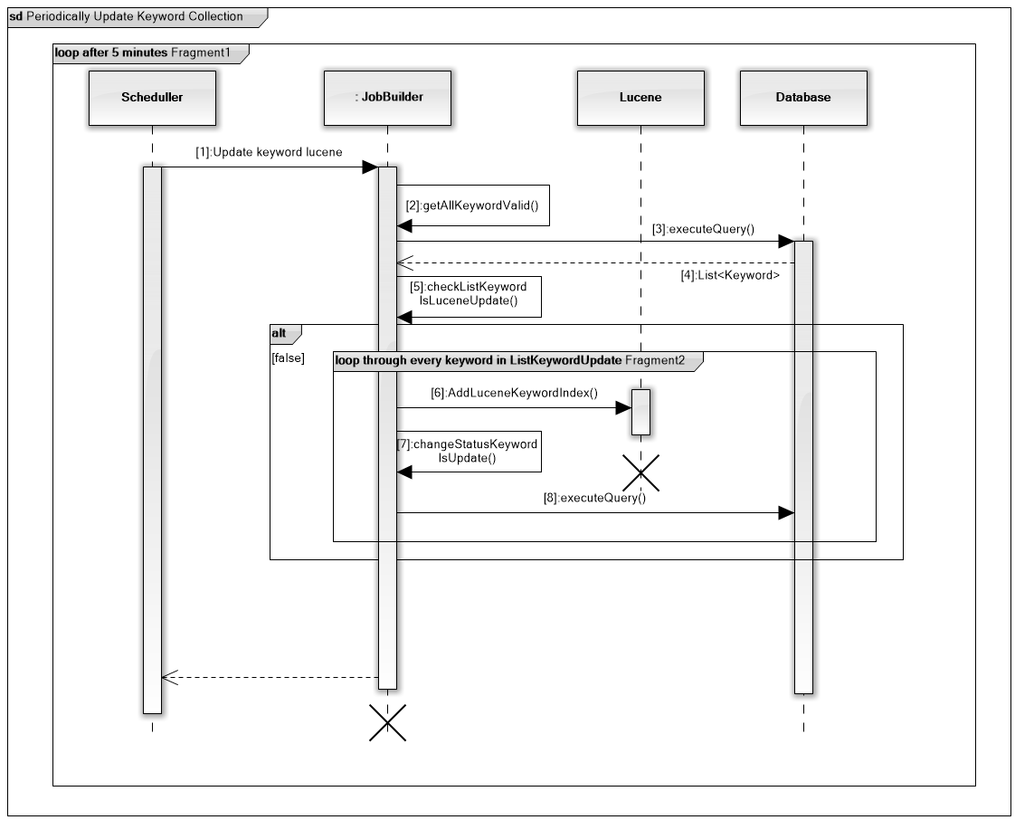

* + - * 1. *Categorize hotel services*

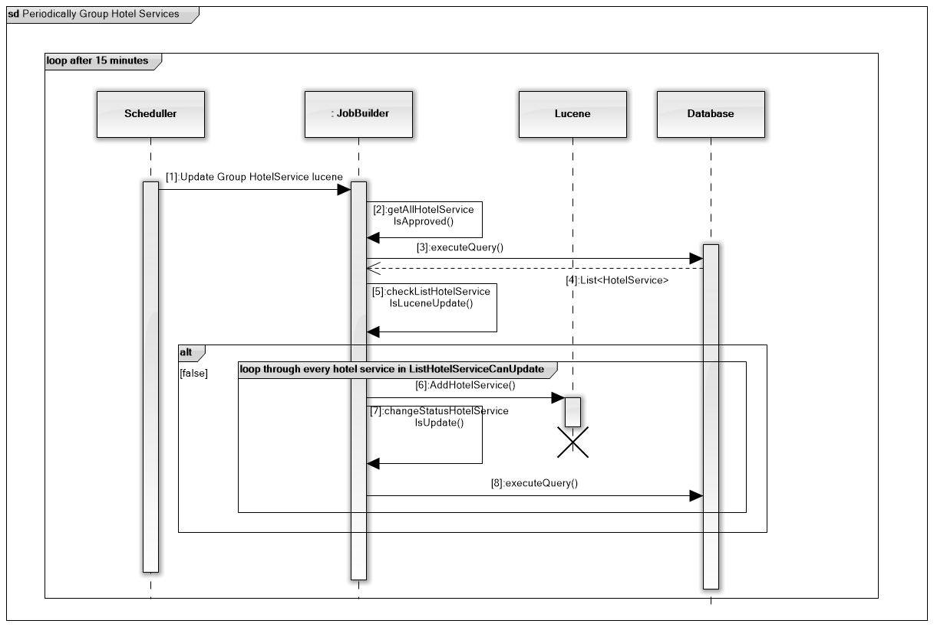

* + - * 1. *Categorize hotel by location*

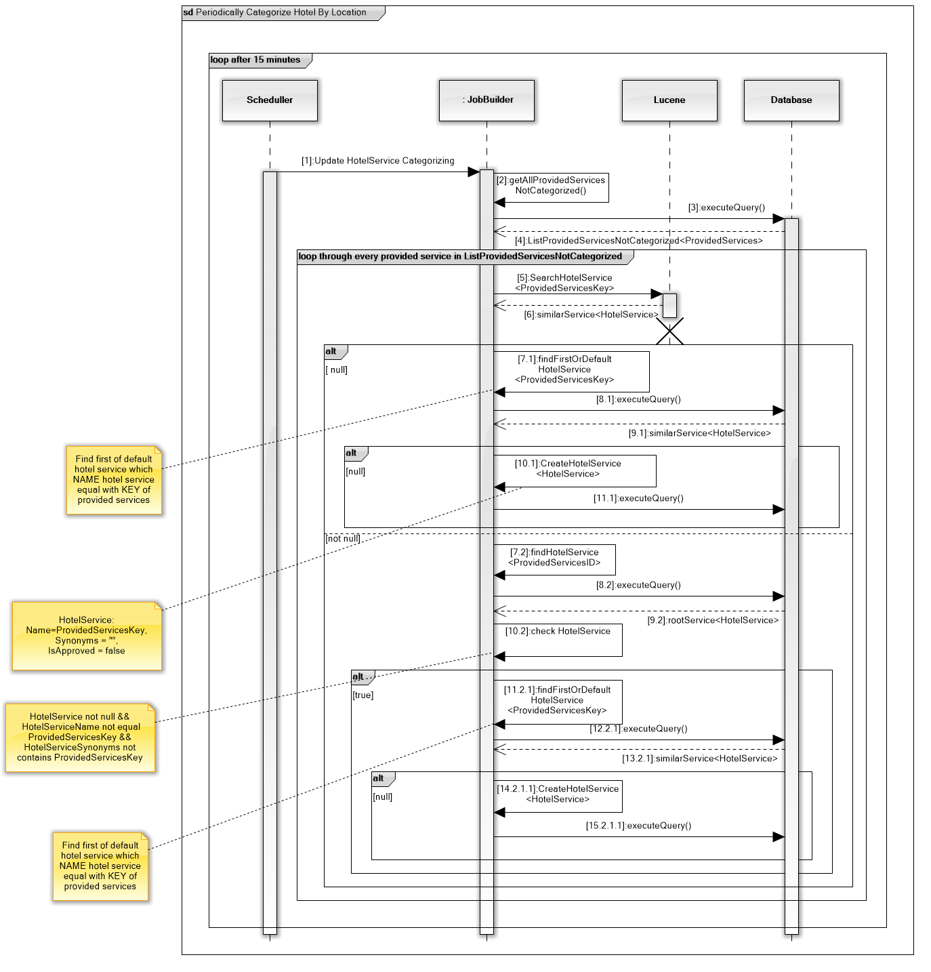

#### *Mobile App*

* + - 1. Search hotels

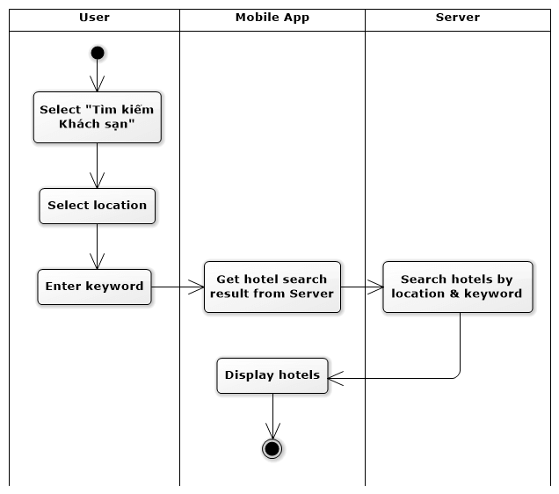

* + - 1. Search tours

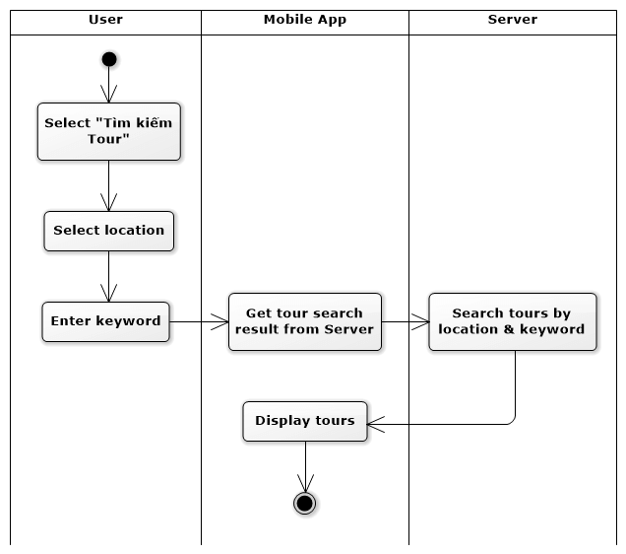

* + - 1. Search flights

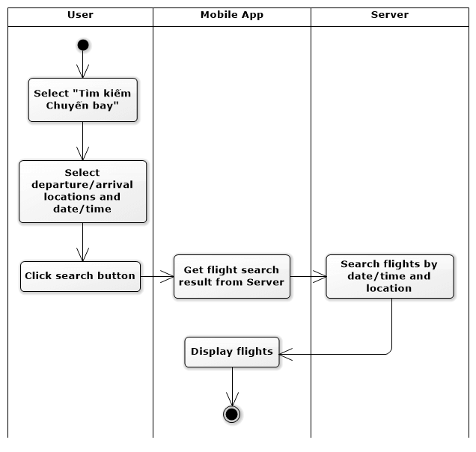

* + - 1. Filter flights

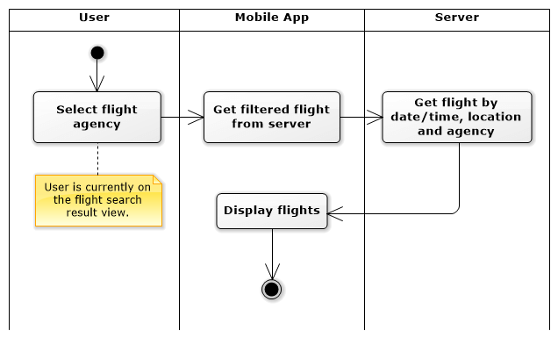

* + - 1. View hotel detail

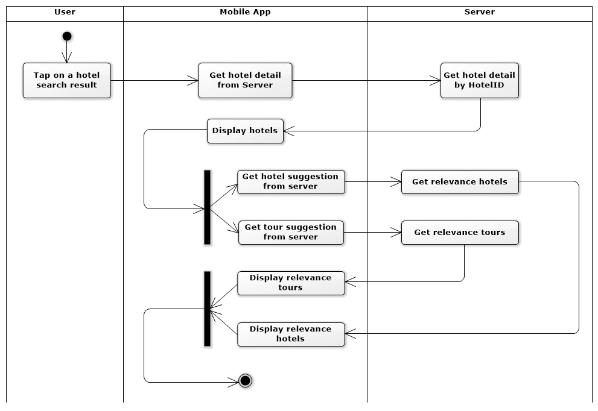

* + - 1. View tour detail

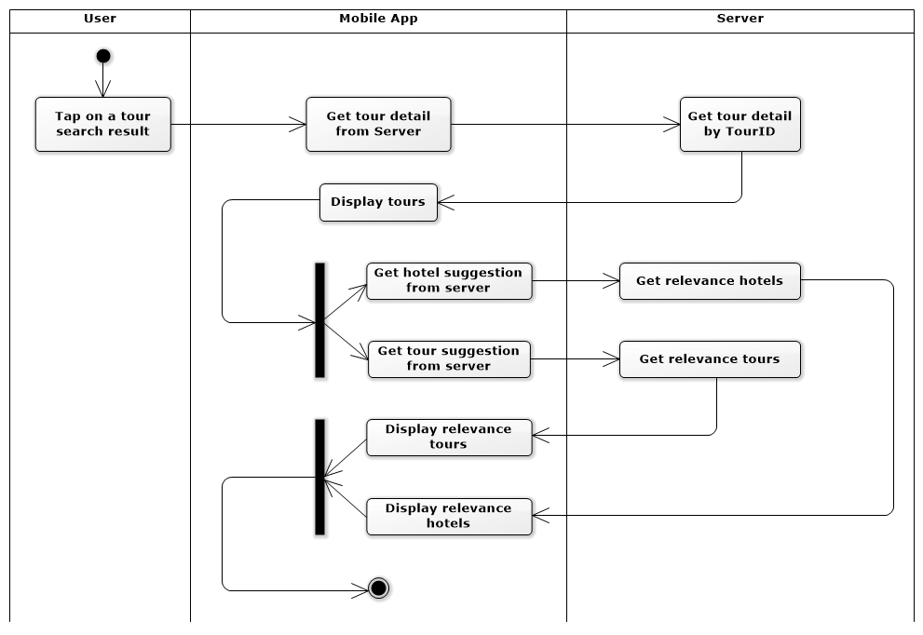

## User Interface Design

### Web app

#### *Search*

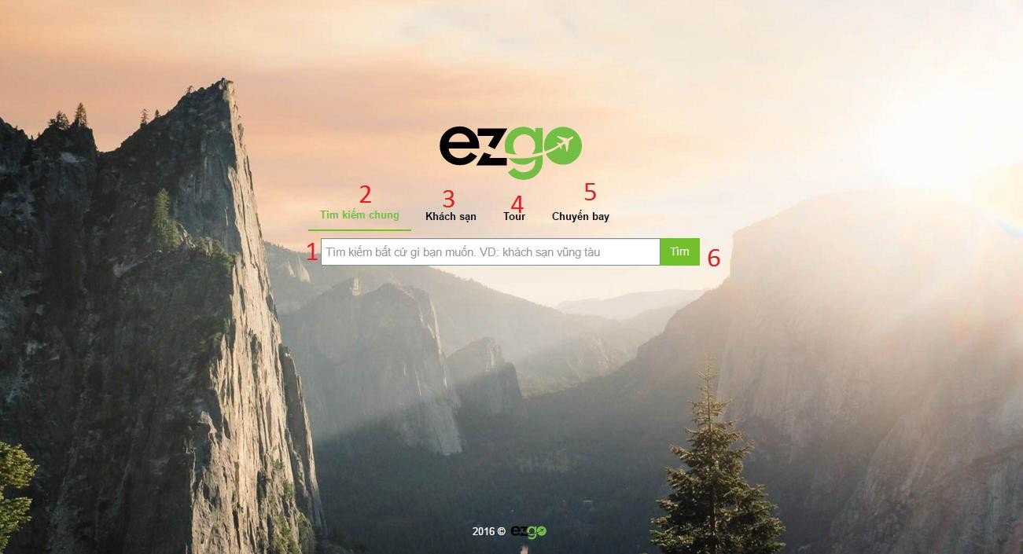

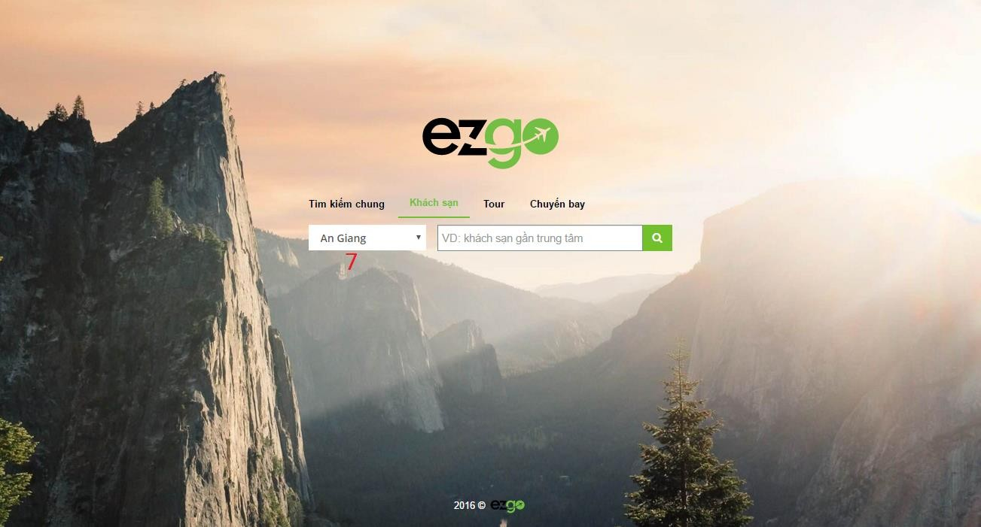

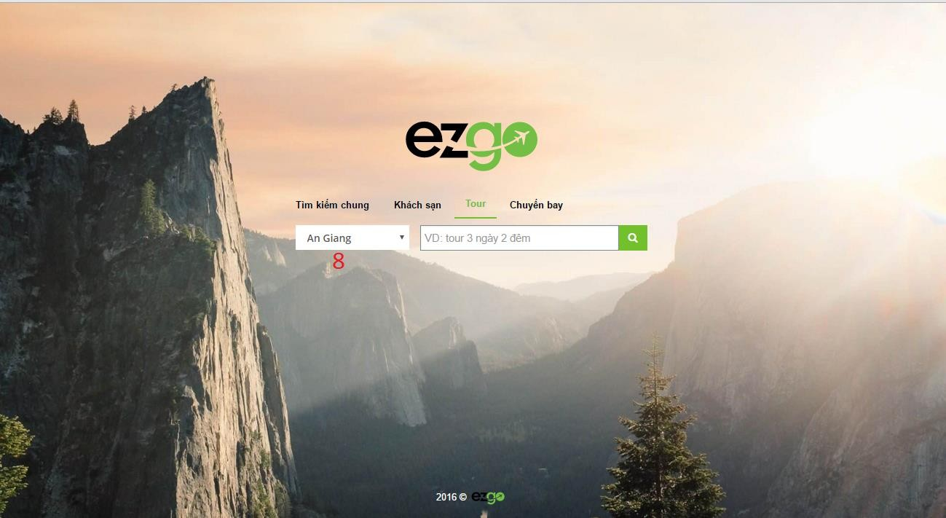

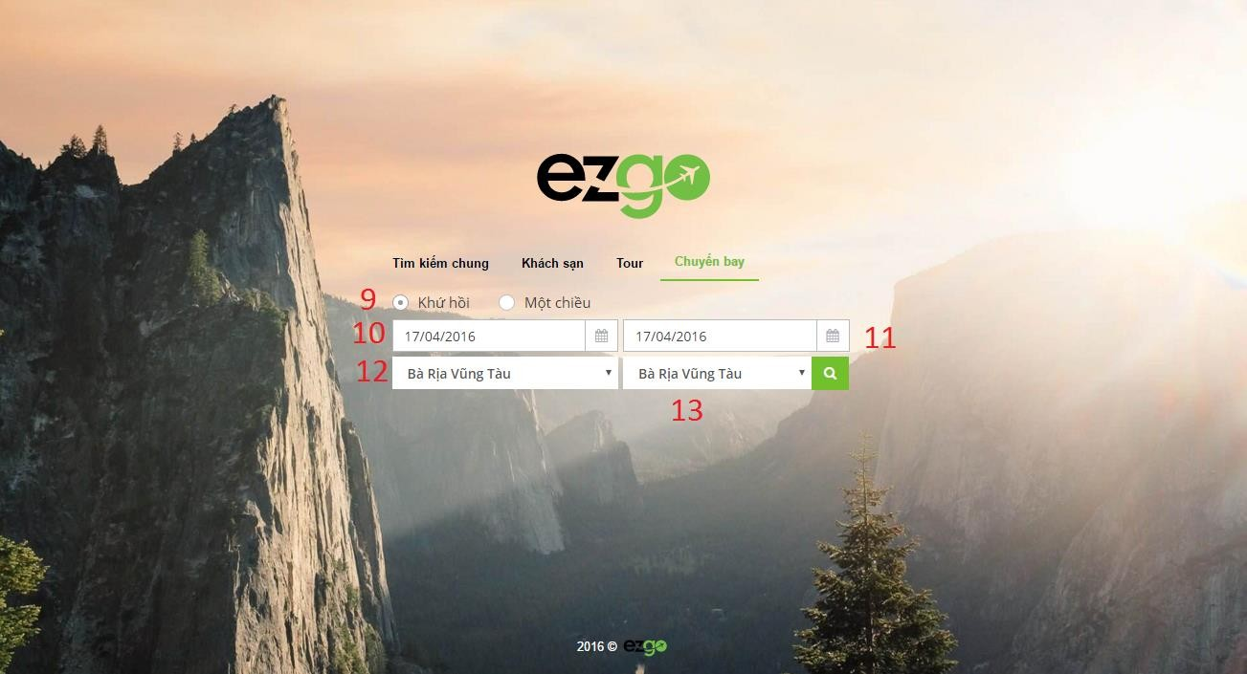

*Figure: Web Application Design - <User>Search*

**Fields**

|  |  |  |  |  |  |  |
| --- | --- | --- | --- | --- | --- | --- |
| **No** | **Field Name** | **Description** | **Read Only** | **Mandator y** | **Control Type** | **Data Type** |
| 1 | Search | Keyword to search | No | Yes | TextBox | String |
| 7 | Location | Location of hotel | No | Yes | Dropdow | Int |

|  |  |  |  |  |  |  |
| --- | --- | --- | --- | --- | --- | --- |
|  |  |  |  |  | n |  |
| 8 | Location | Location of tour | No | Yes | Dropdow n | Int |
| 9 | cbTypeFlight | Type of flight | No | Yes | Combobo x | String |
| 10 | dpStart | Date of start flight | No | Yes | Datetime picker | Date |
| 11 | dpEnd | Date of end flight | No | Yes | Datetime picker | Date |
| 12 | LocationStart | Location of start flight | No | Yes | Dropdow n | Int |
| 13 | LocationEnd | Location of end flight | No | Yes | Dropdow n | Int |

**Buttons/Hyperlinks**

|  |  |  |  |  |
| --- | --- | --- | --- | --- |
| **No** | **Function** | **Description** | **Validation** | **Outcome** |
| 2 | linkSearchGeneral | Show tab search general | N/A | Show tab search general |
| 3 | linkSearchHotel | Show tab search hotel | N/A | Show tab search hotel |
| 4 | linkSearchTour | Show tab search tour | N/A | Show tab search tour |
| 5 | linkSearchFlight | Show tab search flight | N/A | Show tab search flight |
| 6 | btnSearch | Send search command | Validate all required fields before submit. | Submit search. |

#### *Search result*

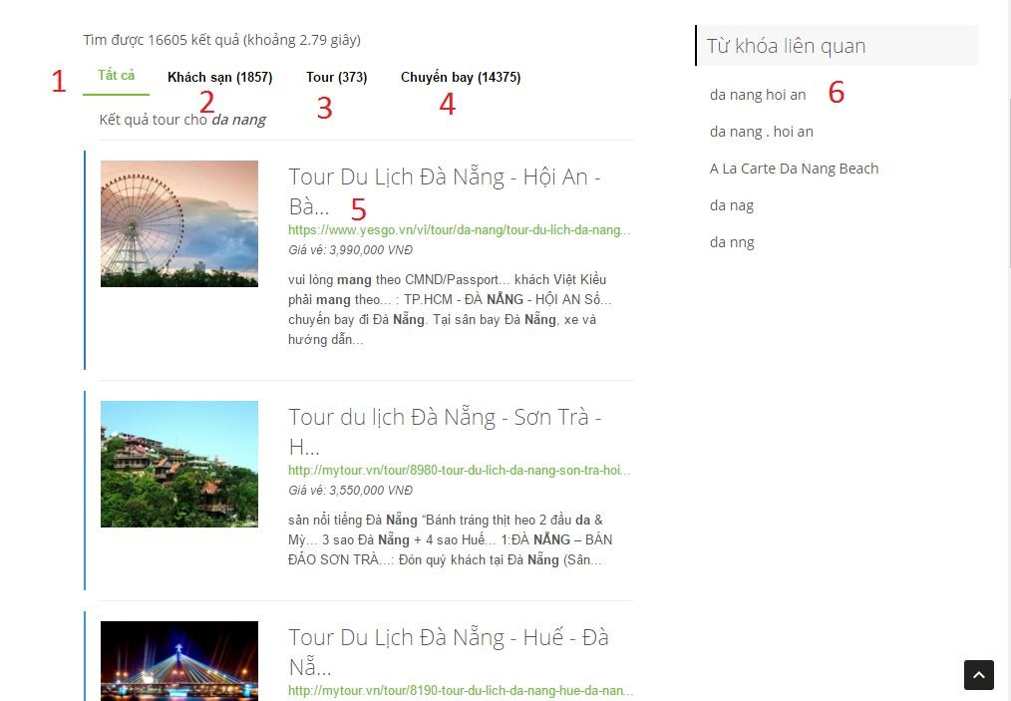

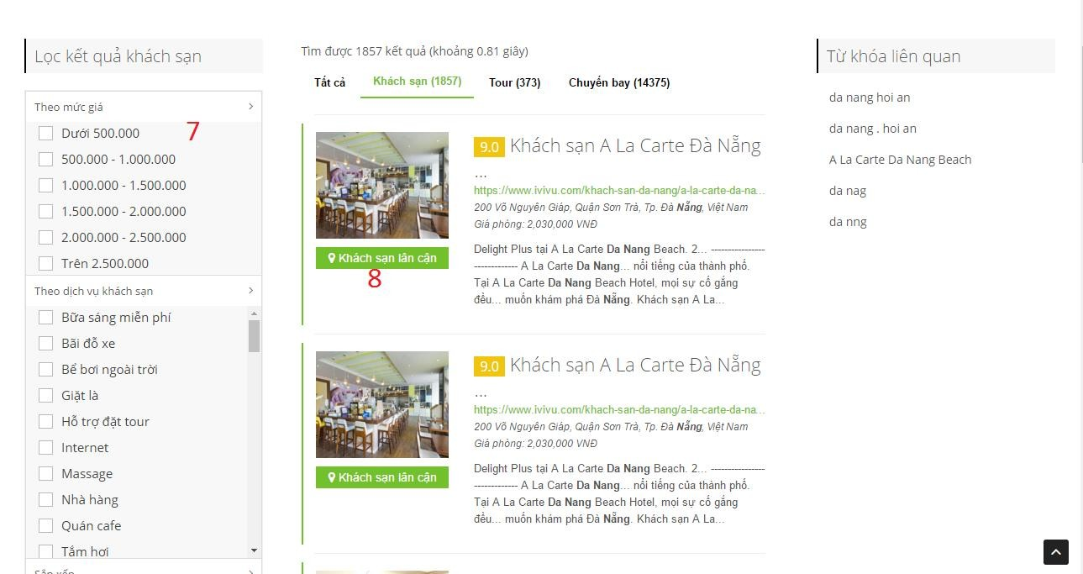

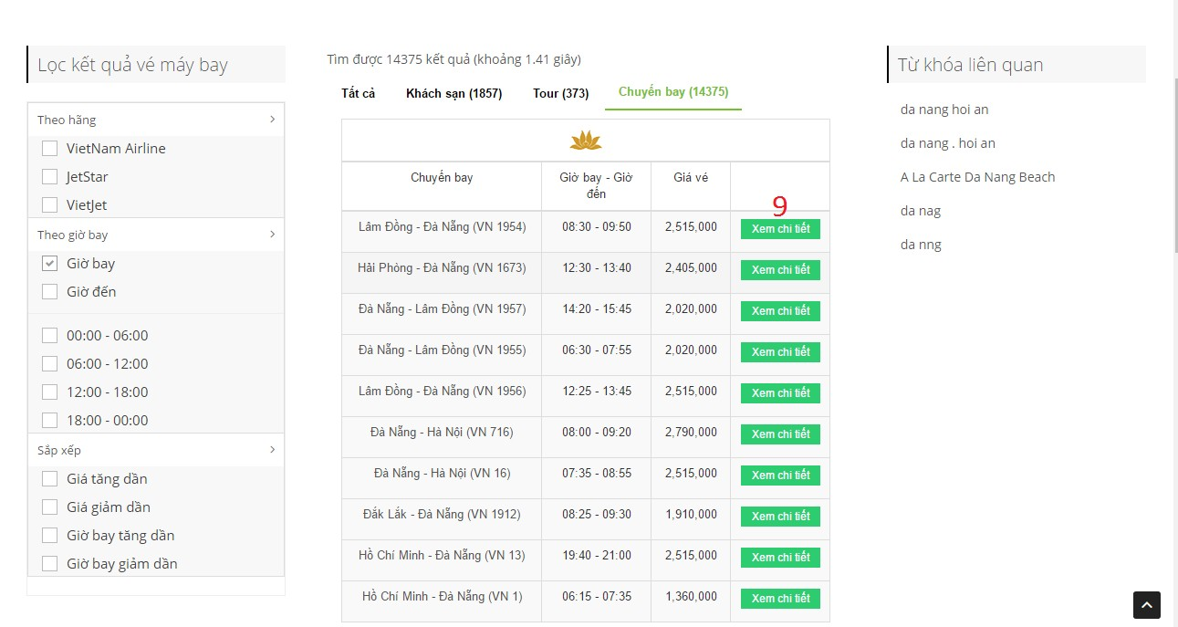

**Fields**

|  |  |  |  |  |  |  |
| --- | --- | --- | --- | --- | --- | --- |
| **No** | **Field Name** | **Description** | **Read Only** | **Mandator y** | **Control Type** | **Data Type** |
| 7 | Filter | Filter of search result | No | No | Checkbox | N/A |

**Buttons/Hyperlinks**

|  |  |  |  |  |
| --- | --- | --- | --- | --- |
| **No** | **Function** | **Description** | **Validation** | **Outcome** |
| 1 | linkSearchGeneral | Show tab search general | N/A | Show tab search general |
| 2 | linkSearchHotel | Show tab search hotel | N/A | Show tab search hotel |
| 3 | linkSearchTour | Show tab search tour | N/A | Show tab search tour |
| 4 | linkSearchFlight | Show tab search flight | N/A | Show tab search flight |
| 5 | linkDetail | Open result detail | N/A | Open result detail page. |
| 6 | linkKeywordRelationship | Search with | N/A | Submit search. |

|  |  |  |  |  |
| --- | --- | --- | --- | --- |
|  |  | word have realationship with keyword |  |  |
| 8 | linkHotelsNear | Detail hotel near. | N/A | Submit detail. |
| 9 | btnShowDetail | Show detail of flight | N/A | Show detail flight. |

#### *Search detail*

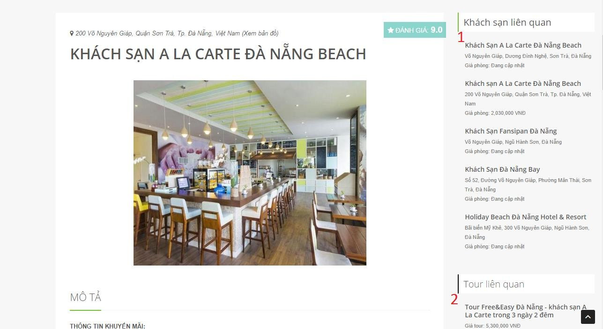

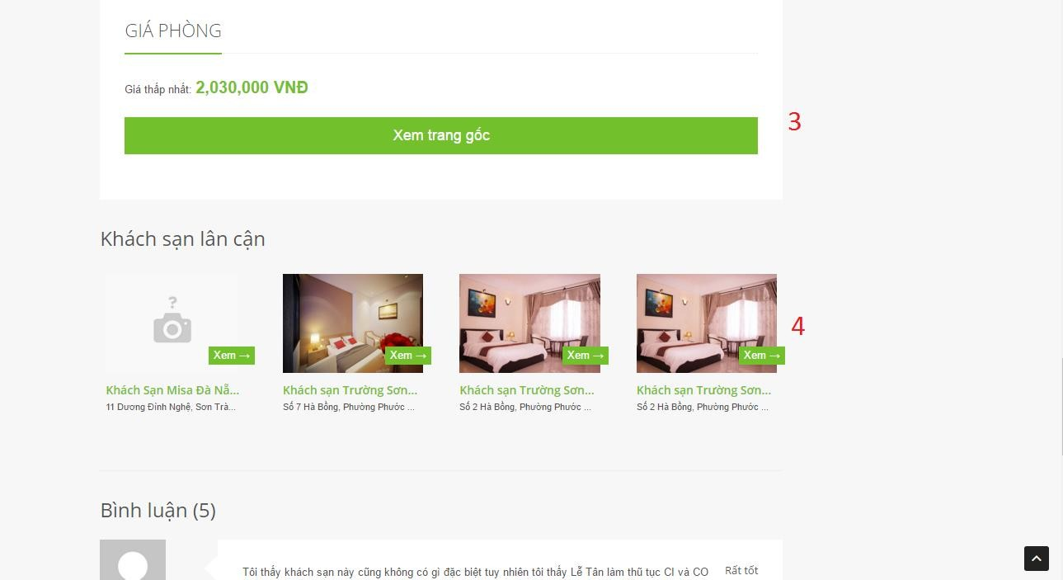

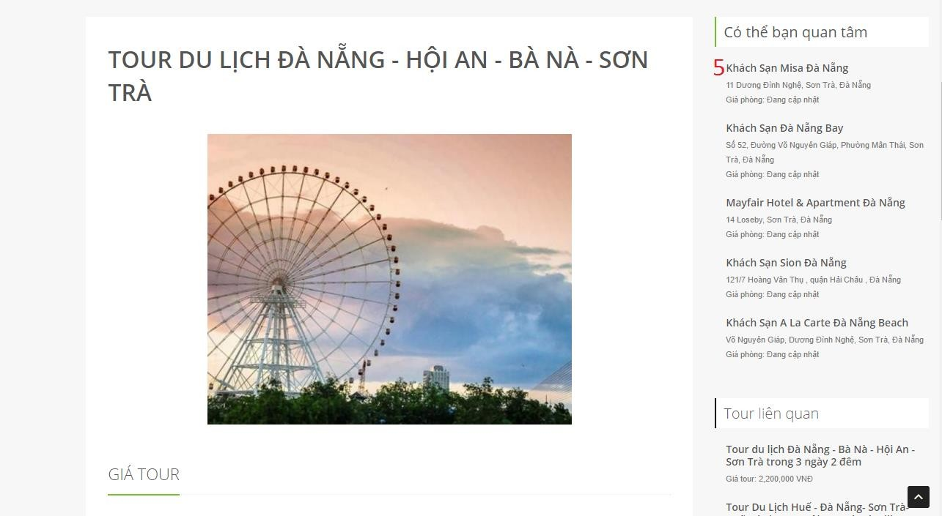

**Buttons/Hyperlinks**

|  |  |  |  |  |
| --- | --- | --- | --- | --- |
| **No** | **Function** | **Description** | **Validation** | **Outcome** |
| 1 | linkHotelRelationship | Detail hotel ralationship | N/A | Detail hotel ralationship |
| 2 | linkTourRelationship | Detail tour ralationship | N/A | Detail tour ralationship |
| 3 | linkHomePage | Redirect to home page of detail | N/A | Redirect to home page of detail |
| 4 | linkHotelsNear | Detail hotel near. | N/A | Submit detail. |
| 5 | linkSuggest | Detail result maybe user care | N/A | Submit detail |

#### *Manage datasources*

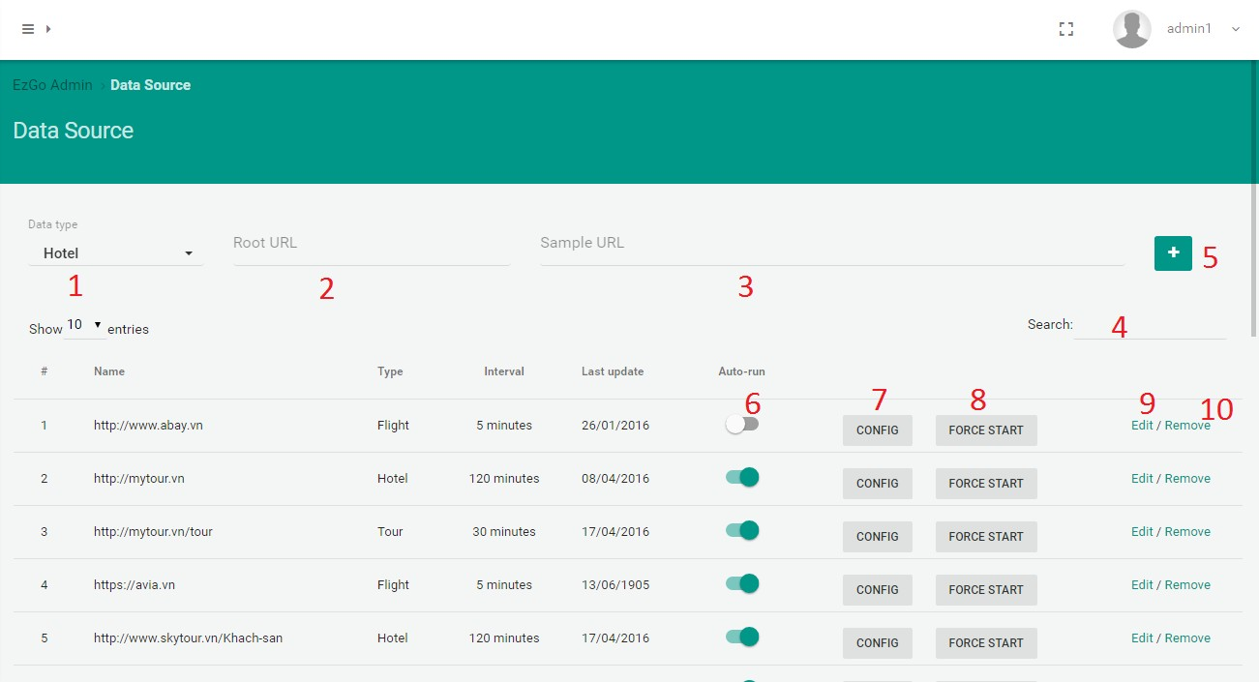

**Fields**

|  |  |  |  |  |  |  |
| --- | --- | --- | --- | --- | --- | --- |
| **No** | **Field Name** | **Description** | **Read Only** | **Mandator y** | **Control Type** | **Data Type** |
| 1 | Data type | Type of datasource | No | Yes | Dropdow n | Int |
| 2 | Root URL | URL of datasource | No | Yes | TextBox | String |
| 3 | Sample URL | Sample URL of datasource | No | Yes | TextBox | String |
| 4 | Search datasource | Search datasource | No | No | TextBox | String |

**Buttons/Hyperlinks**

|  |  |  |  |  |
| --- | --- | --- | --- | --- |
| **No** | **Function** | **Description** | **Validation** | **Outcome** |
| 5 | btnAdd | Send add new datasource command | Validate all required fields before submit. | Submit add new datasource. |
| 6 | btnAutoRun | Send auto run command | N/A | Change status auto-run datasource. |

|  |  |  |  |  |
| --- | --- | --- | --- | --- |
| 7 | btnConfig | Open config | N/A | Open config page |
| 8 | btnForceStart | Send force start parsing data. | N/A | Submit force start parsing data. |
| 9 | btnEdit | Edit datasource | N/A | Open datasource edit modal. |
| 10 | btnRemove | Remove datasourece | N/A | Show delete datasource pop-up |

#### *Edit datasource*

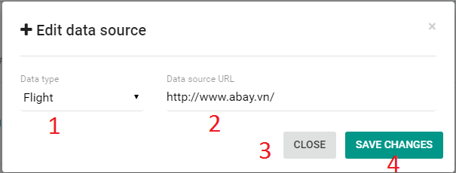

**Fields**

|  |  |  |  |  |  |  |
| --- | --- | --- | --- | --- | --- | --- |
| **No** | **Field Name** | **Description** | **Read Only** | **Mandator y** | **Control Type** | **Data Type** |
| 1 | Datatype | Type of datasource | No | Yes | Dropdow n | Int |
| 2 | Data source URL | URL of datasource | No | Yes | TextBox | String |

**Buttons/Hyperlinks**

|  |  |  |  |  |
| --- | --- | --- | --- | --- |
| **No** | **Function** | **Description** | **Validation** | **Outcome** |
| 3 | btnClose | Close edit datasource modal | N/A | Close edit datasource modal |
| 4 | btnSave | Send change datasource command | Validate all required fields before submit. | Submit save change datasource. |

#### *Config datasource*

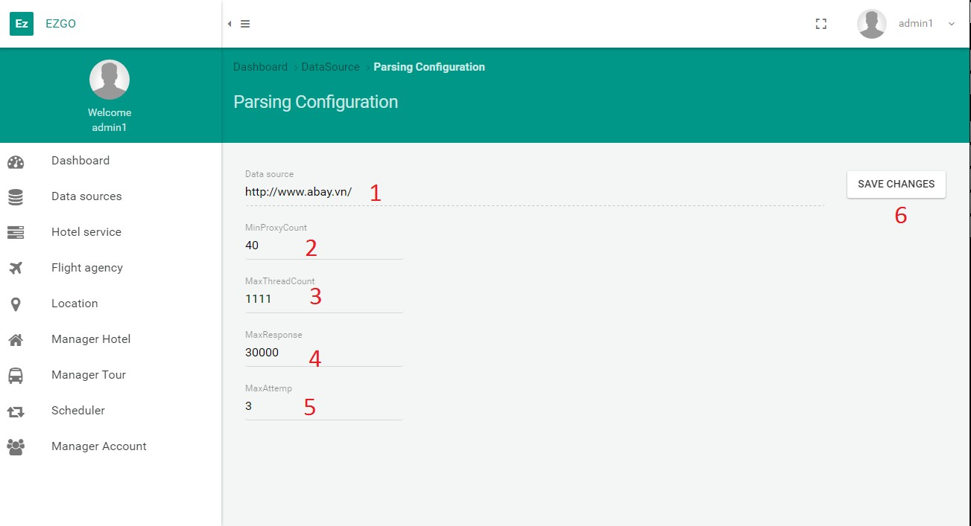

**Fields**

|  |  |  |  |  |  |  |
| --- | --- | --- | --- | --- | --- | --- |
| **No** | **Field Name** | **Description** | **Read Only** | **Mandator y** | **Control Type** | **Data Type** |
| 1 | Data source | URL data source | Yes | No | TextBox | String |
| 2 | MinProxyCou nt | Min proxy count | No | Yes | TextBox | Int |
| 3 | MaxThreadCo unt | Max thread count | No | Yes | TextBox | Int |
| 4 | MaxResponse | Max Response | No | Yes | TextBox | Int |
| 5 | MaxAttemp | Max attemp | No | Yes | TextBox | Int |

**Buttons/Hyperlinks**

|  |  |  |  |  |
| --- | --- | --- | --- | --- |
| **No** | **Function** | **Description** | **Validation** | **Outcome** |
| 6 | btnChange | Send change config datasource command | Validate all required fields before submit. | Submit change config datasource. |

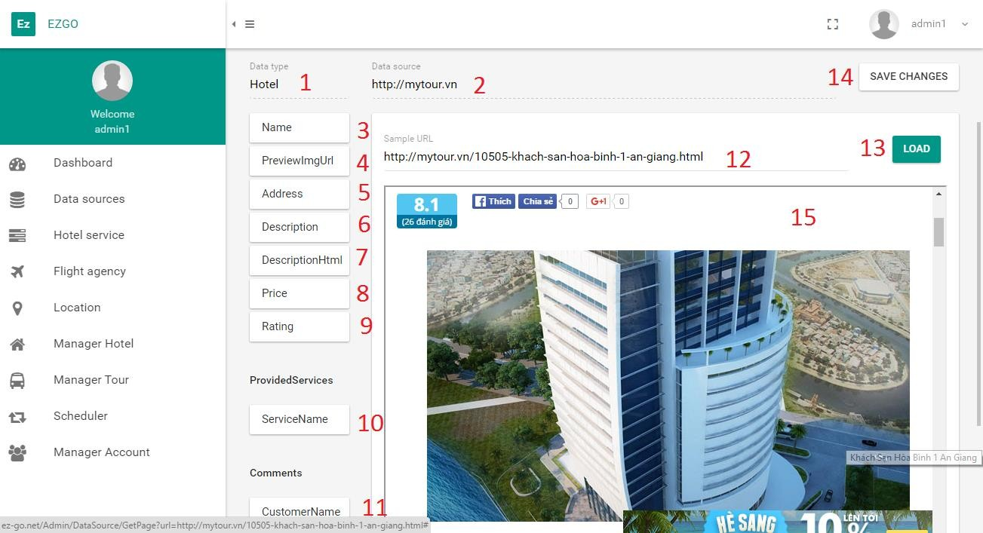

**Fields**

|  |  |  |  |  |  |  |
| --- | --- | --- | --- | --- | --- | --- |
| **No** | **Field Name** | **Description** | **Read Only** | **Mandator y** | **Control Type** | **Data Type** |
| 1 | Data type | Type datasource | Yes | No | TextBox | String |
| 2 | Data source | URL of datasource | Yes | No | TextBox | String |
| 3 | Name | Rating of data | No | Yes | TextBox/ Dropdow n | N/A |
| 4 | PreviewImgU rl | PreviewImgUrl of data | No | No | TextBox/ Dropdow n | N/A |
| 5 | Address | Address of data | No | No | TextBox/ Dropdow n | N/A |
| 6 | Description | Description of data | No | No | TextBox/ Dropdow n | N/A |
| 7 | DescriptionHt ml | DescriptionHtml of data | No | No | TextBox/ Dropdow n | N/A |
| 8 | Price | Price of data | No | No | TextBox/ Dropdow | N/A |

|  |  |  |  |  |  |  |
| --- | --- | --- | --- | --- | --- | --- |
|  |  |  |  |  | n |  |
| 9 | Rating | Rating of data | No | No | TextBox/ Dropdow n | N/A |
| 10 | ServiceName | Name of service | No | No | TextBox/ Dropdow n | N/A |
| 11 | CustomerNam e | Name of customer who commented. | No | No | TextBox/ Dropdow n | N/A |
| 12 | Sample datasource | Sample URL datasource | Yes | No | TextBox | String |
| 15 | IframSample | Load page sample | No | No | Iframe | N/A |

**Buttons/Hyperlinks**

|  |  |  |  |  |
| --- | --- | --- | --- | --- |
| **No** | **Function** | **Description** | **Validation** | **Outcome** |
| 13 | btnLoad | Load sample page into Iframe | N/A | Load sample page into Iframe |
| 14 | btnSave | Send change config command | N/A | Submit change config. |

#### *Manage hotelservices*

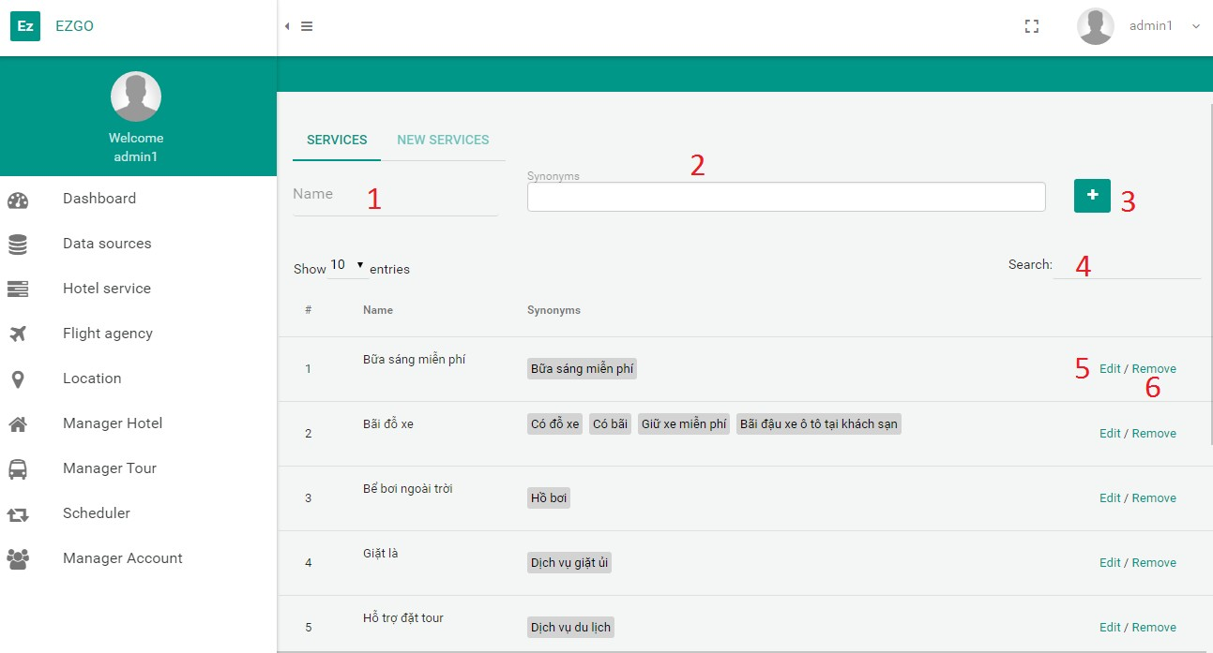

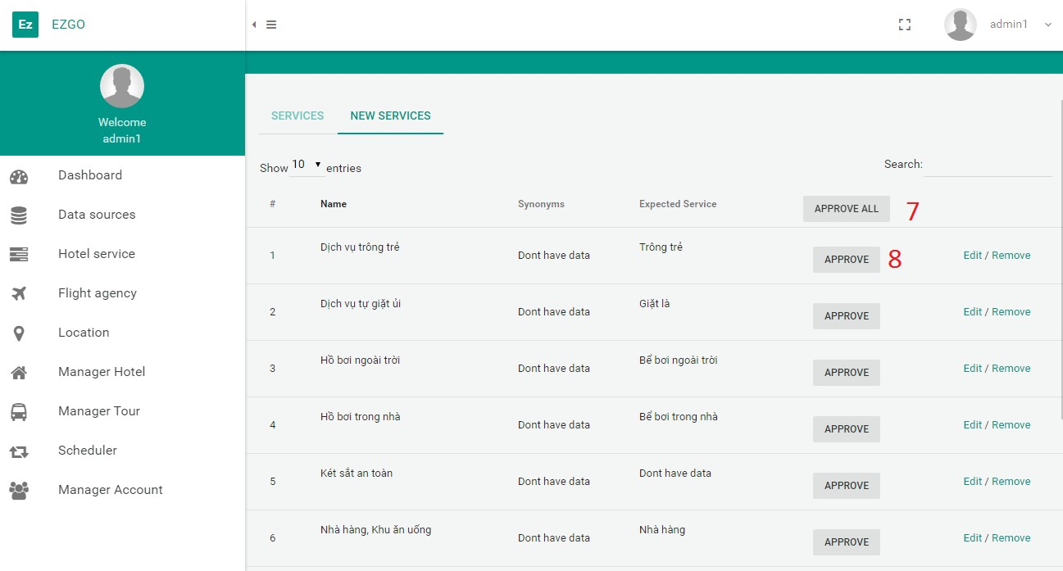

**Fields**

|  |  |  |  |  |  |  |
| --- | --- | --- | --- | --- | --- | --- |
| **No** | **Field Name** | **Description** | **Read Only** | **Mandator y** | **Control Type** | **Data Type** |
| 1 | Name | Name of hotelservice | No | Yes | TextBox | String |
| 2 | Synonyms | Synonyms of hotelservice | No | Yes | TagsInput | String |

|  |  |  |  |  |  |  |
| --- | --- | --- | --- | --- | --- | --- |
| 4 | Search | Search hotelservice | No | No | TextBox | String |

**Buttons/Hyperlinks**

|  |  |  |  |  |
| --- | --- | --- | --- | --- |
| **No** | **Function** | **Description** | **Validation** | **Outcome** |
| 3 | btnAdd | Send add new hotelservice command | Validate all required fields before submit. | Submit add new hotelservice. |
| 5 | btnEdit | Edit hotelservice | N/A | Open hotelservice edit modal. |
| 6 | btnRemove | Remove hotelservice | N/A | Show delete hotelservice pop-up |
| 7 | btnApproveAll | Send approve all hotelservice command | N/A | Submit approve all hotelservice. |
| 8 | btnApprove | Send approve one hotelservice command | N/A | Submit approve one hotelservice. |

#### *Edit hotelservice*

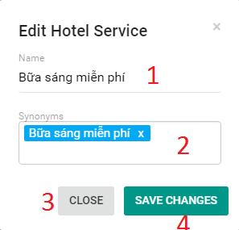

**Fields**

|  |  |  |  |  |  |  |
| --- | --- | --- | --- | --- | --- | --- |
| **No** | **Field Name** | **Description** | **Read Only** | **Mandator y** | **Control Type** | **Data Type** |
| 1 | Name | Name of hotelservice | No | Yes | TextBox | String |
| 2 | Synomyms | Synomyms of hotelservice | No | No | TagsInput | String |

**Buttons/Hyperlinks**

|  |  |  |  |  |
| --- | --- | --- | --- | --- |
| **No** | **Function** | **Description** | **Validation** | **Outcome** |
| 3 | btnClose | Close edit hotelservice modal | N/A | Close edit hotelservice modal |
| 4 | btnSave | Send change hotelservice command | Validate required fields before submit. | Submit save change hotelservice . |

### Mobile app

#### *Home*

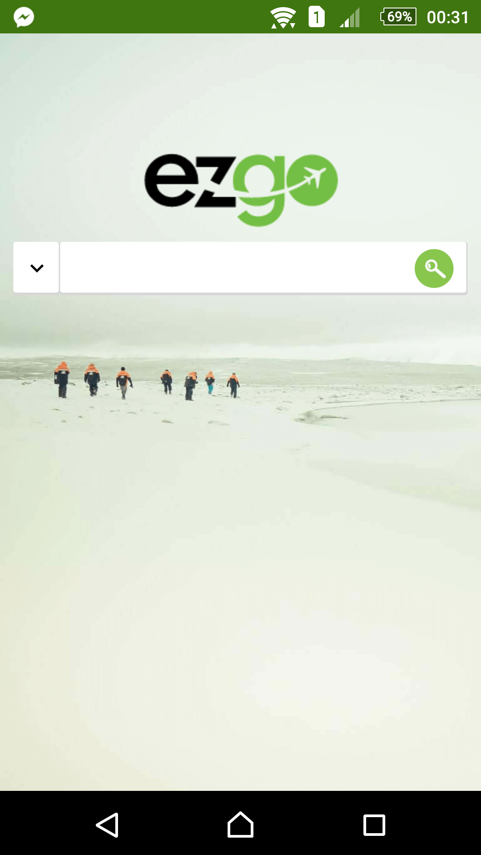 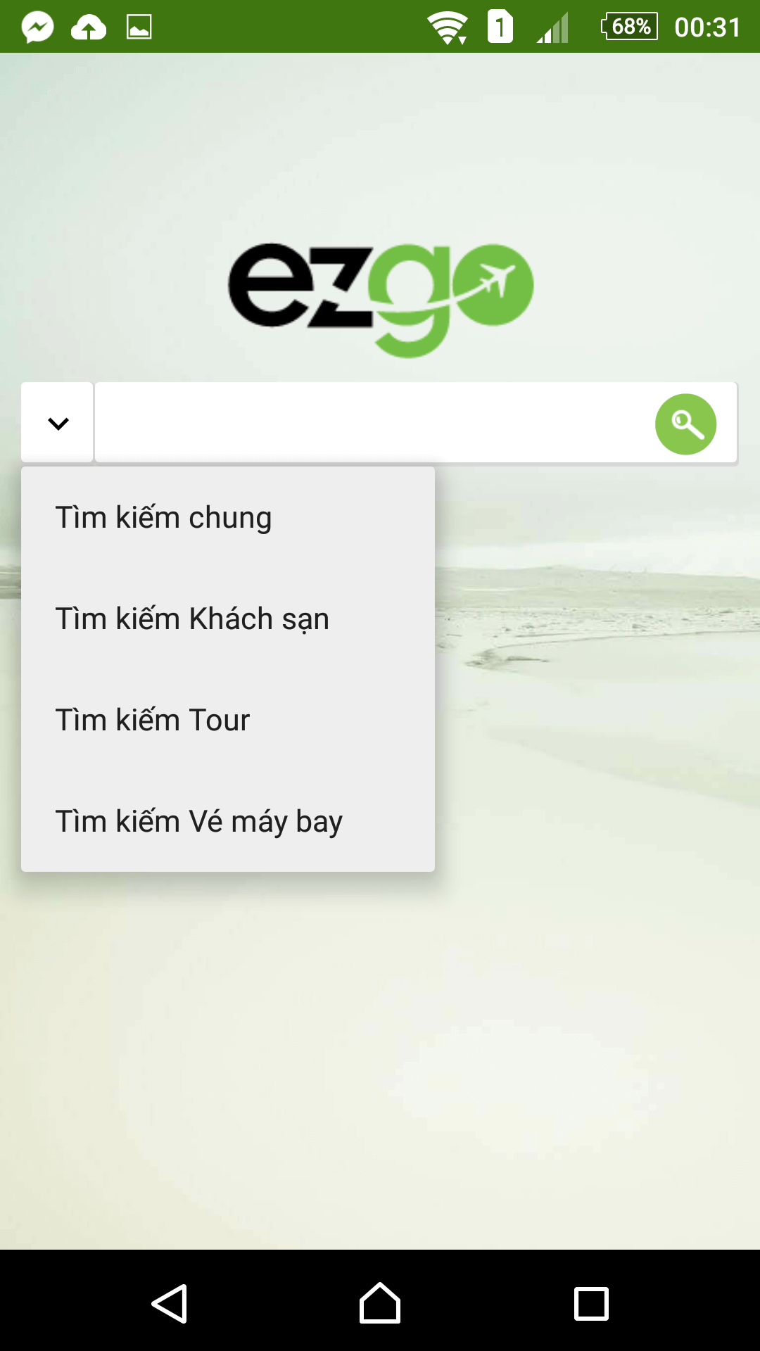

#### *Search result*

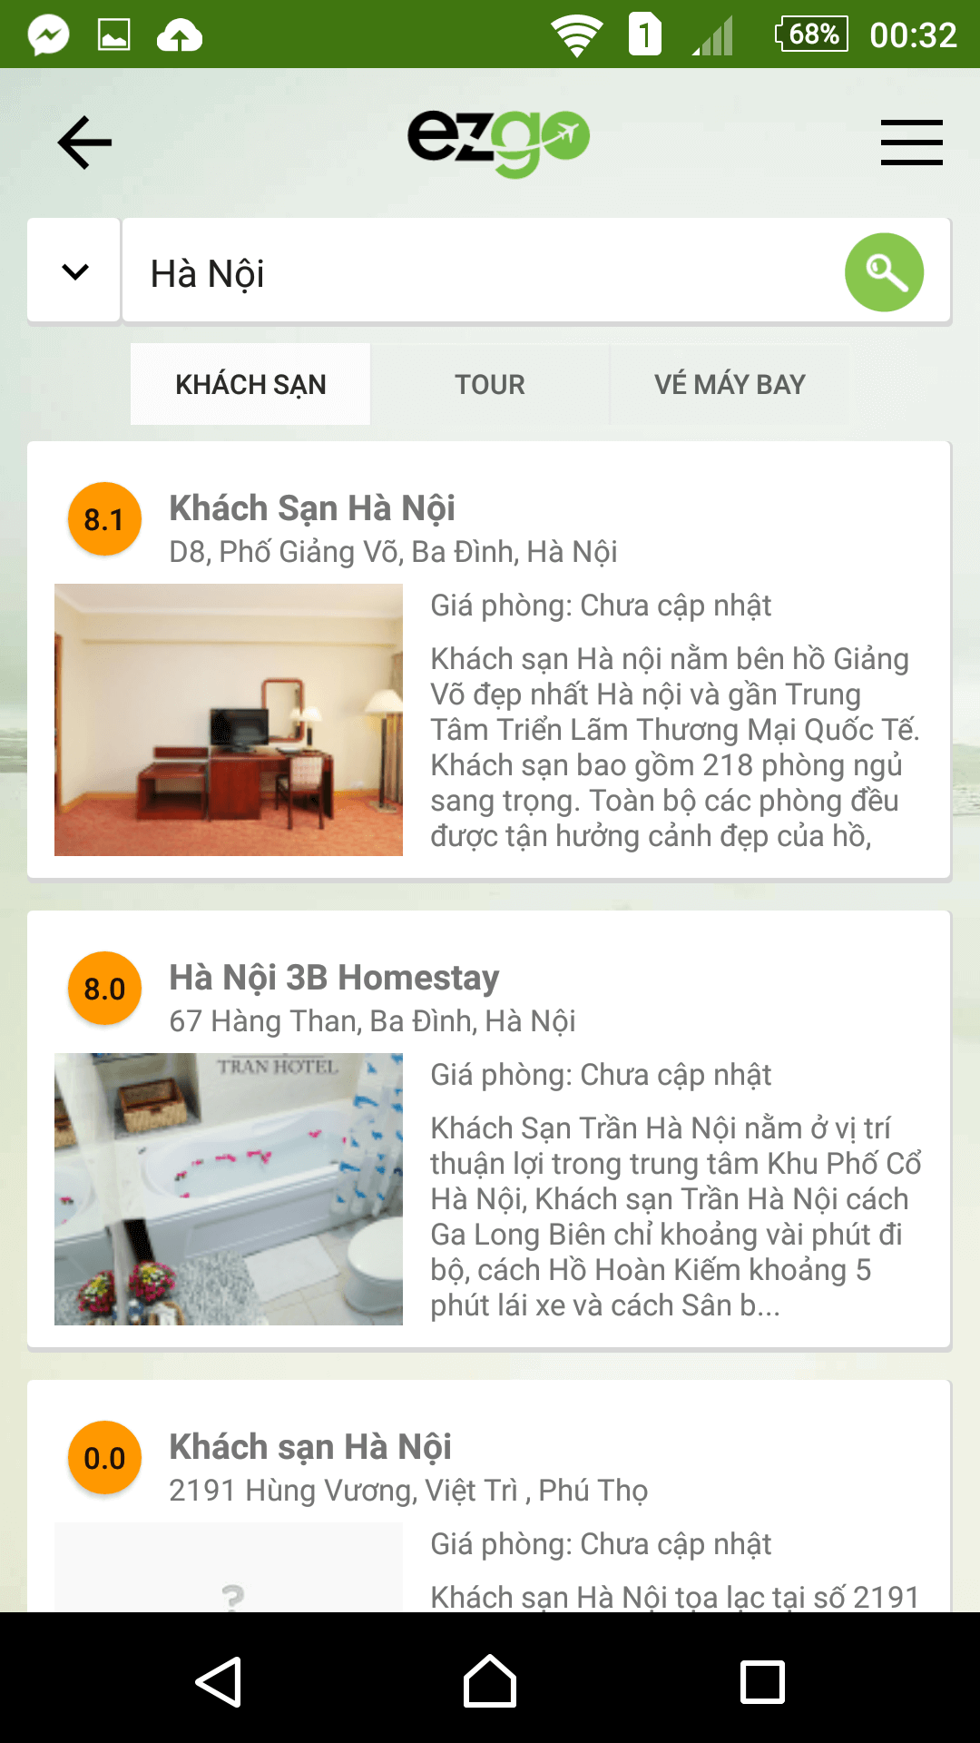 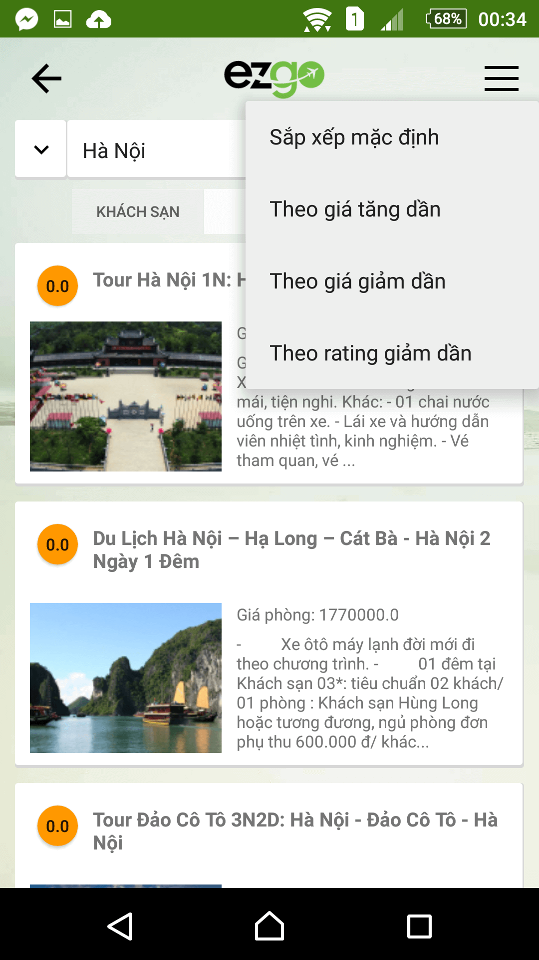

#### *Detail*

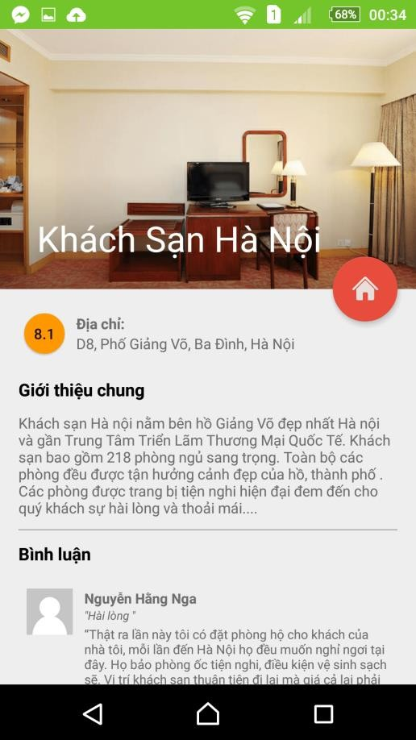 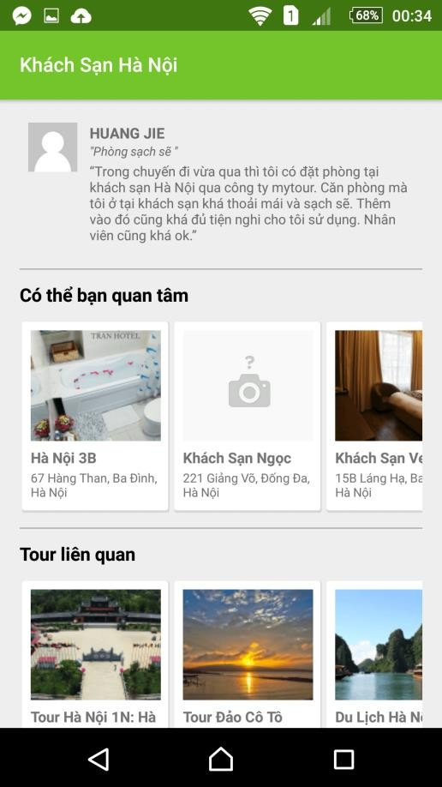

## Database Design

### Entity Relationship Diagram

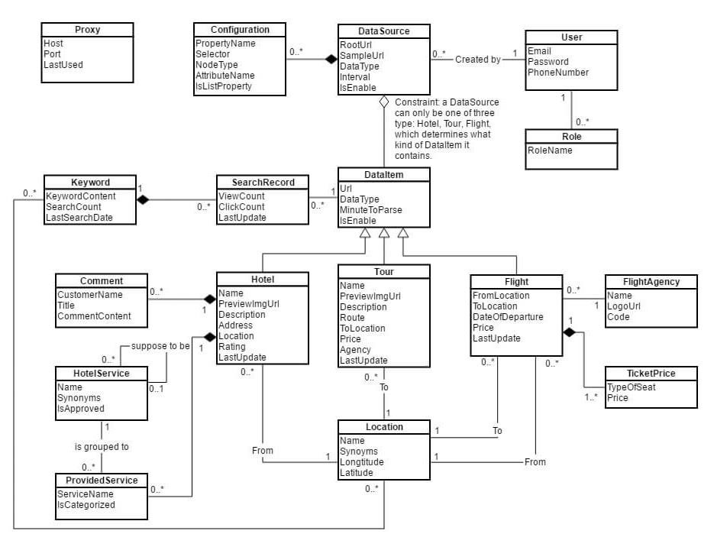

### Entity dictionary

|  |  |
| --- | --- |
| **Entity Name** | **Description** |
| **DataSource** | Contains all the information about websites to be parsed. |
| **Configuration** | Specifies needed properties for parsing data. |
| **Hotel** | Contains all the properties about hotels. |
| **Flight** | Contains all the properties about tours. |
| **Tour** | Contains all the properties about flights. |
| **Keyword** | Recorded from search keywords of users. |
| **SearchRecord** | Used to update click count & view count from user behaviors. |
| **Location** | Used to categorize data by cities/provinces. |
| **Comment** | Parsed comments associated with hotels. |

|  |  |
| --- | --- |
| **HotelService** | Offical hotel services used for filtering search results. |
| **ProvidedService** | Parsed services associated with hotels. |
| **FlightAgency** | Parsed agencies associated with hotels. |
| **TicketPrice** | Categorize flight data into 3 type of tickets: Adult, Children, Orphan |
| **Proxy** | Contains the list of proxies used to parse data without being banned by the data sources. |
| **User** | Store information of admin and staff of the system. |
| **Role** | Has 2 types: Admin, Staff |

## Algorithms

* 1. **Parse data from Html Definition**
     + Automatically parse all the appropriate data from html of a given website.

**Problem Definition**

* + - Each website has a different html structure.
    - There are various types of data to parse.
    - There are many valid and unvalid urls to parse.

**Solution**

* + - The table “Configuration” is used to set parsing configuration for all data types (hotel/tour/flight).
    - Admin/Staff can specify a sample page on the website and pre-define all the html elements for every data property.
    - Process to parse data with the following steps:
      * Crawl all the urls in the same domain as the given website
      * With each url, check if the html structure matches the defined configurations
      * If match, parse the specified data and update to database.
      * Mark the url as “done”

**Flow chart**

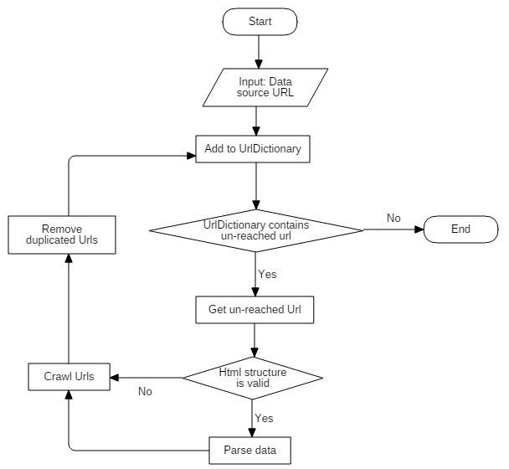

* 1. **Parse data from Ajax Definition**
     + Automatically parse all the appropriate data using the available ajax functions of a given website.
     + Is mainly used for parsing flight information.

**Problem Definition**

* + - Too much requests can cause to IP address being banned by the website.

**Solution**

* + - Create a configuration file containing all the properties for the ajax function.
    - To prevent IP address being banned by the website, a scheduled task is created to collect a list of available proxies and check if those proxies are dead or alive.
    - Proxies are prioritized by Round Robin algorithm.
    - Using those alive proxies:
      * Collect data of flight routes and airports
      * Send ajax request to get data of flight tickets
      * Parse data from ajax response and update to database

**Flow chart**

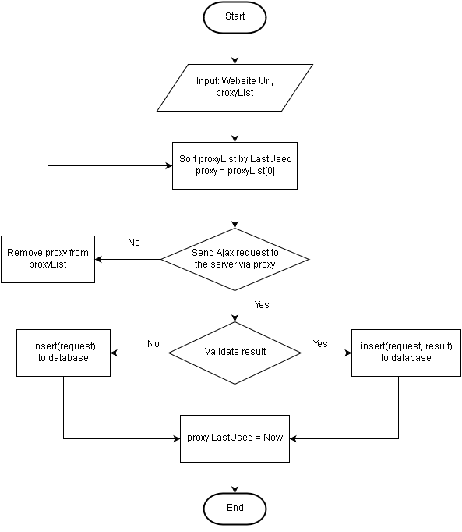

* 1. **Remove low-valuable search keywords Definition**
     + Remove low-valuable keyword from the keyword collection

**Problem definition**

* + - Keyword collection must be updated periodically to keep usable keywords and remove low-valuable keywords.
    - The recorded keywords are used for suggestion.

**Solution**

* + - All the keywords searched by users are recorded and stored to database.
    - After a period of time, every keyword is checked if it will be removed.

Keywords will be removed when meeting both of the conditions below:

* + - * Condition 1: Hasn’t been search in over 3 months

(*A keyword hasn’t been search for such a long time may be considered as possibly useless. Howerver, the last-search date can be affected by other factors such as seasons or trends.)*

* + - * Condition 2: Max last search of relevant keywords – lastSearch of the given keyword > 1 month

(*Compare to the others in the group, if the last-search date of the given keyword seems quite far away, the keyword can be considered as low-value. However, it takes time to make sure if a keyword is really low-value.)*

* + - The process to determine the group of relevant keyword is mentioned in the section *7.5 Suggest relevant keywords*.

**Flow chart**

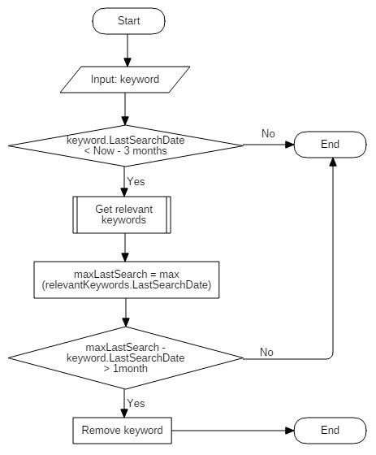

* 1. **Search data by keyword Definition**
     + Retrieve a list of data corresponding to the inputed keyword.

**Problem definition**

* + - The search result content must be relevant to the the keyword.
    - The search result must be prioritized by users’ interest and optimized time by time.

**Solution**

* + - Each pair of a keyword and a data item must have a RelevantScore to be evaluated for search result.
    - RelevantScore of keyword K and data item D is a combination of SimilarityScore and Click-through rate (CTR):

𝑅𝑒𝑙𝑆𝑐𝑜𝑟𝑒(𝐾, 𝐷) = 𝑆𝑖𝑚𝑆𝑐𝑜𝑟𝑒(𝐾, 𝐷) ∗ 𝐶𝑇𝑅(𝐾, 𝐷)

* + - SimScore: SimScore is a measure of how well the keyword matchs the content of the data item.
    - CTR: CTR is the number of clicks that a result receives divided by the number of times it is shown expressed as a percentage.

**Flow chart**

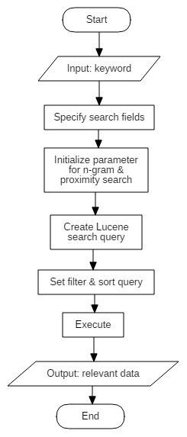

* + - Initialize parameters for:
      * N-gram: specify acceptable matching percentage of two strings
      * Levenshtein distance: specify acceptable maximum distance of two strings
    - Create Lucene query:
      * Customize scoring factors: TF(keyword, data), IDF(keyword, data), Coord(data)
      * Set boost value for important search terms
      * Add value of “SearchCount” field to scoring factors
  1. **Suggest relevant keyword Definition**
     + Retrieve a list of relevant keywords to a the keyword searched by users.

**Problem definition**

* + - When user search a particular keyword, the system will suggest relevant keywords which are often searched by other users.

**Solution: Pearson Correlation**

* + - Giving two keywords K1 and K2, retrieve a list of common relevant data of both K1 and K2.
    - Consider each data item d in data collection D as a point in the coordinate system with:
      * x = RelScore(K1, d)
      * y = RelScore(K2, d)
    - The correlation coefficient is a measure of how well that set of data items fit on a straight line.
    - The Pearson score of two keywords K1 and K2 is calculated as below:

∑ (𝑥 ∗ 𝑦) − ∑ 𝑥 ∗ ∑ 𝑦

𝑑′∈𝐷

𝑃𝑒𝑎𝑟𝑠𝑜𝑛𝑆𝑐𝑜𝑟𝑒(𝐾1, 𝐾2) = |𝐷|

√(∑(𝑥2) − (∑ 𝑥)2) ∗ (∑(𝑦2) − (∑ 𝑦)2)

|𝐷| |𝐷|

* + - PearsonScore is between -1 and 1, where 1 is total positive correlation, 0 is no correlation, and −1 is total negative correlation.
    - The final results are those keywords in the top highest PearsonScore to the given keyword.

**Flow chart**

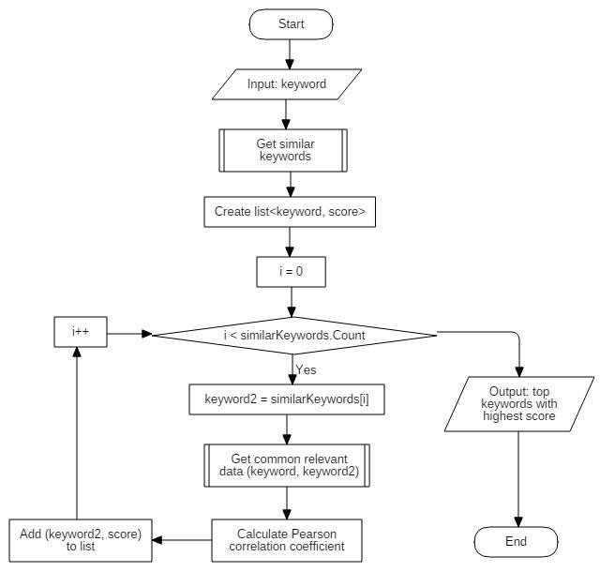

* 1. **Suggest relevant data Definition**
     + Retrieve a list of relevant data to a the hotel/tour/flight viewed by users.

**Problem definition**

* + - When user view a particular data item, the system will suggest the relevant data which are often viewed by other users.

**Solution: Pearson Correlation**

* + - Giving two data items D1 and D2, calculate PearsonScore(D1, D2) the same way as the keyword suggestion algorithm:
      * Consider each keyword as a point in the coordinate system.
      * D1 and D2 are the two axis.
    - The final results are those data items in the top highest PearsonScore to the given data item.

**Flow chart**

(Similar as section *7.5 Suggest relevant keyword*)

* 1. **Suggest near-by hotels Definition**
     + Retrieve a list of near-by hotels to the hotel viewed by users.

**Problem definition**

* + - Suggest hotels in the same are as the chosen hotel.

**Solution: Euclidean distance**

* + - Use Google map API to retrieve longtitude and latitude based on the given address (perform when paring data).
    - Get list of relevant data items using RelScore with query terms only on field “Address”.
    - Retrieve longtitude and latitude of the relevant data.
    - Calculate Euclidean distance of two data item D1 and D2:

𝐷𝑖𝑠𝑡𝑎𝑛𝑐𝑒(𝐷1, 𝐷2) = √(𝑙𝑜𝑛𝑔1 − 𝑙𝑜𝑛𝑔2)2 + (𝑙𝑎𝑡1 − 𝑙𝑎𝑡2)2

* + - The final results are those data items in the top lowest distance to the given data item.

**Flow chart**

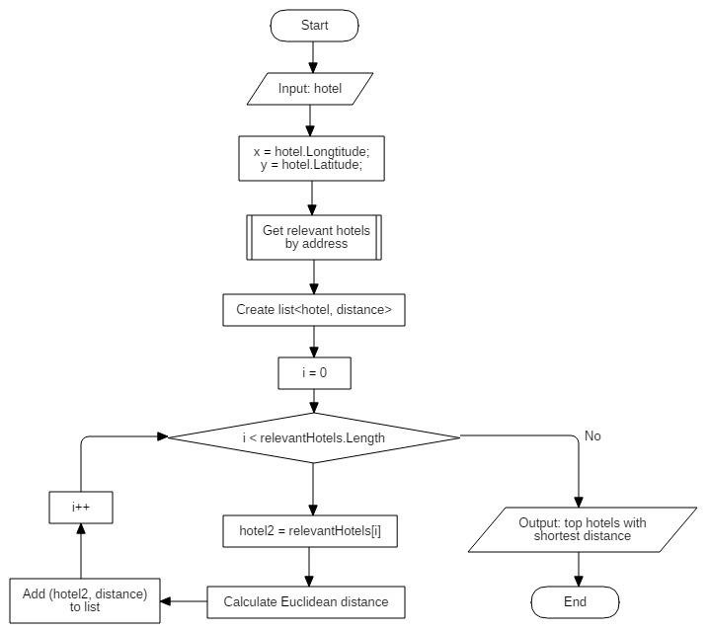

* 1. **Categorize data by location Definition**
     + Categorize hotels by location (city/province).

**Problem definition**

* + - Data parsed from different data sources has different format of address.
    - Categorizing data by location is necessary to implement functions of filtering.

**Solution**

* + - Admin/Staff can create a standard list of locations. Each location has a official name and a list of synonyms.
    - A scheduler is created to do the job:
      * Get a list of all locations.
      * Get a list of all “unlocated” data.
      * Calculate SimScore(location, data) by using official name and synonyms of location and “Address” field of data.
      * The data item will be categorized to the location with the highest SimScore.

**Flow chart**

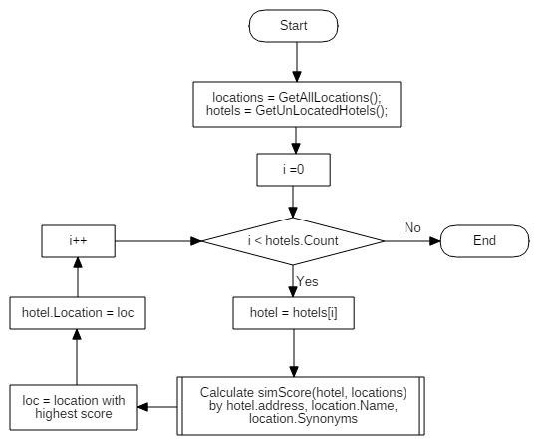

* 1. **Group hotel services Definition**
     + Group similar hotel services.

**Problem definition**

* + - Data parsed from different data sources has different format of hotel services.
    - Grouping hotel services is necessary to implement functions of filtering.

**Solution**

* + - When parsing data, add provided services:
      * HotelID = hotel ID
      * ServiceName = parsed data
      * ServiceID = null
    - A scheduler is created to group those raw services:
      * Get all uncategorized provided services, grouped by ServiceName.
      * For each service S, search for the approved service S1 with the highest simScore.
      * If cannot find any similar approved service, add new service as unapproved if there’s no service with the same name as S.
      * Otherwise, if the service S1 has name & synonyms match name of S, group S to S1; else, add new add new service as unapproved if there’s no service with the same name as S.
    - Admin can edit, approve or remove those newly created services.

**Flow chart**

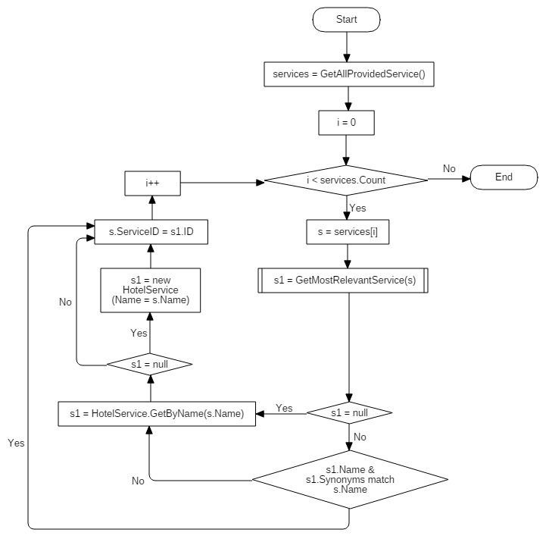

* 1. **Updating data process Definition**
     + Periodically check state of data in main storage and update data to Lucene server.

**Problem definition**

* + - Data being stored in main storage (Microsoft SQL Server) cannot perform efficient search with large data. Thus, it’s necessary to update all the needed data in the main storage to a no-SQL storage (Lucene) to optimize the performance.

**Solution**

* + - 6 concurrent schedulers are created to run periodically to do the following jobs:
      * Scheduler ParseData: Create a thread for each enabled data source to perform parsing by the specified intervals and configurations.
      * Scheduler UpdateData: Check the data states and update newly parsed data to Lucene.
      * Scheduler RemoveRedundantData: Check and remove out-of- date flight data.
      * Scheduler RemoveRedundantKeyword: Check the state and last- search-date of all the keywords and update keyword collections in Lucene.
      * Scheduler CategorizeHotelByLocation: Categorize newly updated hotels by location using hotel addresses.
      * Scheduler GroupHotelServices: Group hotel services and update service synonyms.

1. **System Implementation & Test**

## Introduction

### Overview

This section describes the approach and methodologies used by group to plan, organize and manage the testing of EZGO. It provides in the detail all necessary information about the implementation and testing procedure of the system included test plans, test cases, test result, test environments, pass/fail criteria and risks estimations as well as a checklist to cover all possible cases.

### Test Approach

* + - **Goal:** Test all features in the whole system based on the core flow.
    - **Method:** black-box testing
    - **Technique:** check list

The testing for this project will consists of Integration System test level. Testing the program which was integrated and as a complete system to ensure that the software requirements have been met.

* + - Integration testing would be performed by all member of team and approved by team leader.
    - System testing is focused on assessing the system’s reliability. This process is concerned with finding errors that result from unanticipated interactions between components and component interface problems.

## Database relationship diagram

### Physical Diagram

**Proxies**

Column Name Condensed Type

|  |  |  |
| --- | --- | --- |
|  | Id | int |
|  | Host | nvarchar(MAX) |
|  | Port | int |
|  | LastUsed | datetime |
|  |  |  |

**DataSource**

Column Name Condensed Type

**AspNetUserRoles**

 Column Name Condensed Type

|  |  |  |  |
| --- | --- | --- | --- |
| **AspNetRoles** | | | |
| Column Name Condensed Type | | | |
|  | Id | nvarchar(128) |  |
|  | Name | nvarchar(256) |
|  |  |  |
|  | | | |

|  |  |  |
| --- | --- | --- |
|  | Id | int |
|  | UserId | nvarchar(128) |
|  | RoleId | nvarchar(128) |
|  |  |  |

**AspNetUsers**

|  |  |  |  |
| --- | --- | --- | --- |
|  | | | |
| **Configuration** | | | |
| Column Name Condensed Type | | | |
|  | ID | int |  |
|  | DataSourceID | int |
|  | PropertyName | varchar(50) |
|  | Selector | nvarchar(MAX) |
|  | NodeType | int |
|  | AttributeNa... | varchar(50) |
|  | IsListProperty | bit |
|  | NestedConfi... | int |
|  |  |  |
|  | | | |

Column Name Condensed Type

**Comment**

|  |  |  |
| --- | --- | --- |
|  | ID | int |
|  | SampleUrl | nvarchar(MAX) |
|  | RootUrl | nvarchar(50) |
|  | DataType | int |
|  | LastUpdate | datetime |
|  | MinuteToPar... | int |
|  | IsEnable | bit |
|  | MinProxyCo... | int |
|  | MaxThreadC... | int |
|  | MaxResponse | int |
|  | MaxAttemp | int |
|  | SleepTime | int |
|  | DayLimit | int |
|  |  |  |

|  |  |  |
| --- | --- | --- |
|  | Id | nvarchar(128) |
|  | Email | nvarchar(256) |
|  | EmailConfir... | bit |
|  | PasswordHash | nvarchar(MAX) |
|  | SecurityStamp | nvarchar(MAX) |
|  | PhoneNumber | nvarchar(MAX) |
|  | PhoneNumb... | bit |
|  | TwoFactorEn... | bit |
|  | LockoutEnd... | datetime |
|  | LockoutEnab... | bit |
|  | AccessFaile... | int |
|  | UserName | nvarchar(256) |
|  |  |  |

Column Name Condensed Type

|  |  |  |
| --- | --- | --- |
|  | ID | int |
|  | CustomerNa... | nvarchar(MAX) |
|  | Title | nvarchar(MAX) |
|  | CommentCo... | nvarchar(MAX) |
|  | CommentDate | datetime |
|  | HotelID | int |
|  |  |  |

**Hotel**

Column Name Condensed Type

**Tour**

Column Name Condensed Type

**Flight**

Column Name Condensed Type

**FlightAgency**

Column Name Condensed Type

|  |  |  |
| --- | --- | --- |
|  | ID | int |
|  | Name | nvarchar(250) |
|  | LogoUrl | nvarchar(250) |
|  |  |  |

**TicketPrice**

|  |  |  |
| --- | --- | --- |
|  | ID | int |
|  | Url | nvarchar(MAX) |
|  | Name | nvarchar(MAX) |
|  | PreviewImgUrl | nvarchar(MAX) |
|  | Description | nvarchar(MAX) |
|  | Description... | nvarchar(MAX) |
|  | Address | nvarchar(MAX) |
|  | LocationID | int |
|  | Rating | nvarchar(50) |
|  | Price | nvarchar(50) |
|  | DataSourceID | int |
|  | LastUpdate | datetime |
|  | IsLuceneUp... | bit |
|  | Lat | float |
|  | Lng | float |
|  |  |  |

|  |  |  |
| --- | --- | --- |
|  | ID | int |
|  | Url | nvarchar(MAX) |
|  | Name | nvarchar(MAX) |
|  | PreviewImgUrl | nvarchar(MAX) |
|  | ToLocationN... | nvarchar(MAX) |
|  | ToLocationID | int |
|  | Description | nvarchar(MAX) |
|  | Description... | nvarchar(MAX) |
|  | Route | nvarchar(MAX) |
|  | RouteHtml | nvarchar(MAX) |
|  | Agency | nvarchar(MAX) |
|  | Price | nvarchar(50) |
|  | DataSourceID | int |
|  | LastUpdate | datetime |
|  | IsLuceneUp... | bit |
|  |  |  |

|  |  |  |
| --- | --- | --- |
|  | ID | int |
|  | DateOfDepa... | datetime |
|  | DateOfArrival | datetime |
|  | Description | nvarchar(MAX) |
|  | FromLocatio... | int |
|  | ToLocationID | int |
|  | DataSourceID | int |
|  | LastUpdate | datetime |
|  | IsLuceneUp... | bit |
|  | TicketCode | nvarchar(MAX) |
|  | Url | nvarchar(MAX) |
|  | FlightAgenc... | int |
|  |  |  |

Column Name Condensed Type

|  |  |  |
| --- | --- | --- |
|  | ID | int |
|  | TypeOfSeat | int |
|  | Price | int |
|  | FlightID | int |
|  |  |  |

**ProvidedService**

Column Name Condensed Type

**SearchRecord**

Column Name Condensed Type

**Location**

Column Name Condensed Type

|  |  |  |
| --- | --- | --- |
|  | ID | int |
|  | HotelID | int |
|  | ServiceName | nvarchar(MAX) |
|  | HotelService... | int |
|  | IsCategorized | bit |
|  |  |  |

|  |  |  |
| --- | --- | --- |
|  | ID | int |
|  | KeywordID | int |
|  | HotelID | int |
|  | TourID | int |
|  | FlightID | int |
|  | ViewCount | int |
|  | ClickCount | int |
|  | LastUpdate | datetime |
|  |  |  |

|  |  |  |
| --- | --- | --- |
|  | ID | int |
|  | ShortName | nvarchar(50) |
|  | FullName | nvarchar(MAX) |
|  | IsAirport | bit |
|  | InLocationID | int |
|  | Synonyms | nvarchar(MAX) |
|  | Lat | float |
|  | Lng | float |
|  |  |  |

**HotelService**

Column Name Condensed Type

|  |  |  |
| --- | --- | --- |
|  | ID | int |
|  | Name | nvarchar(250) |
|  | Synonyms | nvarchar(MAX) |
|  | ExpectedSer... | int |
|  | IsApproved | bit |
|  |  |  |

**KeywordLocation**

Column Name Condensed Type

|  |  |  |  |
| --- | --- | --- | --- |
| **Keyword** | | | |
| Column Name Condensed Type | | | |
|  | ID | int |  |
|  | KeywordCon... | nvarchar(MAX) |
|  | SearchCount | int |
|  | LastSearchD... | datetime |
|  | IsLuceneUp... | bit |
|  | IsValidKeyw... | bit |
|  |  |  |
|  | | | |

|  |  |  |
| --- | --- | --- |
|  | ID | int |
|  | KeywordID | int |
|  | LocationID | int |
|  | SearchCount | int |
|  | LastSearchD... | datetime |
|  |  |  |



### Data Dictionary

|  |  |
| --- | --- |
| **Entity Name** | **Description** |
| **DataSource** | Contains all the information about websites to be parsed. |
| **Configuration** | Specifies needed properties for parsing data. |
| **Hotel** | Contains all the properties about hotels. |
| **Flight** | Contains all the properties about tours. |
| **Tour** | Contains all the properties about flights. |
| **Keyword** | Recorded from search keywords of users. |
| **SearchRecord** | Used to update click count & view count from user behaviors. |
| **Location** | Used to categorize data by cities/provinces. |
| **Comment** | Parsed comments associated with hotels. |
| **HotelService** | Offical hotel services used for filtering search results. |
| **ProvidedService** | Parsed services associated with hotels. |
| **FlightAgency** | Parsed agencies associated with hotels. |
| **TicketPrice** | Categorize flight data into 3 type of tickets: Adult, Children, Orphan |
| **Proxy** | Contains the list of proxies used to parse data without being banned by the data sources. |
| **User** | Store information of admin and staff of the system. |
| **Role** | Has 2 types: Admin, Staff |

## Test Plan

### Feature to be tested

* + - Search by keywords
    - Search hotels/tours/flights by criterias
    - Sort & filter hotels/tours/flights
    - Suggest: relevance keywords, relevance hotels/tours/flights, nearby hotels
    - Configure data source parsing
    - Schedulers: data parsing, data updating, data categorizing

### Feature not to be tested

* + - View data detail
    - Admin: CRUD operation

## System Testing Test Case

### 4.1. Test case

#### *.<User> Search*

|  |  |  |  |  |  |  |
| --- | --- | --- | --- | --- | --- | --- |
| **ID** | **Test Case Description** | **Test case procedure** | **Expected output** | **Inter-test case dependence** | **Result** | **Test Date** |
| **TC01** | Search all without key keyword | * Go to home page * Press “Search” button | Show message “Vui long nhập từ khóa” |  | Pass | From 8/4/16 To 8/10/16 |
| **TC02** | Search hotel without key keyword | * Go to home page * Press “Search” button | Show message “Vui long nhập từ khóa” |  | Pass | From 8/4/16 To 8/10/16 |
| **TC03** | Search tour without key keyword | * Go to home page * Press “Search” button | Show message “Vui long nhập từ khóa” |  | Pass | From 8/4/16 To 8/10/16 |
| **TC04** | Search round trip flight without date departure | * Go to home page * Press “Search” button | Show message “Vui long chọn ngày đi” |  | Pass | From 8/4/16 To 8/10/16 |
| **TC05** | Search round trip flight without date return | * Go to home page * Input date departure * Press “Search” button | Show message “Vui long chọn ngày về” |  | Pass | From 8/4/16 To 8/10/16 |
| **TC06** | Search round trip flight with date return less than date departure | * Go to home page * Input date departure value is “07/04/2016” * Input date return value is “06/04/2016” * Press “Search” button | Show message “Ngày về không được nhỏ hơn ngày đi” |  | Pass | From 8/4/16 To 8/10/16 |

|  |  |  |  |  |  |  |
| --- | --- | --- | --- | --- | --- | --- |
| **TC07** | Search round trip flight with departure and arrival in duplicate. | * Go to home page * Input date departure value is “Hồ Chí Minh” * Input date return value is “Hồ Chí Minh” * Press “Search” button | Show message “Điểm đi và điểm đến không được trùng nhau” |  | Pass | From 8/4/16 To 8/10/16 |

#### *.<User> Log in*

|  |  |  |  |  |  |  |
| --- | --- | --- | --- | --- | --- | --- |
| **ID** | **Test Case Description** | **Test case procedure** | **Expected output** | **Inter-test case dependence** | **Result** | **Test Date** |
| **TC08** | Login | * Go to login page. * Input username ”admin” and password “admin” * Press “Login” button. | Show “Dashboard” page |  | Pass | From 8/4/16 to 8/4/16 |
| **TC09** | Login with wrong username | * Go to login page. * Input username ”aaa” and password “admin” * Press “Login” button. | Show message “ Tên đăng nhập hoặc mật khẩu không đúng |  | Pass | From 8/4/16 to 8/4/16 |
| **TC10** | Login with wrong password | * Go to login page. * Input username ”admin” and password “123456” * Press “Login” button. | Show message “ Tên đăng nhập hoặc mật khẩu không đúng |  | Pass | From 8/4/16 to 8/4/16 |

#### *.<User> Log out*

|  |  |  |  |  |  |  |
| --- | --- | --- | --- | --- | --- | --- |
| **ID** | **Test Case Description** | **Test case procedure** | **Expected output** | **Inter-test case dependence** | **Result** | **Test Date** |
| **TC11** | Logout | * Guest opens menu on the right top page. * Patient clicks on “Logout” item. | Show “Login” page |  | Pass | From 8/4/16 to 8/4/16 |

#### *.<Staff> Manage Hotels*

|  |  |  |  |  |  |  |
| --- | --- | --- | --- | --- | --- | --- |
| **ID** | **Test Case Description** | **Test case procedure** | **Expected output** | **Inter-test case dependence** | **Result** | **Test Date** |
| **TC13** | Edit location hotel | * Go to “Manager Hotel” page. * Click on “Edit” item, show “Edit” popup * Select location * Press “Save changes” | Show “Success” popup |  | Pass | From 8/4/16 to 8/4/16 |
| **TC14** | Remove hotel | * Go to “Manager Hotel” page. * Select hotel must remove. * Click on “Remove” item. | Show “Success” popup |  | Pass | From 8/4/16 to 8/4/16 |

#### *.<Staff> Manage Tours*

|  |  |  |  |  |  |  |
| --- | --- | --- | --- | --- | --- | --- |
| **ID** | **Test Case Description** | **Test case procedure** | **Expected output** | **Inter-test case dependence** | **Result** | **Test Date** |
| **TC15** | Edit location tour | * Go to “Manager Tour” page. * Click on “Edit” item, show “Edit” popup * Select location * Press “Save changes” | Show “Success” popup |  | Pass | From 8/4/16 to 8/4/16 |
| **TC16** | Remove tour | * Go to “Manager Tour” page. * Select hotel must remove. * Click on “Remove” item. | Show “Success” popup |  | Pass | From 8/4/16 to 8/4/16 |

#### *.<Staff> Manage Hotel Services*

|  |  |  |  |  |  |  |
| --- | --- | --- | --- | --- | --- | --- |
| **ID** | **Test Case Description** | **Test case procedure** | **Expected output** | **Inter-test case dependence** | **Result** | **Test Date** |
| **TC17** | Edit hotel service synonyms | * Go to “Manager Hotel Service” page. * Select tab “Services” * Click on “Edit” item, show “Edit” popup * Input synonyms keyword * Press “Save changes” | Show “Success” popup |  | Pass | From 8/4/16 to 8/4/16 |
| **TC18** | Remove hotel service | * Go to “Manager Hotel Service” page. | Show “Success” popup |  | Pass | From 8/4/16 to 8/4/16 |

|  |  |  |  |  |  |  |
| --- | --- | --- | --- | --- | --- | --- |
|  |  | * Select tab “Services” * Select hotel service must remove. * Click on “Remove” item. |  |  |  |  |
| **TC19** | Approve new hotel service | * Go to “Manager Hotel Service” page. * Select tab “New Services” * Select hotel service must approve. * Press on “Approve” button. | Show “Success” popup |  | Pass | From 8/4/16 to 8/4/16 |
| **TC20** | Edit new hotel service | * Go to “Manager Hotel Service” page. * Select tab “New Services” * Click on “Edit” item, show “Edit” popup * Input synonyms keyword * Press “Save changes” | Show “Success” popup |  | Pass | From 8/4/16 to 8/4/16 |
| **TC21** | Remove new hotel service | * Go to “Manager Hotel Service” page. * Select tab “New Services” * Select hotel service must remove. * Click on “Remove” item. | Show “Success” popup |  | Pass | From 8/4/16 to 8/4/16 |

1. **Sofware User’s Manual**

## Installation Guide

### Setting up environment at server side

The specifications are based on the dependencies requirements and performance test result from previous section of this document.

#### *Hardware requirement*

|  |  |
| --- | --- |
| **Hardware** | **Specification** |
| **Internet Connection** | 8 Mbps |
| **Computer Processor** | Intel® Core(TM) i5 CPU , M 460 @ 2.53GHz |
| **Computer Memory** | 4GB of RAM or more |
| **Hard Disk Drive** | 40GB or more |

*Table 12: Installation Guide - Hardware Requirement*

#### *Software requirement*

|  |  |
| --- | --- |
| **Software** | **Application name / version** |
| **Operating System** | Window Server 2012 |
| **.Net** | 4.5 |
| **DBMS** | SQL Server 2014 |

*Table 13: Installation Guide - Software Requirement*

### Web Application Deployment Process

#### *Check environment*

Check .Net Framework version.

Open command prompt and enter: dir %WINDIR%\Microsoft.Net\Framework\v*

Output:

Directory of C:\Windows\Microsoft.Net\Framework

11/21/2010 10:31 AM

07/14/2009 10:20 AM

04/10/2016 06:27 PM

11/21/2010 02:06 PM

03/28/2016 02:48 AM

04/17/2016 12:18 PM

<DIR>

<DIR>

<DIR>

<DIR>

<DIR>

<DIR>

v1.0.3705

v1.1.4322 v2.0.50727 v3.0

v3.5 v4.0.30319

Note: .NET Framework 4.5 is stored in a sub-directory of 4.0.

#### *Import Database*

Using file database.sql located under Deployment directory from this document.

#### *Build project*

1. Open **SearchEngine Solution (SearchEngine.sln)** in Visual Studio 2013
2. Right-click on **SearchEngine Solution**, select “Build”

#### *Deploy project to IIS*

* 1. Open source code folder, copy **SearchEngine** folder to another disk.
  2. Open **Internet Information Services (IIS) Manager**

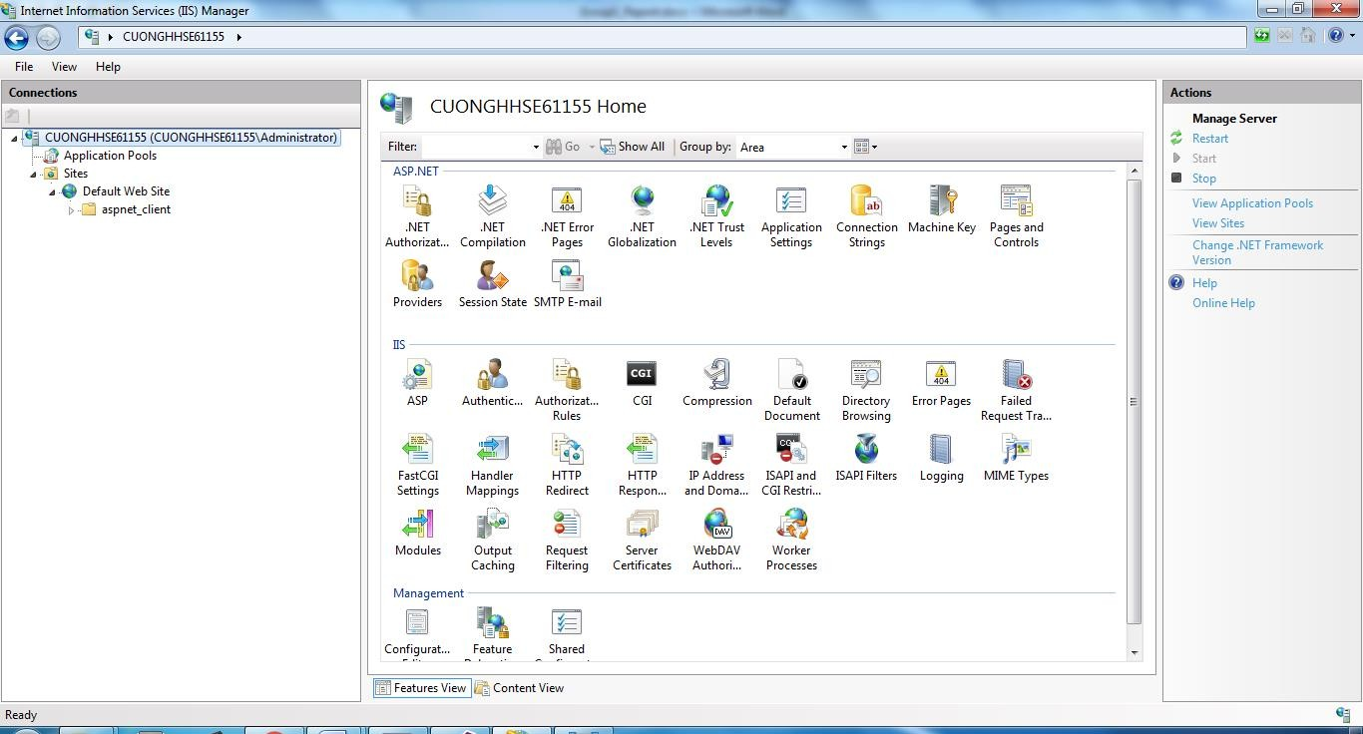

* 1. Config application Pool to .Net Framework v4.0.30319
     + Select “**Application Pool**”
     + Double click on “**DefaultAppPool**”
     + In pop-up, select item flow by image

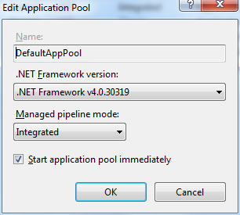

* + - Click “OK”
  1. Deploy project to IIS
     + Right click on “**Default Web Site**”, select “**Add Application**”
     + In pop-up input flow by image

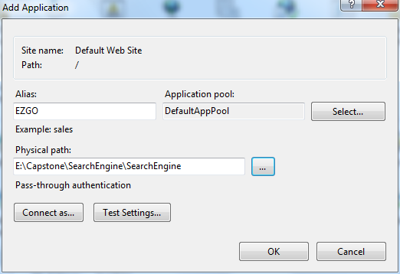

Note: - Physical path: located direction of SearchEngine.Web project that copy on step 1.

-Alias: Name of web after deploy to IIS, can be free input.

* 1. Click “OK”

## User Guide

### Web application

#### *User*

* + - 1. **General search**

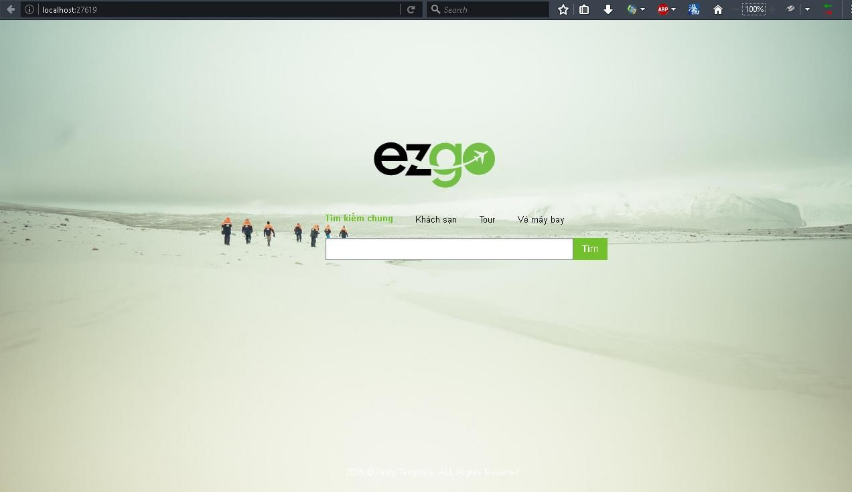

|  |  |
| --- | --- |
| **Step Description** | |
| **1** | Click on “Tìm kiếm chung”. |
| **2** | Fill in field: Searching keywords. |
| **3** | Click “Tìm” button. |

* + - 1. **Search for hotels**

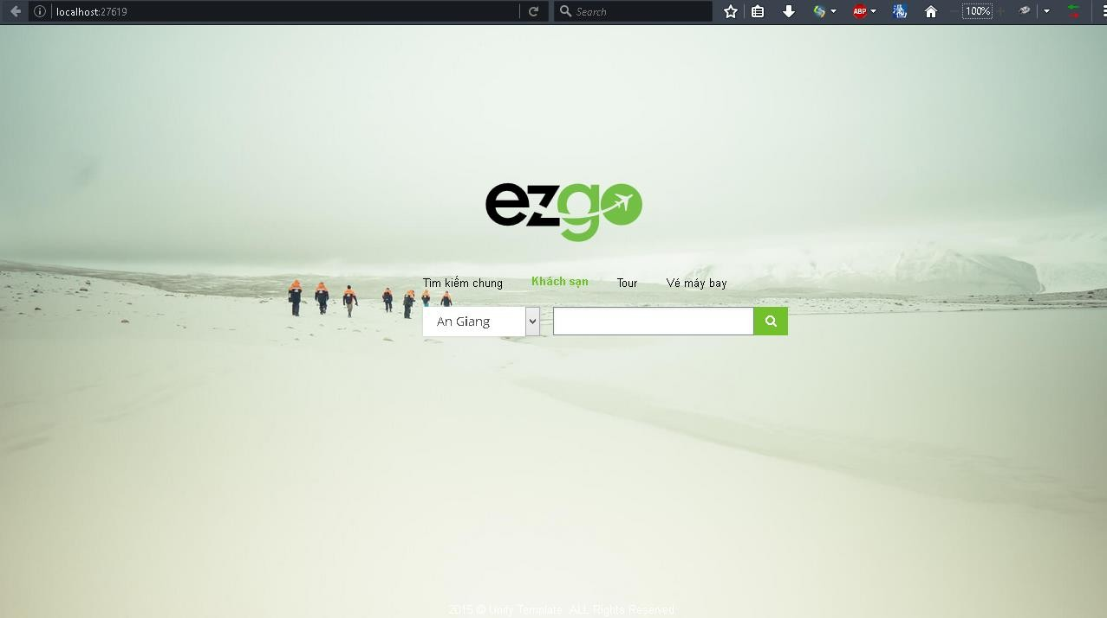

|  |  |
| --- | --- |
| **Step Description** | |
| **1** | Click on “Khách sạn”. |
| **2** | Drop drown list: List of provinces. Fill in field: Searching keywords. |
| **3** | Click on button with magnitude glass icon. |

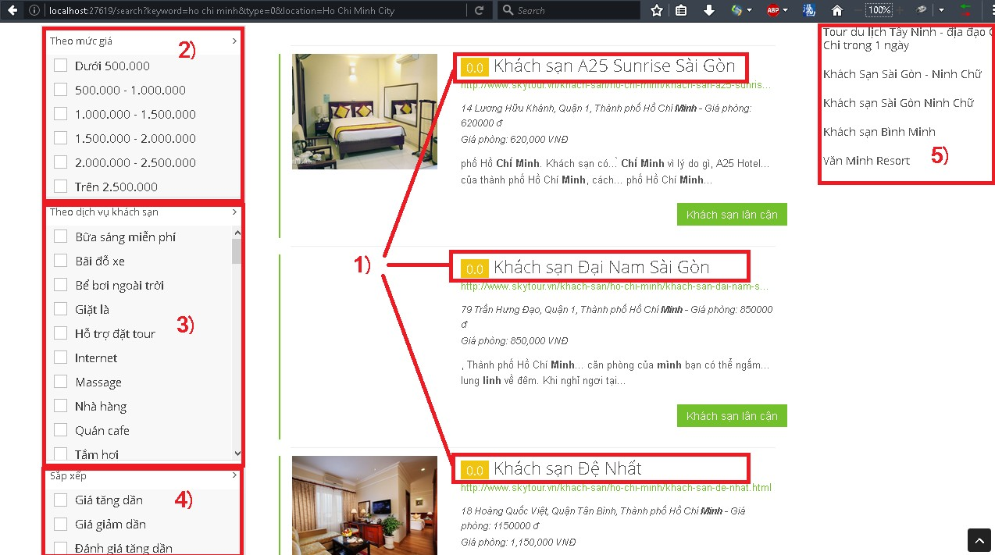

|  |  |
| --- | --- |
| **Step Description** | |
| **4** | Click on “Khách sạn lân cận” to show nearby hotels.   1. Filter results by price. 2. Filter results by hotel services. 3. Sort results. 4. Show relevant results. |
| **5** | Click on (1) to go to the detail page. |

* + - 1. **Search for tours**

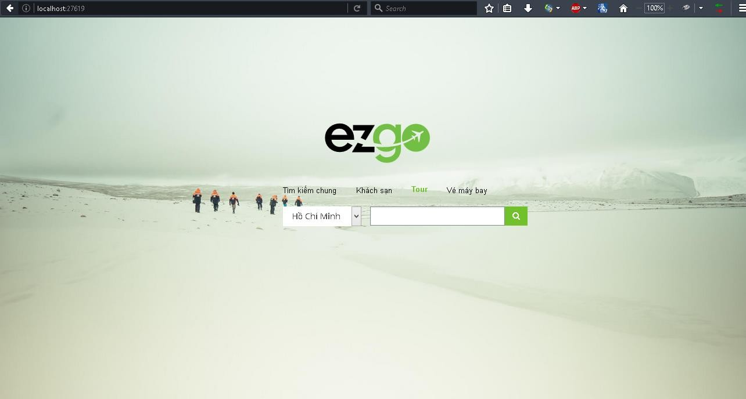

|  |  |
| --- | --- |
| **Step Description** | |
| **1** | Click on “Tour”. |
| **2** | Drop drown list: List of provinces. Fill in field: Searching keywords. |
| **3** | Click on button with magnitude glass icon. |

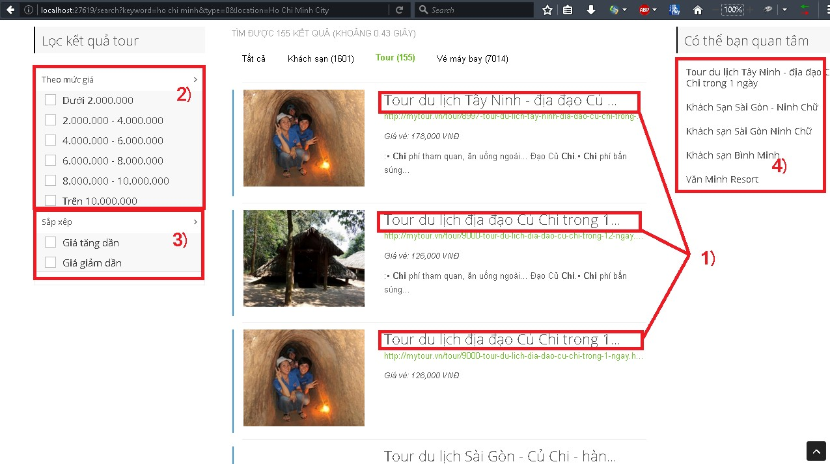

|  |  |
| --- | --- |
| **Step Description** | |
| **4** | 1. Filter results by price. 2. Sort results.   (5) Show relevant results. |
| **5** | Click on (1) to go to the detail page. |

* + - 1. **Search for flight tickets**

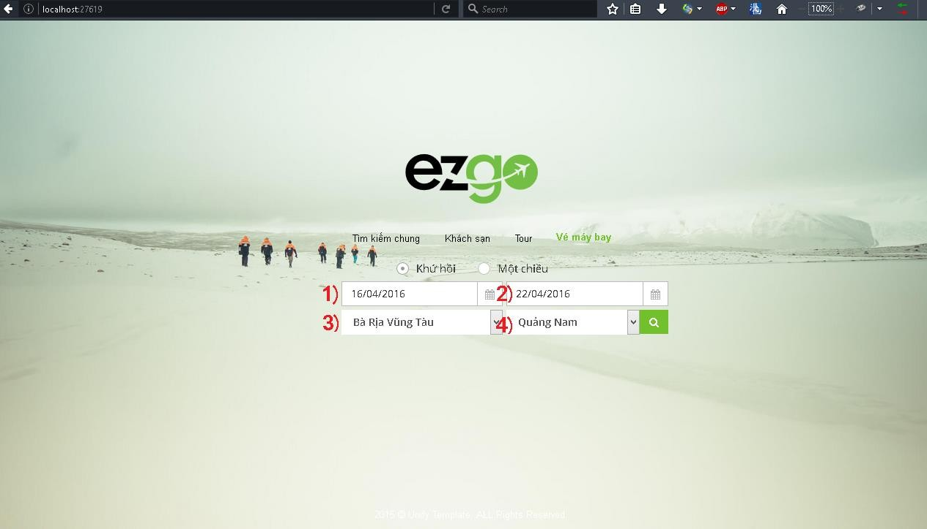

|  |  |
| --- | --- |
| **Step Description** | |
| **1** | Click on “Vé máy bay”. |
| **2** | Radio buttons:   * “Khứ hồi”: Round-trip ticket. * “Một chiều”: One-way ticket. Fill in fields:   1. Date of departure.   2. Date of arrival,   3. Departure location.   4. Arrival location. |
| **3** | Click on button with magnitude glass icon. |

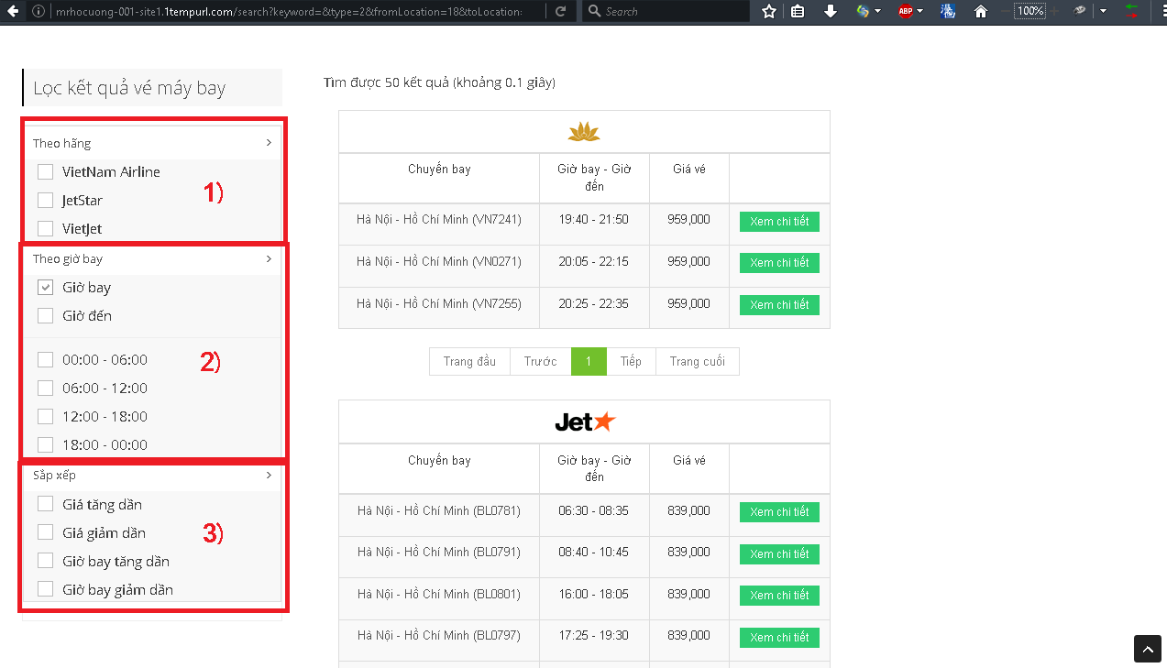

|  |  |
| --- | --- |
| **Step Description** | |
| **4** | 1. Filter results by company. 2. Filter results by date of departure/date of arrival. 3. Sort results. |
| **5** | Click on “Xem chi tiết” button. |

#### *Staff*

* + - 1. **Manage Data sources**
         1. *Add new data source*

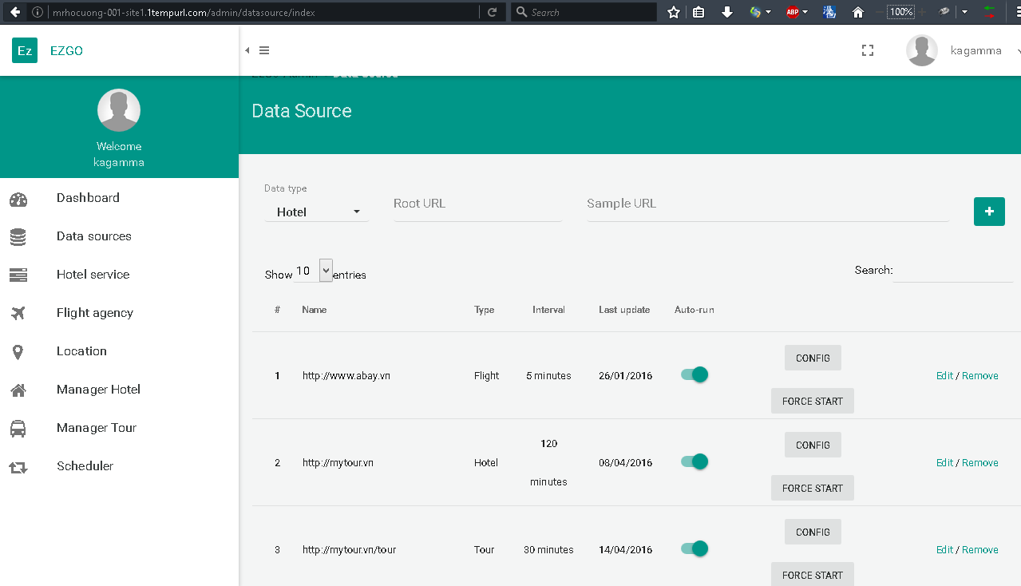

|  |  |
| --- | --- |
| **Step Description** | |
| **1** | Click on “Data sources”. |
| **2** | Fill in fields:  “Data type”: Type of data this site offered. “Root URL”. URL root of the site.  “Sample URL”. Sample url contains the sample structure. |
| **3** | Click on “+” button. |

* + - * 1. *Modify existing data sources*



|  |  |
| --- | --- |
| **Step Description** | |
| **1** | Click on “Data sources”. |
| **2** | Click on “Edit”. |

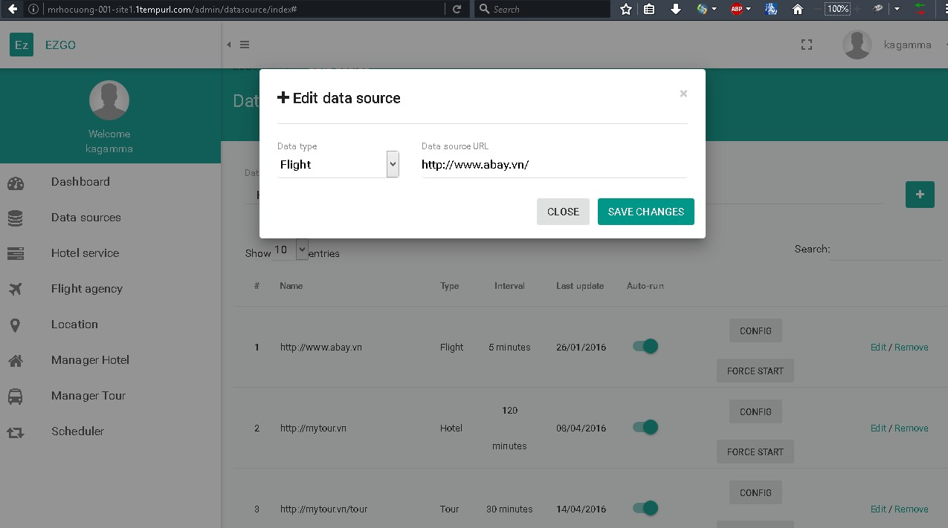

|  |  |
| --- | --- |
| **Step Description** | |
| **3** | Fill in fields:  “Data type”: Type of data this site offered. “Root URL”. URL root of the site. |
| **4** | Click on “Save changes” button. |

* + - * 1. *Configure existing data source of type Hotel / Tour*



|  |  |
| --- | --- |
| **Step Description** | |
| **1** | Click on “Data sources”. |
| **2** | Click on “Config” button. |

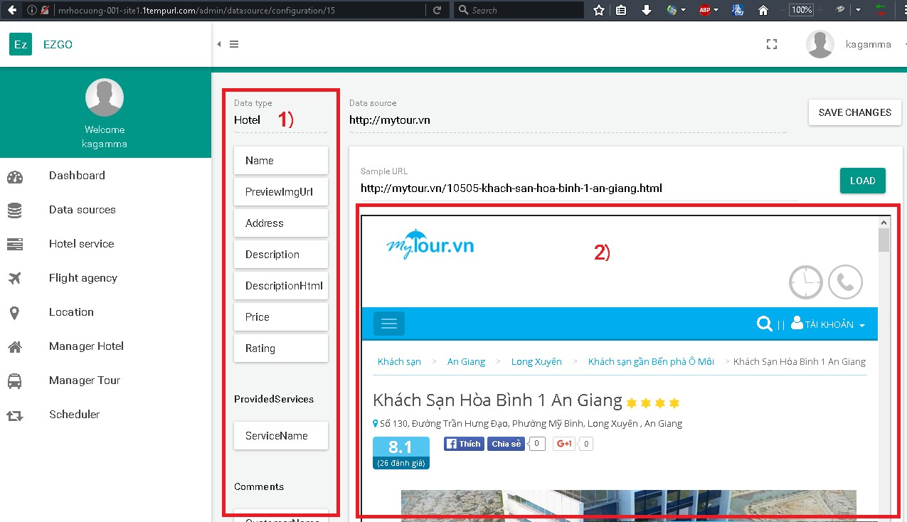

|  |  |
| --- | --- |
| **Step Description** | |
| **3** | Click on “Load” button to reload sample page to (2). |
| **4** | Select an attribute from (1).  Double-click to an item in (2) to copy it’s query string to (1). |
| **5** | Click on “Save changes” button. |

* + - * 1. *Configure existing data source of type Flight*



|  |  |
| --- | --- |
| **Step Description** | |
| **1** | Click on “Data sources”. |
| **2** | Click on “Config” button. |

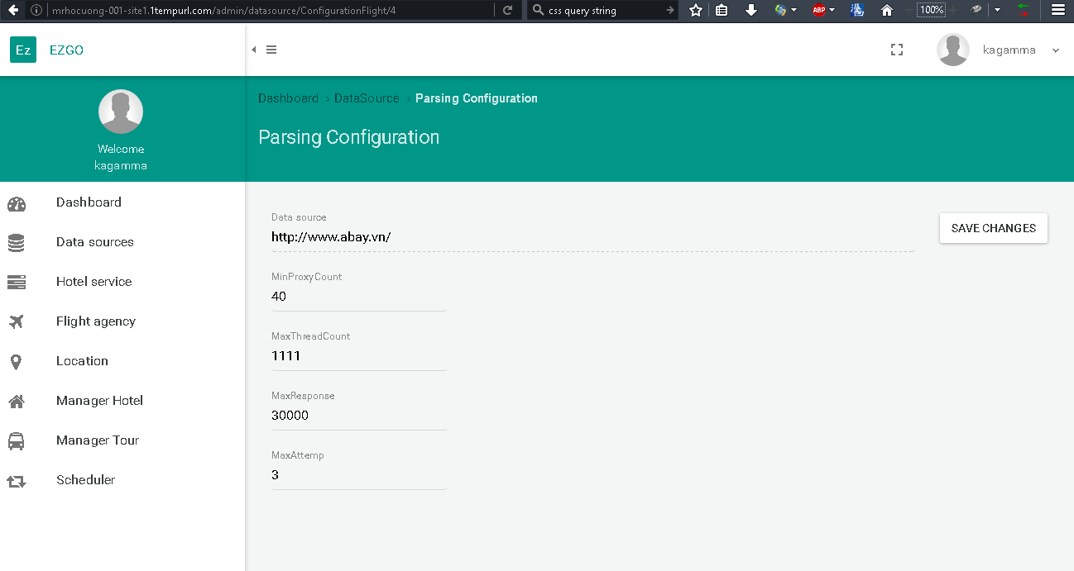

|  |  |
| --- | --- |
| **Step Description** | |
| **3** | Fill in fields:   * “Data source”: URL root of the site. * “MinProxyCount”: Minimum number of proxies require to parse this site. * “MaxThreadCount”: Number of threads. * “MaxResponse”: Maximum response time for a connection. * “MaxAttemp”: Maximum number of attempt to connect to the site per proxy. |
| **4** | Click on “Save changes” button. |

* + - * 1. *Execute data sources*



|  |  |
| --- | --- |
| **Step Description** | |
| **1** | Click on “Data sources”. |
| **2** | Click on “Force start” button to make the scheduler runs 1 time. Click on “Auto-run” switch to make scheduler runs periodically. |

* + - 1. **Manage Hotel Services**

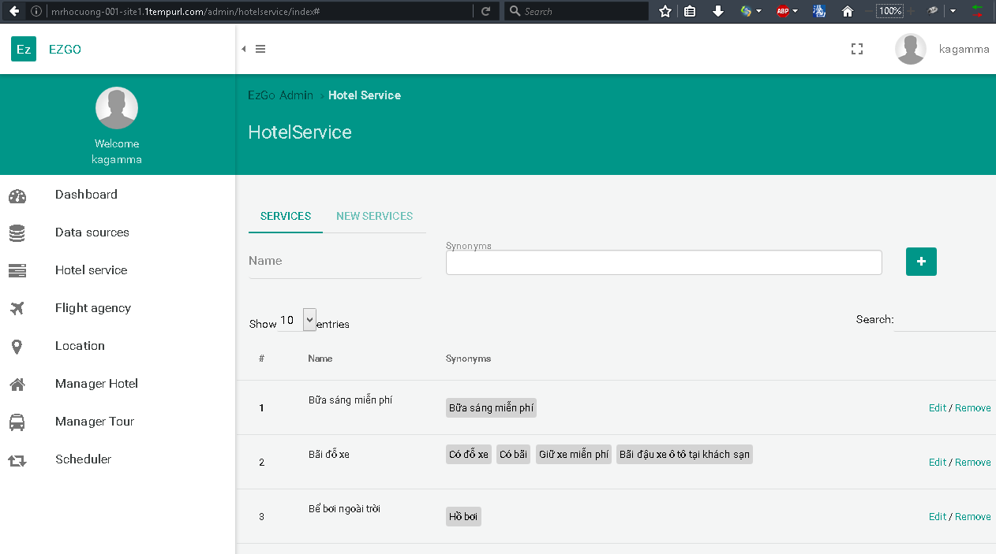

|  |  |
| --- | --- |
| **Step Description** | |
| **1** | Click on “Hotel Services”. |
| **2** | Click on “+” button to add new service with “Name” and “Synonyms”.  Click on “Edit” to edit services.  Click on “Remove” to remove services.  Click on “New services” to show list of unapproved services. |

* + - 1. **Manage Flight agency**

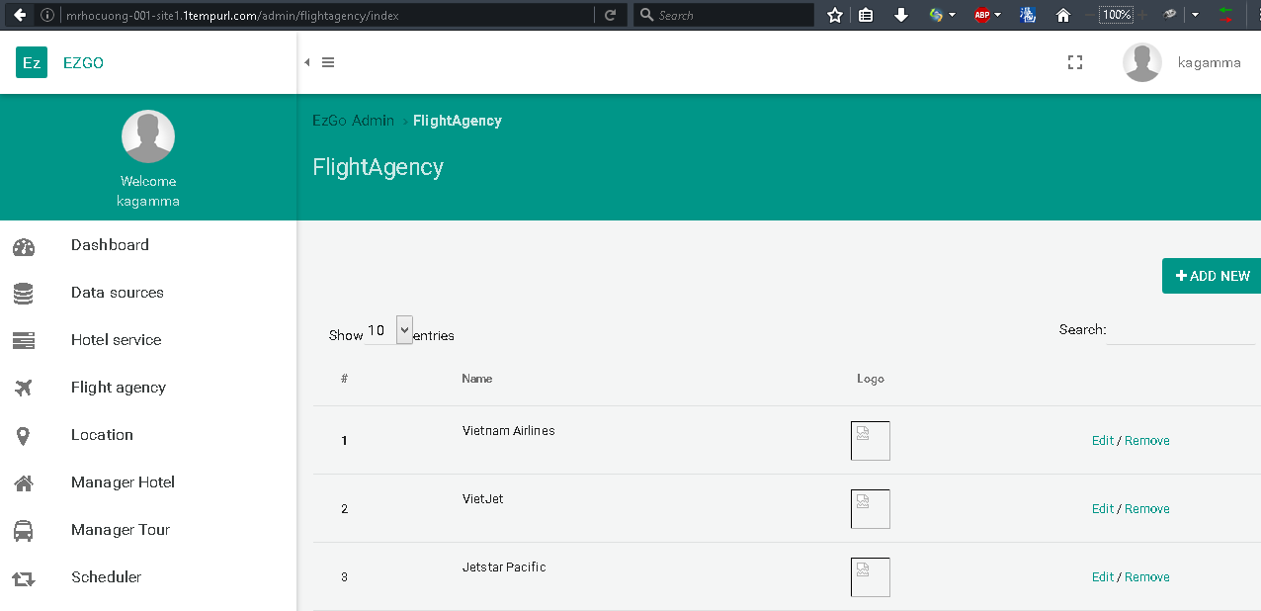

|  |  |
| --- | --- |
| **Step Description** | |
| **1** | Click on “Flight agency”. |
| **2** | Click on “Add new” button to add new agency. Click on “Edit” to edit agency.  Click on “Remove” to remove agency. |

* + - 1. **Manage Location**

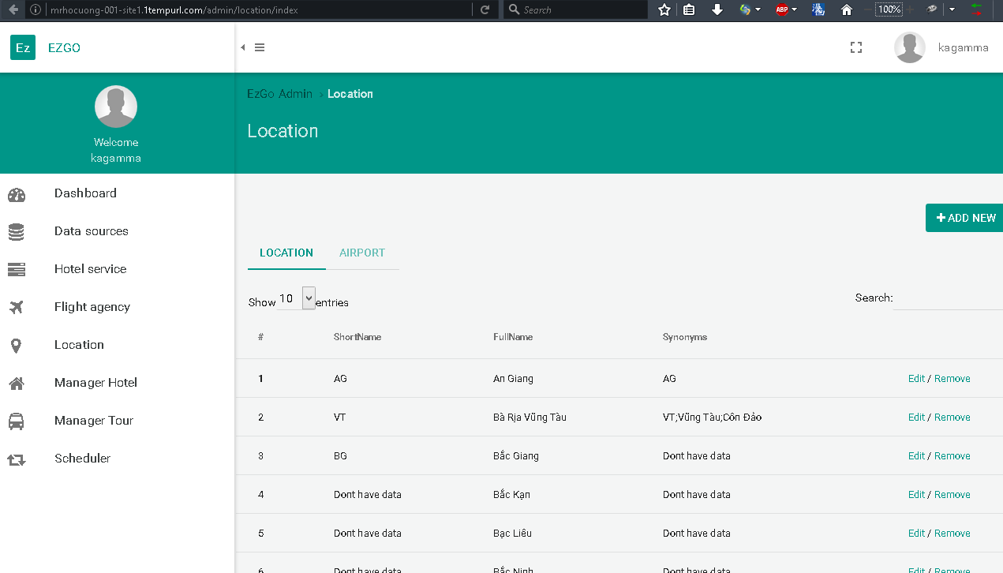

|  |  |
| --- | --- |
| **Step Description** | |
| **1** | Click on “Location”. |
| **2** | Click on “Add new” button to add new location. Click on “Edit” to edit location.  Click on “Remove” to remove location. |

* + - 1. **Manage schedulers**

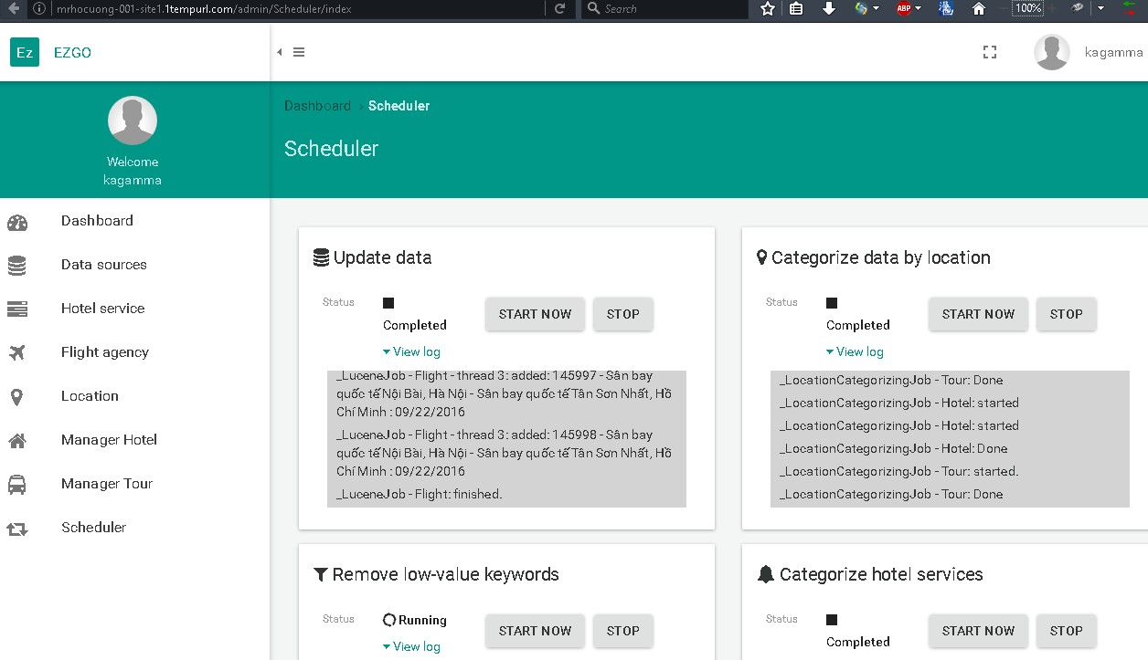

|  |  |
| --- | --- |
| **Step Description** | |
| **1** | Click on “Scheduler”. |
| **2** | Click on “Start now” to start a scheduler. Click on “Stop” to stop a scheduler. |

#### *Admin*

* + - 1. **Add new staff**

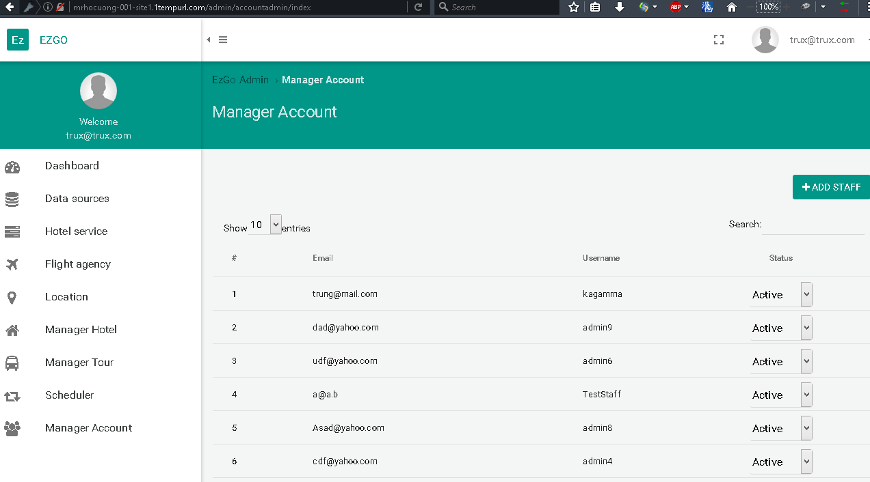

|  |  |
| --- | --- |
| **Step Description** | |
| **1** | Click on “Manager Account”. |
| **2** | Click on “Add staff” button. |

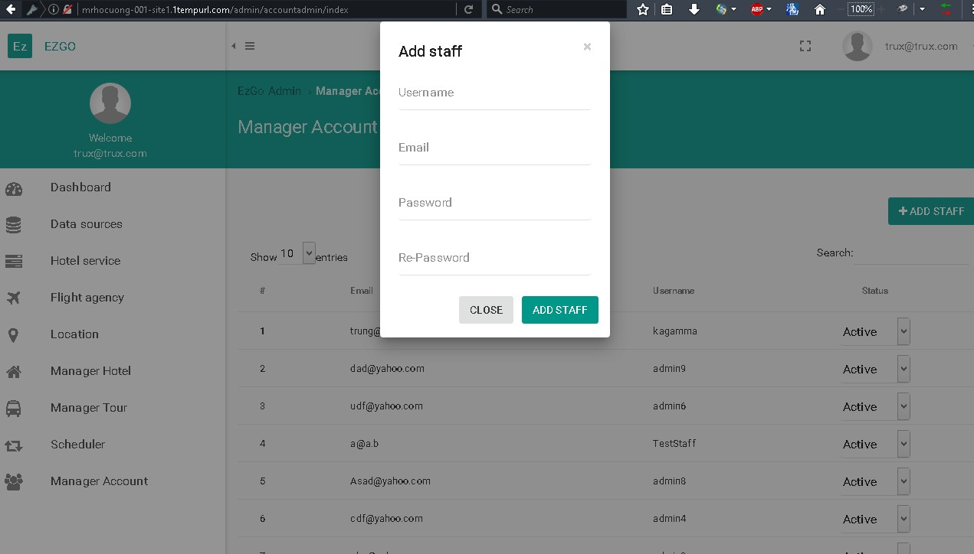

|  |  |
| --- | --- |
| **Step Description** | |
| **3** | Fill in fields:  “Username”: Staff’s username. Must be at least 6 characters. “Email”: Staff’s email.  “Password”: Staff’s password.  “Re-Password”: Confirm password. |
| **4** | Click on “Add staff” button. |

### Mobile application

#### *General search*



|  |  |
| --- | --- |
| **Step Description** | |
| **1** | Input keyword to the textbox. |
| **2** | Touch to the button with magnitude glass icon. |

#### *Search for hotels*

 

|  |  |
| --- | --- |
| **Step Description** | |
| **1** | Select “Tìm kiếm khách sạn” from the drop down list. |
| **2** | Select province from the drop down list. Input keywords to the textbox. |
| **3** | Touch to the button with magnitude glass icon. |

#### *Search for tours*



|  |  |
| --- | --- |
| **Step Description** | |
| **1** | Select “Tìm kiếm Tour” from the drop down list. |
| **2** | Select province from the drop down list. Input keywords to the textbox. |
| **3** | Touch to the button with magnitude glass icon. |

1. **Appendix**
2. **The Unified Modeling Language** *[Online].* Available: [http://www.uml- diagrams.org/](http://www.uml-diagrams.org/) . Accessed on: Mar. 2016.
3. **C# Coding Convention** [Online]. Available: [http://msdn.microsoft.com/en- us/library/vstudio/ff926074.aspx](http://msdn.microsoft.com/en-us/library/vstudio/ff926074.aspx) . Accessed on: Jan. 2016
4. Toby Segaran, “**Programming Collective Intelligence**”, Sebastopol, CA, USA: O’Reilly Media Inc., 2007.
5. Andrew Smith, **Introducing to Lucene .NET** *[Online].* Available: <http://www.codeproject.com/Articles/29755/Introducing-Lucene-Net>. Accessed on: Jan 2016.
6. **Lucene .NET 3.0.3 Documentation** *[Online].* Available: [https://lucenenet.apache.org/docs/3.0.3/db/d65/class_lucene_1_1_net_1_1_doc uments_1_1_document.html](https://lucenenet.apache.org/docs/3.0.3/db/d65/class_lucene_1_1_net_1_1_documents_1_1_document.html) . Accessed on: Jan. 2016.
7. **Lucene Similarity** *[Online].* Available: [https://lucene.apache.org/core/3_6_0/api/all/org/apache/lucene/search/Simil arity.html](https://lucene.apache.org/core/3_6_0/api/all/org/apache/lucene/search/Similarity.html) . Accessed on: Feb. 2016.
8. **Lucene Scoring** *[Online].* Available: [http://www.lucenetutorial.com/advanced- topics/scoring.html](http://www.lucenetutorial.com/advanced-topics/scoring.html) . Accessed on: Feb. 2016.
9. Doug Turnbull, **Build your own Custom Lucene query and scorer** *[Online].* Available: [http://opensourceconnections.com/blog/2014/01/20/build-your- own-custom-lucene-query-and-scorer/](http://opensourceconnections.com/blog/2014/01/20/build-your-own-custom-lucene-query-and-scorer/) . Accessed on: Feb. 2016.
10. Rion Williams, **Preven Repeated Request using ActionFilters in ASP .NET MVC** *[Online].* Available: [http://www.codeproject.com/Articles/582845/PreventplusRepeatedplusReque stsplususingplusAction](http://www.codeproject.com/Articles/582845/PreventplusRepeatedplusRequestsplususingplusAction) . Accessed on: Mar. 2016.
11. Brian Dean, **Google’s 200 Ranking Factors: The Complete List** *[Online].*

Available: <http://backlinko.com/google-ranking-factors>. Accessed on: Mar. 2016.